Name

Mathematics Stage 5 Paths
Further Parabolas

Book 1 | Further transformations of parabolas  Graphing parabolas using a variety of methods | Version: 260730  Feedback:  https://MrDingMaths.com
Contents
Syllabus Content 2
Sketching Parabolas by Factorisation 3
Further Parabola Transformations 13
Sketching Parabolas from Vertex Form 21
Sketching Parabolas by Completing the Square 28
Sketching Parabolas by The Quadratic Formula 34
Finding the Equation of a Parabola from its Graph 44
Applying Parabolas to Solve Problems 54

Syllabus Content
MA5-NLI-P-01 interprets and compares non-linear relationships and their transformations, both algebraically and graphically
Graph parabolas and describe their features and transformations
- Use graphing applications to compare parabolas of the form $y={kx}^{2}$,$y={kx}^{2}+c, y=k{\left(x-b\right)}^{2}$ and $y=k{\left(x-b\right)}^{2}+c$, and describe their features and transformations
- Find $x$- and $y$-intercepts algebraically, where appropriate, for the graph of $y={ax}^{2}+bx+c$, given $a,b$ and $c$
- Determine the equation of the axis of symmetry of a parabola using either the formula $x=-\frac{b}{2a}$ or the midpoint of the $x$-intercepts
- Find the coordinates of a parabola’s vertex using a variety of methods
- Graph quadratic relationships of the form $y={ax}^{2}+bx+c$ by identifying and applying features of parabolas and their equations without graphing software

Sketching Parabolas by Factorisation

- General Form of a Parabola
The general form of a parabola tells us the concavity and $y$-intercept.

$$y=ax^{2}+bx+c$$

Concavity $y$-intercept

- Identify $y$-intercept and concavity from the equation of a parabola
- $y=x^{2}-2x-15$  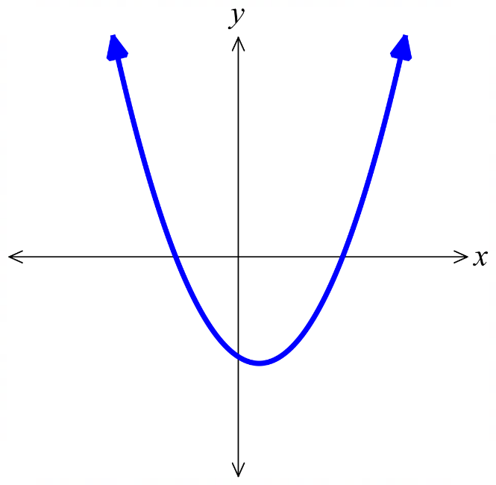  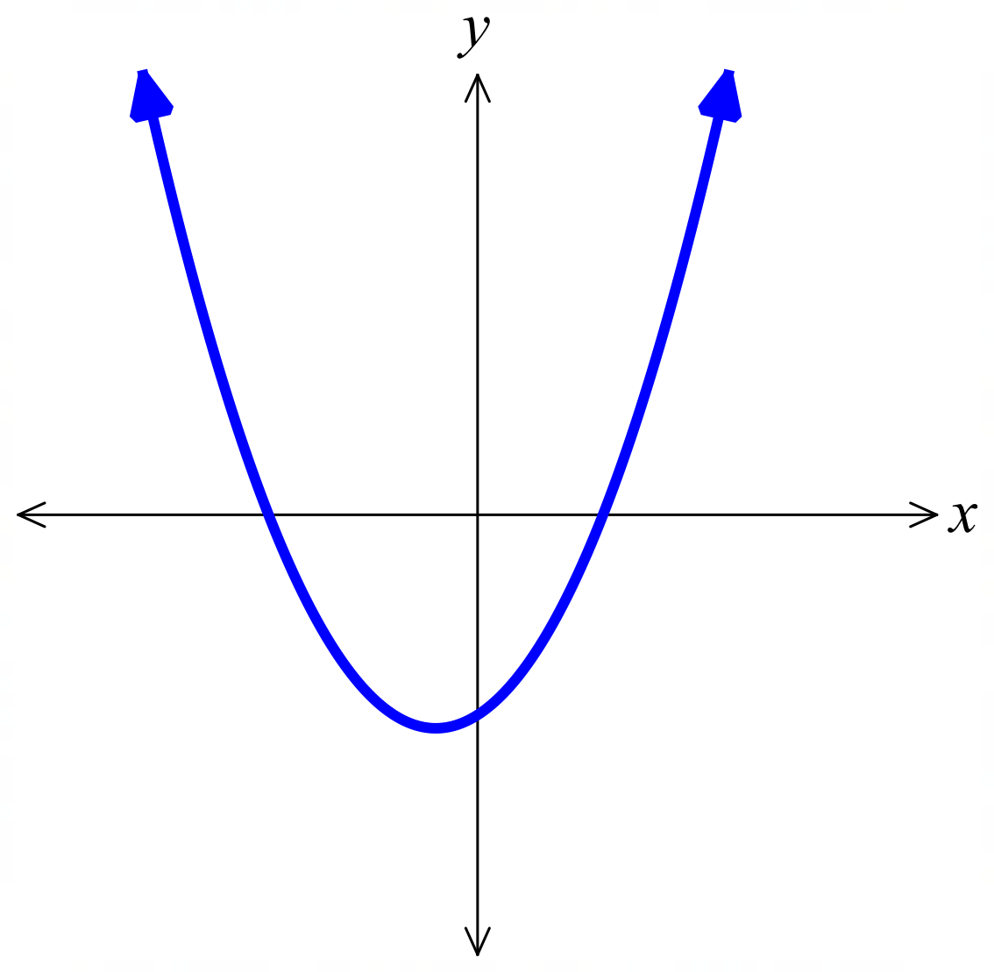  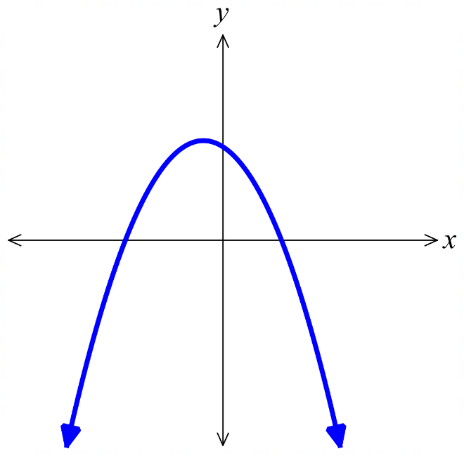 | - $y=x^{2}+2x-15$ | - $y=-x^{2}-2x+15$
- $y=x^{2}-\frac{13}{2}x-\frac{7}{2}$  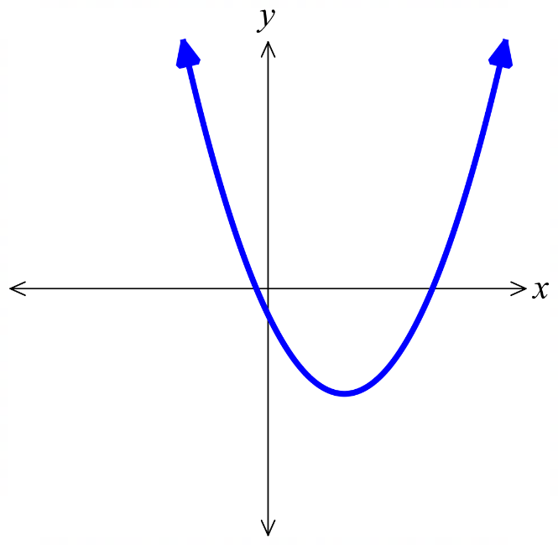 | - $y=2x^{2}+4x-16$  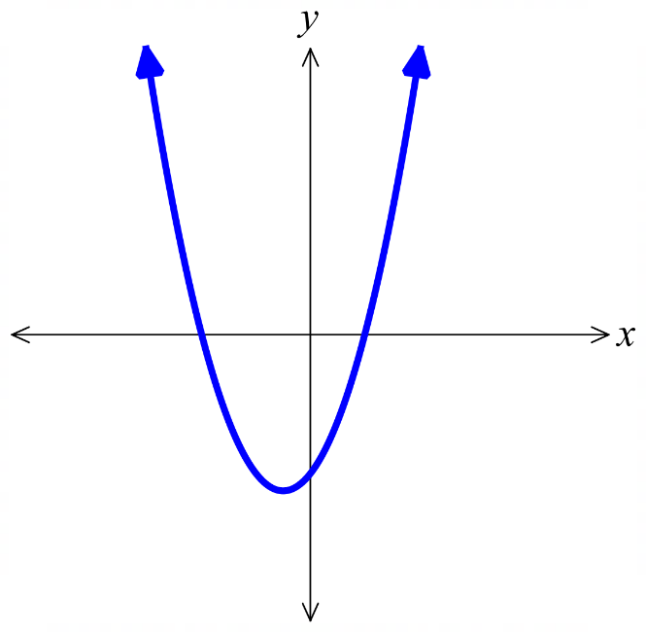 | - $y=x^{2}+4x$  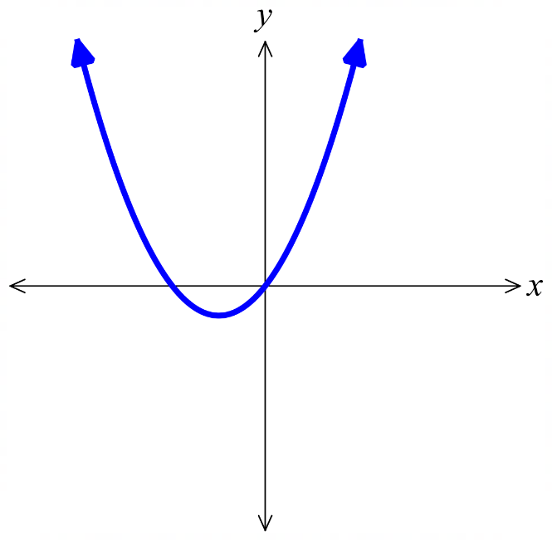
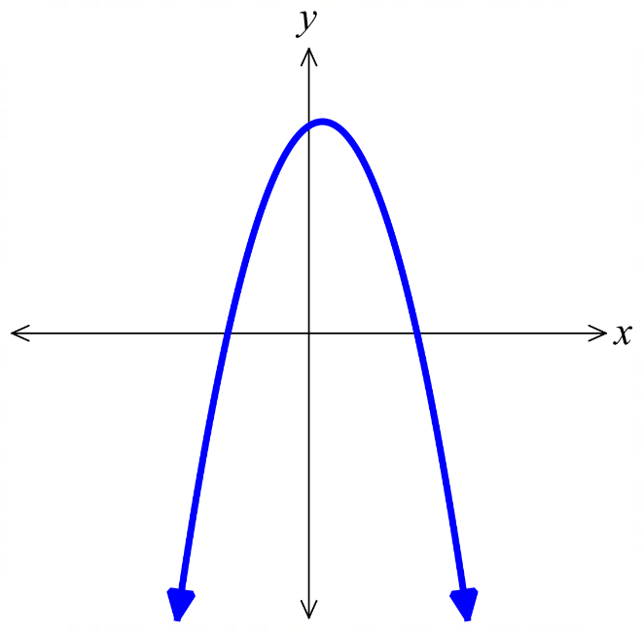  - $y=-x^{2}+4x$  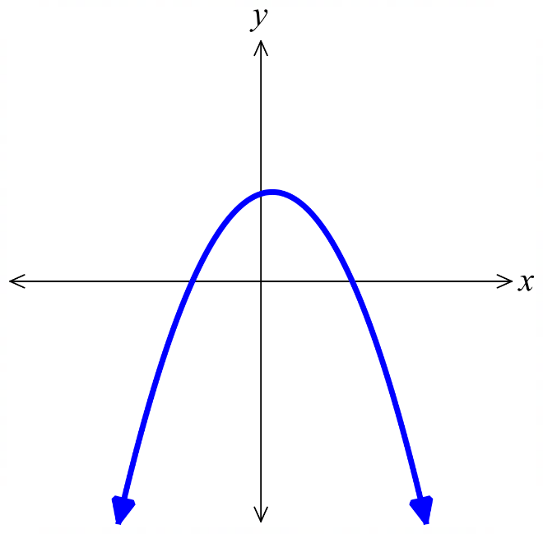  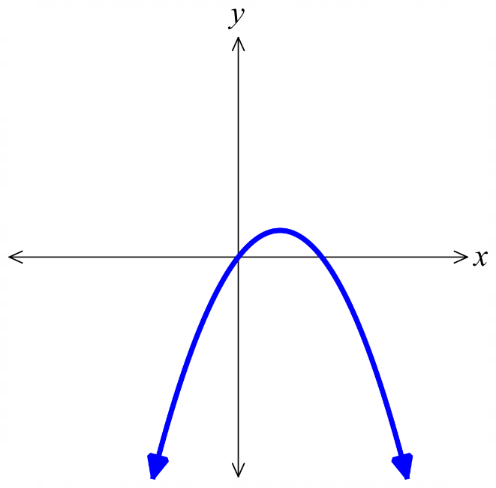 | - $y=-x^{2}+x+12$ | - $y=-2x^{2}+2x+24$
- Intercept Form of a Parabola
The intercept form of a parabola reveals its $x$-intercepts, since setting $y=0$ allows the solutions to be found using the null factor law.

$$y=a\left(x-α\right)\left(x-β\right)$$

Concavity $x$-intercepts

- Identify $x$-intercepts from the equation of a parabola
- $y=\left(x+3\right)\left(x-5\right)$ | - $y=\left(x-3\right)\left(x+5\right)$ | - $y=-\left(x-3\right)\left(x+5\right)$
- $y=\left(x+\frac{1}{2}\right)\left(x-7\right)$ | - $y=\left(2x+8\right)\left(x-2\right)$ | - $y=x\left(x+4\right)$
- $y=x(4-x)$ | - $y=\left(x+3\right)\left(4-x\right)$ | - $y=\left(2x+6\right)\left(4-x\right)$
- Sketch Parabolas by Factorisation
- Factorise $y=ax^{2}+bx+c$ to $y=a\left(x-α\right)\left(x-β\right).$
- Determine the concavity. $a>0$, concave up U $a<0$, concave down ∩.
- Find the $y$-intercept, $x=0$.
- Find the $x$-intercepts, if any. $y=0$.
- Determine the turning point.
Use the mean of the $x$-intercepts to find the $x$-coordinate,
then substitute into the equation to find the $y$-coordinate.

- Example Sketch parabolas from factored form
Sketch $y=x^{2}-6x+5$
0. Factorise: $y=\left(x-5\right)\left(x-1\right)$  1. Concavity: $a>0$, concave up  2. $y$-int: Let $x=0$  $y=5$  3. $x$-int: Let $y=0$  $0=\left(x-5\right)\left(x-1\right)$  $x=5$ or $1$  4. TP: Avg of $x$-intercepts: $\frac{1+5}{2}$ $=3$  Sub $x=3$ into equation  $y=3^{2}-6\left(3\right)+5$  $y=-4$ | 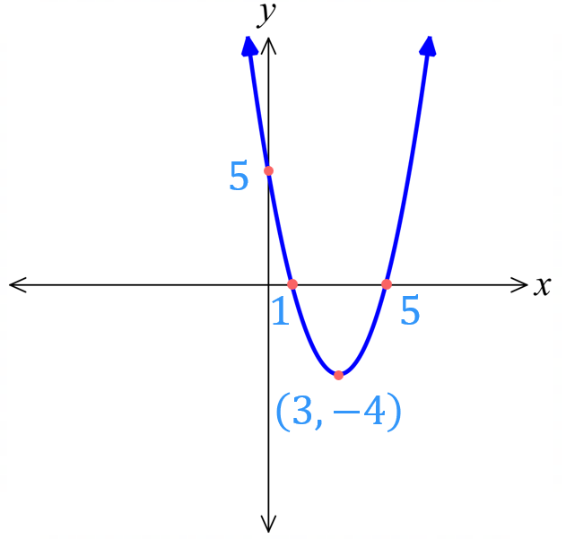

- Guided Practice
Sketch $y=x^{2}+4x-12$
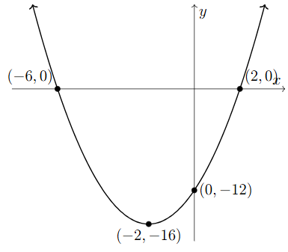
0. Factorise:

1. Concavity:
2. $y$-int:

3. $x$-int:

4. TP:
- Guided Practice
- $y=-x^{2}+4x$
0. Factorise:

1. Concavity:

2. $y$-int:
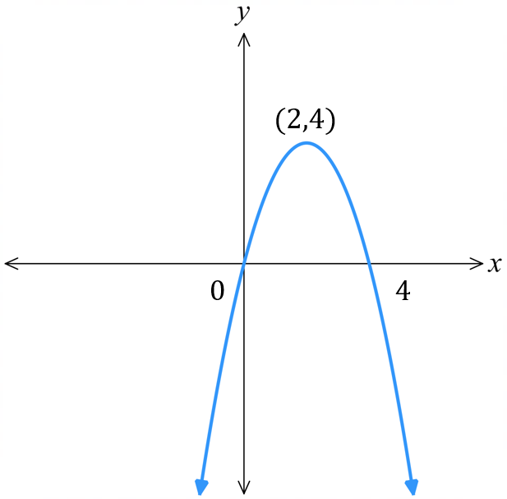

3. $x$-int:

4. Vertex:

- $y=2x^{2}+7x+5$
0. Factorise:

1. Concavity:

2. $y$-int:
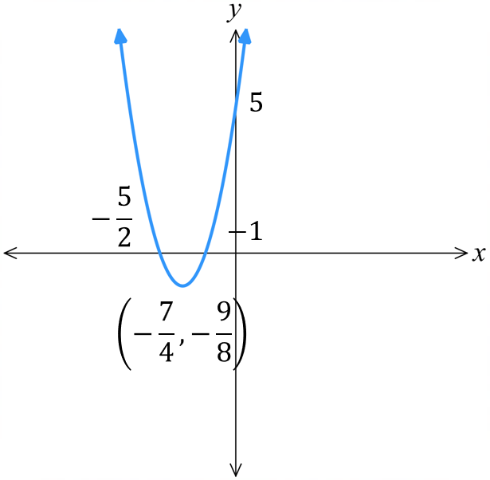

3. $x$-int:

4. Vertex:

Foundation
- Substitute $y=0$ then use the null factor law to find the $x$-intercepts of these quadratics.
- $y=\left(x+1\right)\left(x-2\right)$  $$x=-1, 2$$ | - $y=\left(x-3\right)\left(x-4\right)$  $$x=3, 4$$ | - $y=\left(x+1\right)\left(x+5\right)$  $$x=-1, -5$$
- $y=x\left(x-3\right)$  $$x=0, 3$$ | - $y=2x\left(x-5\right)$  $$x=0, 5$$ | - $y=-3x\left(x+2\right)$  $$x=0, -2$$
- $y=\left(x+\sqrt{5}\right)\left(x-\sqrt{5}\right)$  $$x=-\sqrt{5}, \sqrt{5}$$ | - $y=\left(x+\sqrt{7}\right)\left(x-\sqrt{7}\right)$  $$x=-\sqrt{7}, \sqrt{7}$$ | - $y=\left(x+2\sqrt{2}\right)\left(x-2\sqrt{2}\right)$  $$x=-2\sqrt{2}, 2\sqrt{2}$$

- Factorise and use the null factor law to find the $x$-intercepts for these quadratics.
- $y=x^{2}+3x+2$  $$x=-2, -1$$ | - $y=x^{2}+2x-8$  $$x=-4, 2$$ | - $y=x^{2}-8x+16$  $$x=4$$
- $y=x^{2}-4x$  $$x=0, 4$$ | - $y=x^{2}-6x$  $$x=0, 6$$ | - $y=2x^{2}+10x$  $$x=0, -5$$
- $y=x^{2}-9$  $$x=-3, 3$$ | - $y=x^{2}-25$  $$x=-5, 5$$ | - $y=x^{2}-10$  $$x= -\sqrt{10}, \sqrt{10}$$

- Using symmetry, state the missing coordinate in these quadratic graphs.
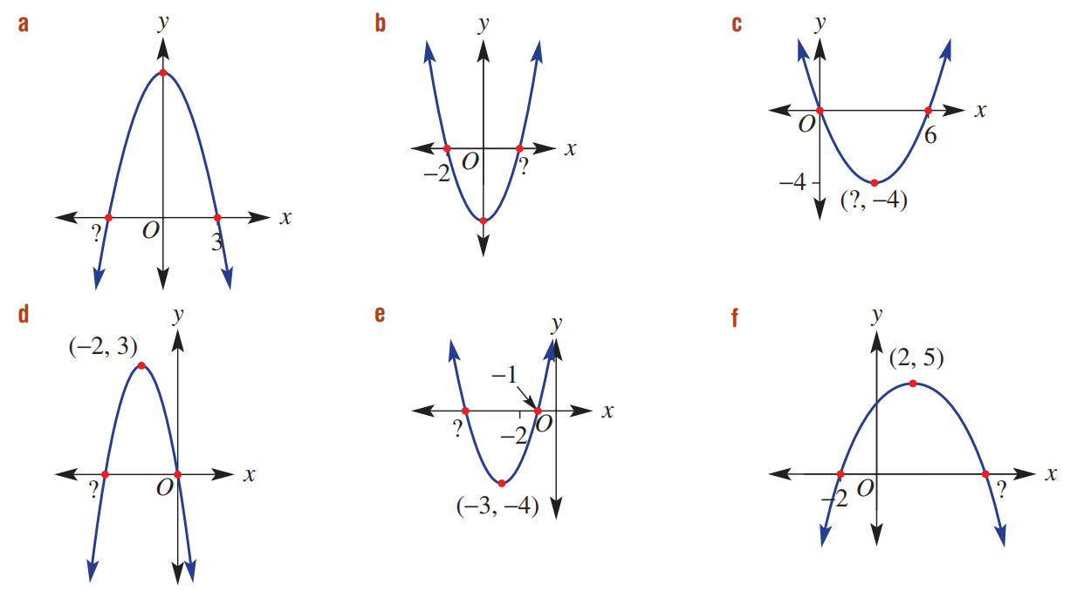  $$-3$$ | $$2$$ | $$3$$
$$-4$$ | $$-5$$ | $$6$$
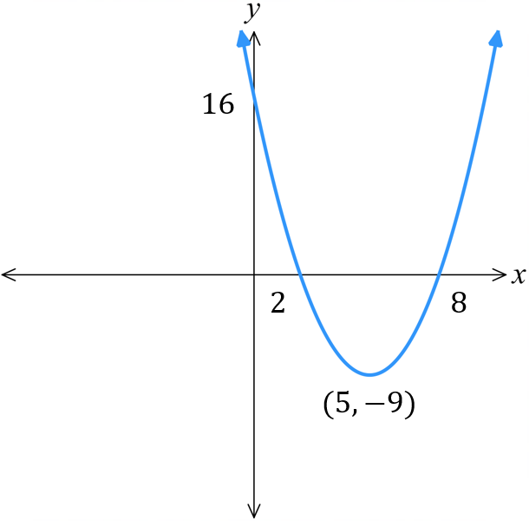
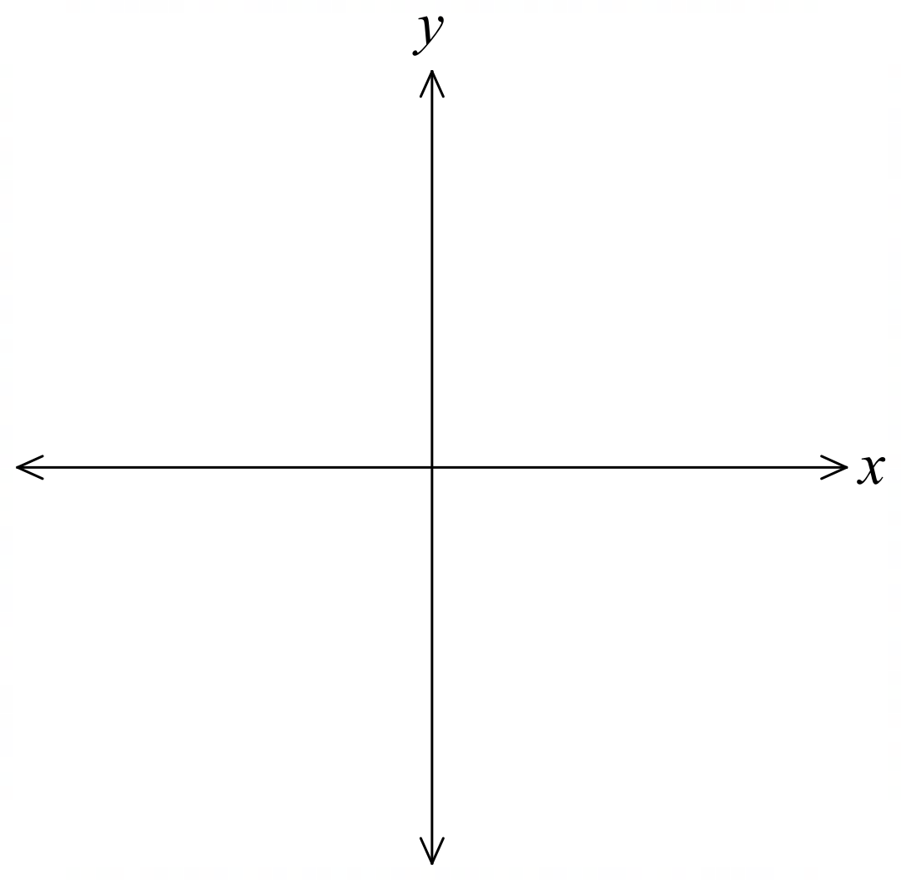
- Sketch $y=\left(x-2\right)\left(x-8\right)$:
  - concavity:
  - $y$-intercept:
  - $x$-intercepts:
  - vertex:

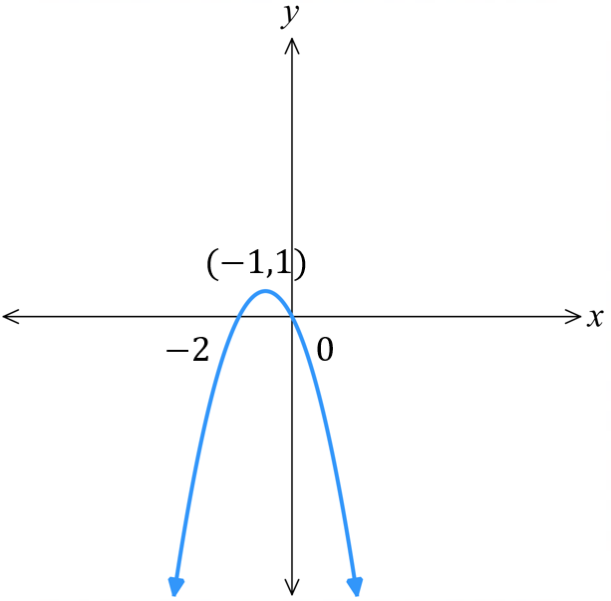
- Sketch $y=-x\left(x+2\right)$:
  - concavity:
  - $y$-intercept:
  - $x$-intercepts:
  - vertex:

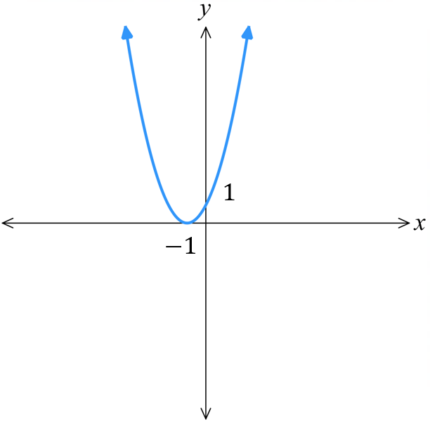
- Sketch $y={\left(x+1\right)}^{2}$:
  - concavity:
  - $y$-intercept:
  - $x$-intercepts:
  - vertex:

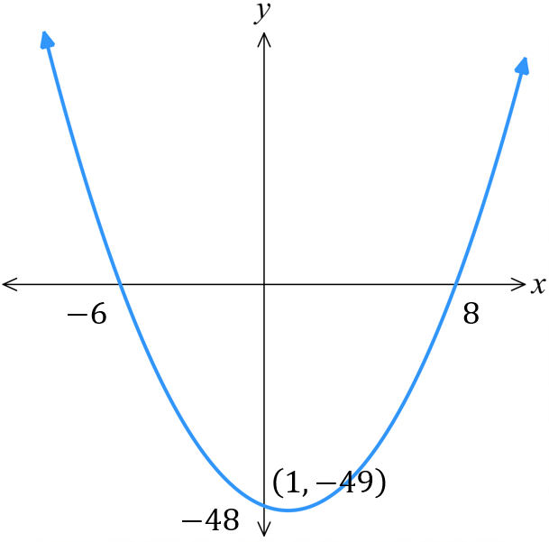
- Sketch $y=x^{2}-2x-48$:
  - factorise:
  - concavity:
  - $y$-intercept:
  - $x$-intercepts:
  - vertex:

Development
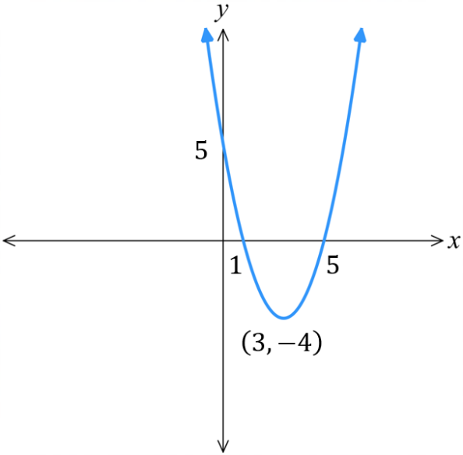
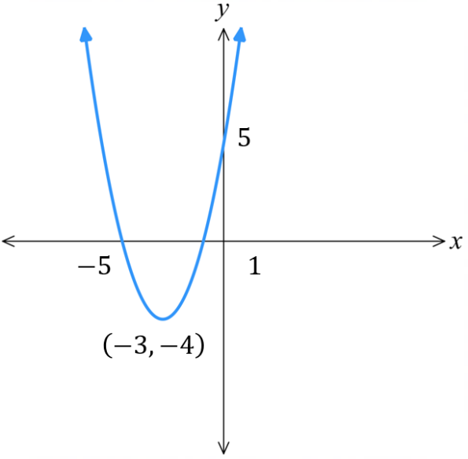
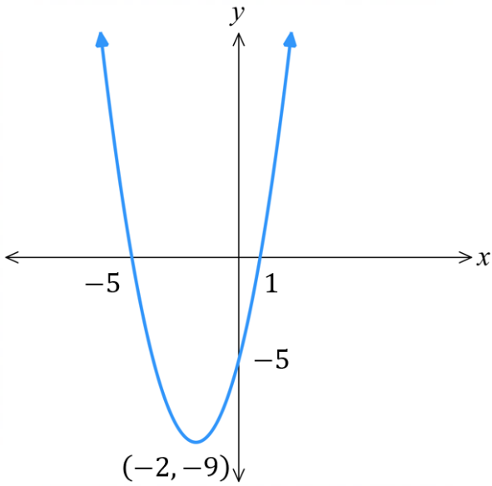
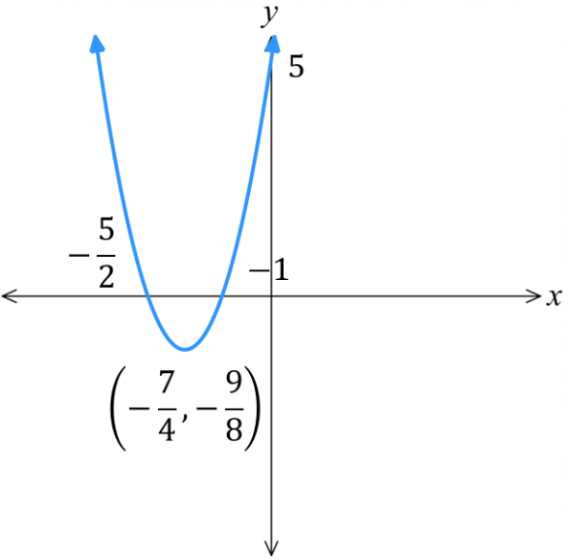
- Sketch these parabolas. Clearly label the vertex and intercepts.
- $y=\left(x-5\right)\left(x-1\right)$  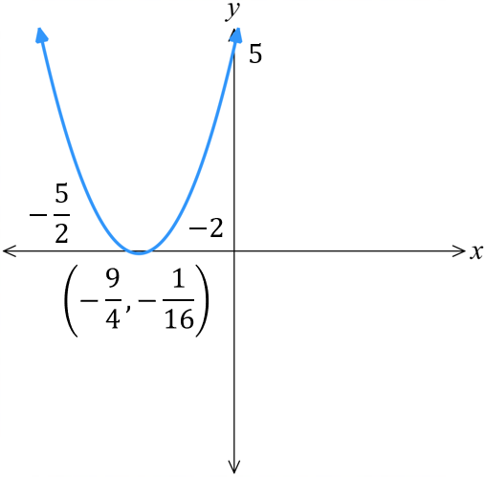 | - $y=\left(2x+5\right)\left(x+1\right)$
- $y=\left(x+5\right)\left(x-1\right)$  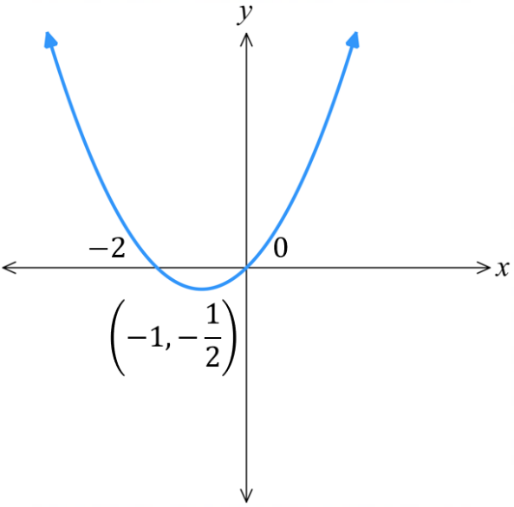 | - $y=\left(2x+5\right)\left(\frac{1}{2}x+1\right)$
- $y=\left(x+5\right)\left(x+1\right)$  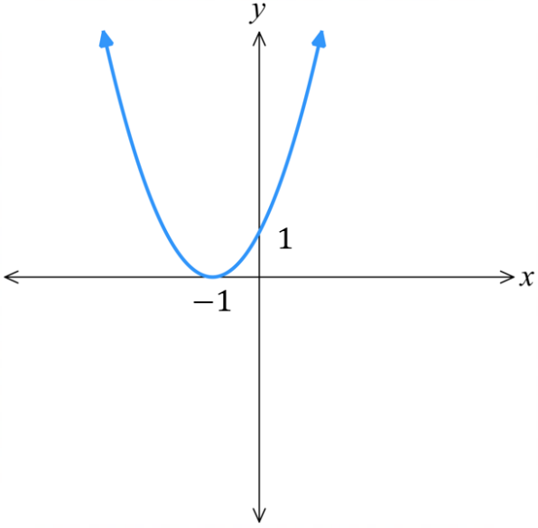 | - $y=x\left(\frac{1}{2}x+1\right)$
- $y=\left(5+x\right)\left(x+1\right)$  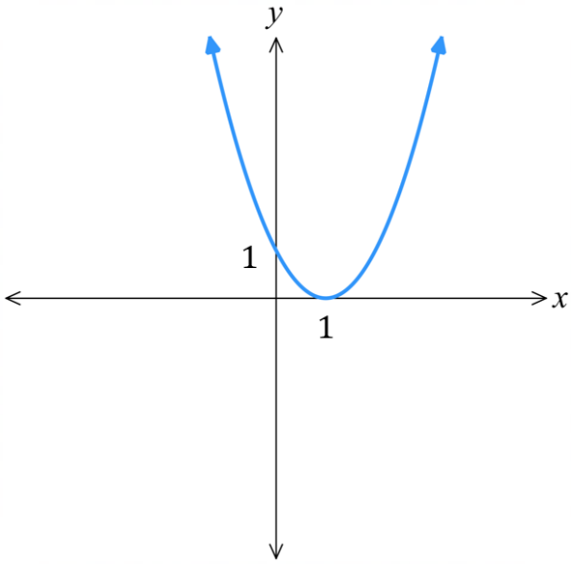 | - $y={\left(x+1\right)}^{2}$
- $y=\left(5-x\right)\left(1-x\right)$ | - $y={\left(x-1\right)}^{2}$
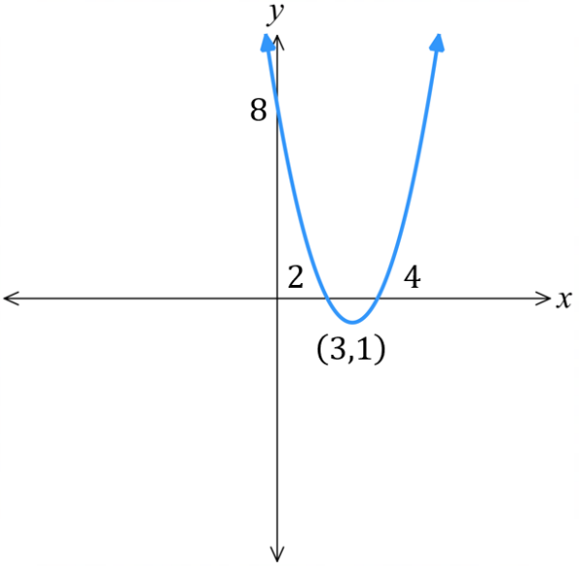
- Sketch these parabolas by factorising first. Show the vertex and all intercepts.
- $y=x^{2}-6x+8$ | 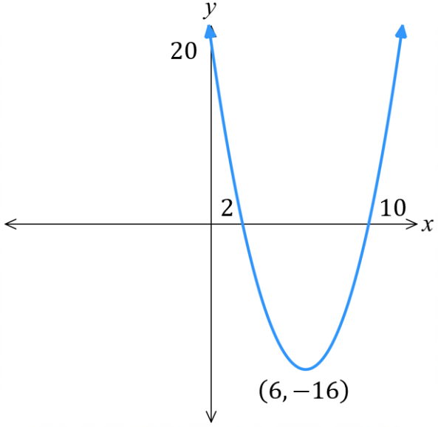  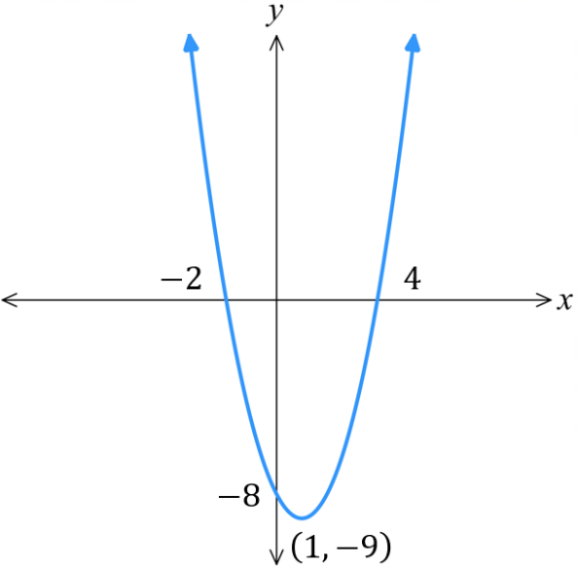  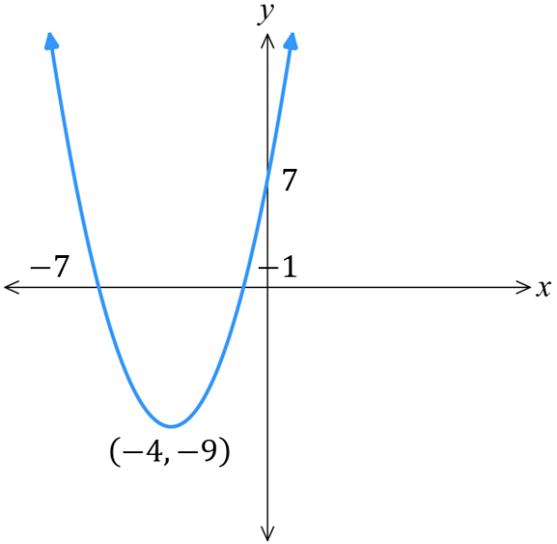  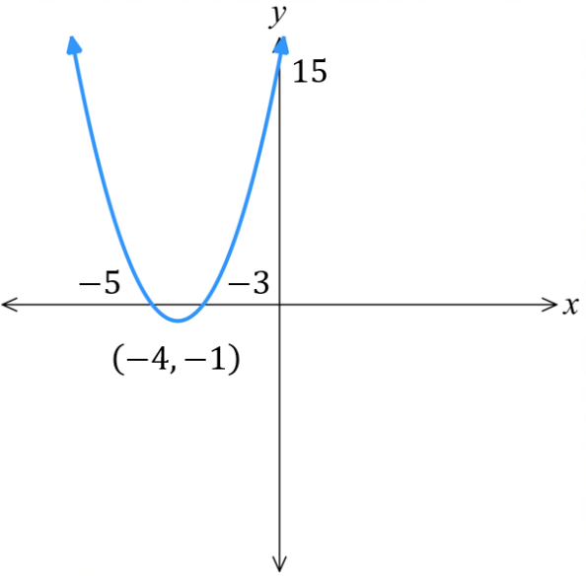  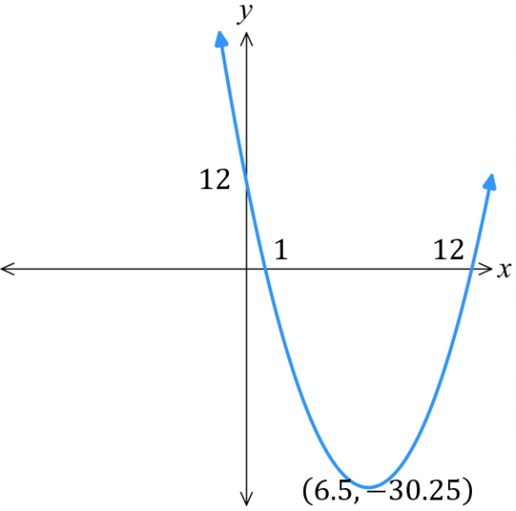  - $y=x^{2}+8x+15$
- $y=x^{2}-2x-8$ | - $y=x^{2}+8x+7$
- $y=x^{2}-12x+20$ | 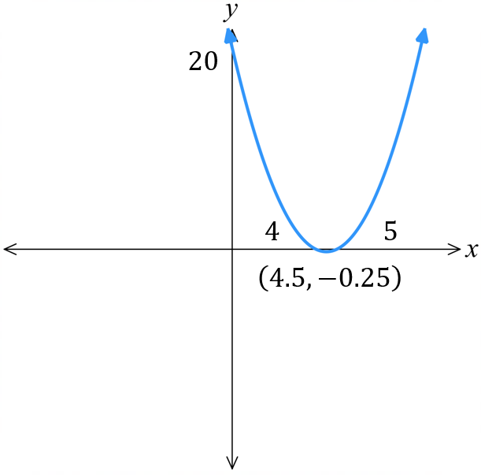  - $y=x^{2}-9x+20$
- $y=x^{2}-13x+12$ | - $y=x^{2}+5x+4$  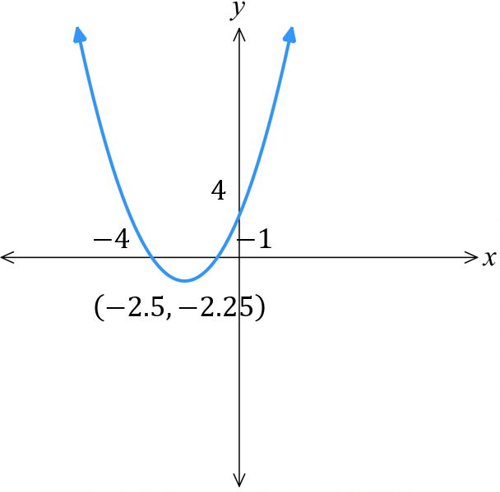
- $y=x^{2}-4x-12$ | 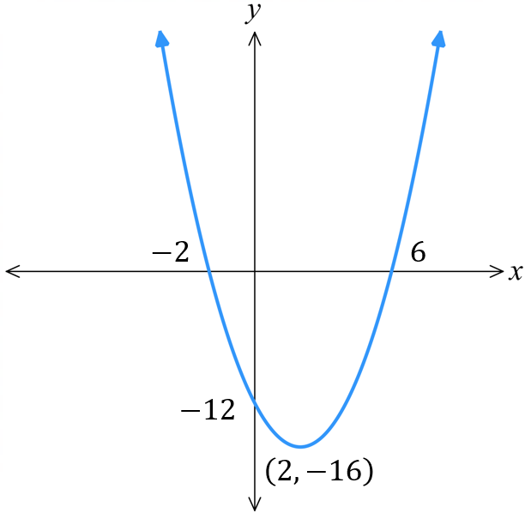  - $y=x^{2}+2x$  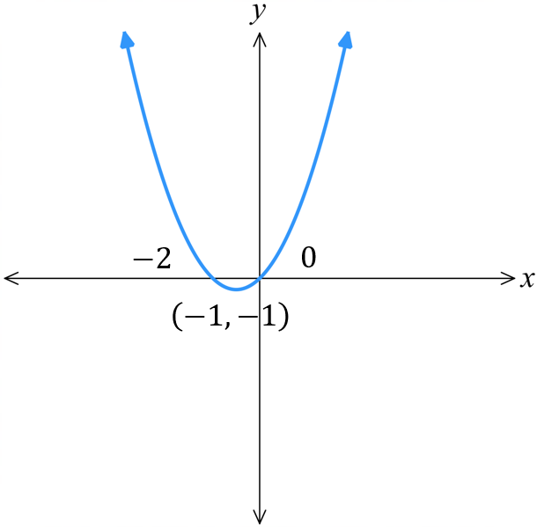
- $y=x^{2}-4x$ | 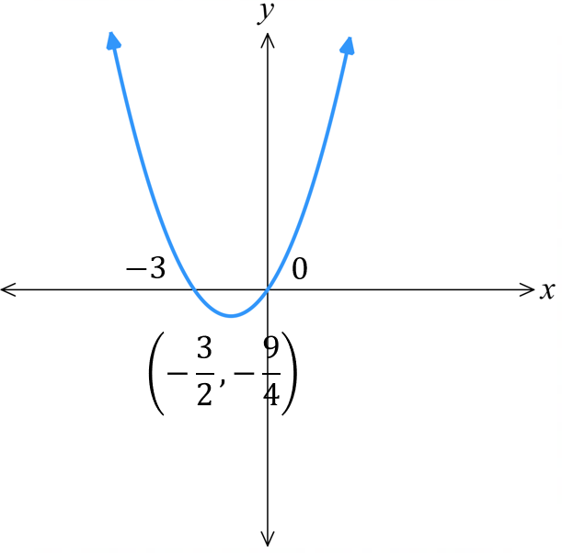  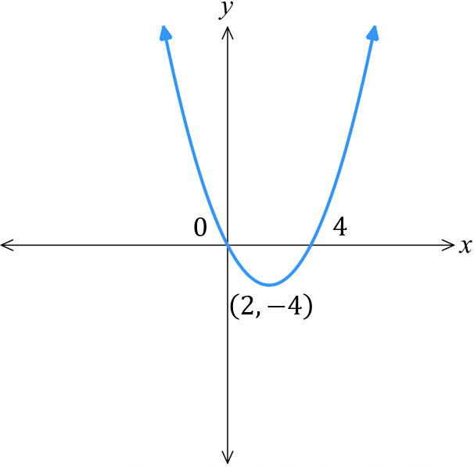  - $y=x^{2}+3x$
- $y=x^{2}+4x+4$ | 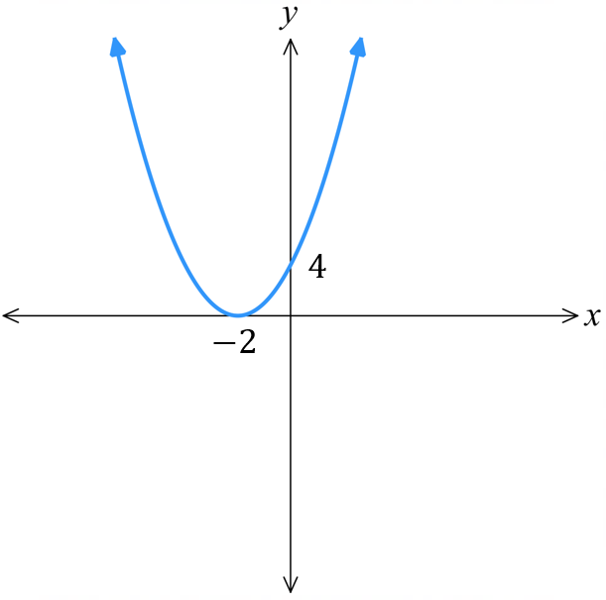  - $y=x^{2}-10x+25$  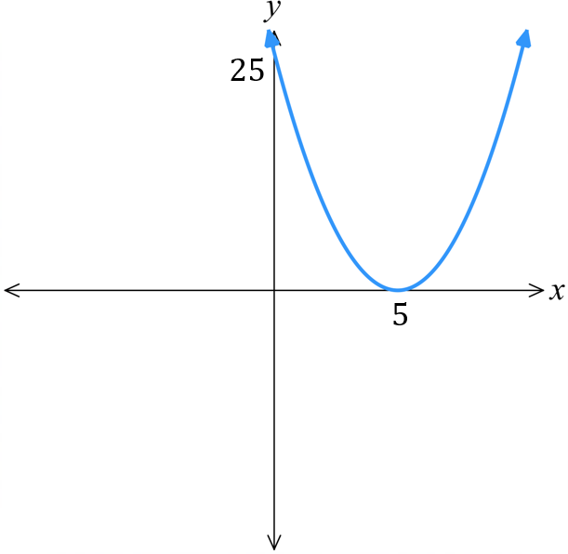
- $y=x^{2}+8x+16$ | 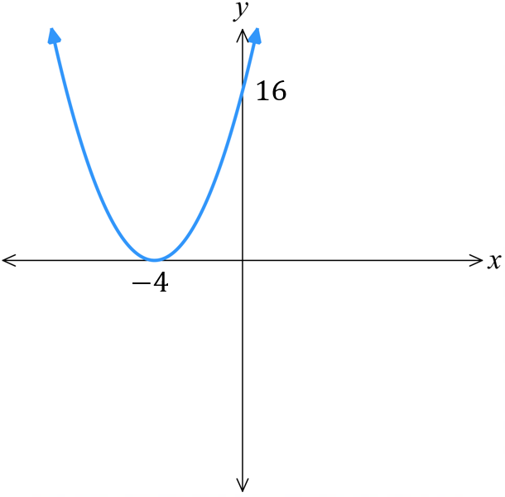  - $y=x^{2}-16$  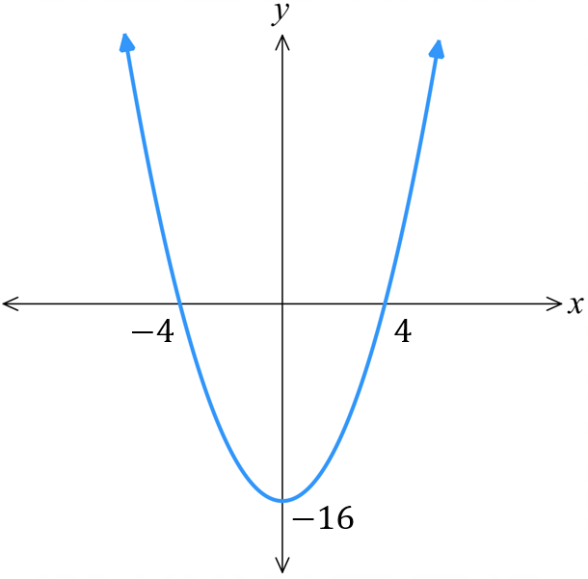

Mastery
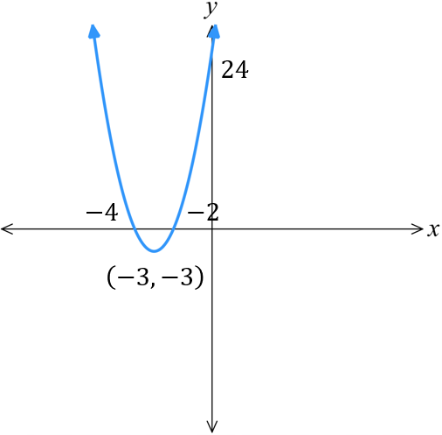
- Sketch these parabolas. Show the vertex and all intercepts.
- $y=3x^{2}+18x+24$ | - $y=4x^{2}+24x+32$  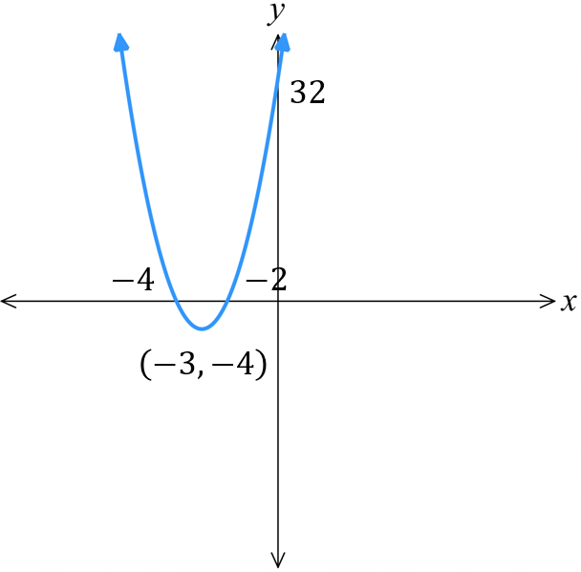
- $y=-x^{2}+8x+9$ | 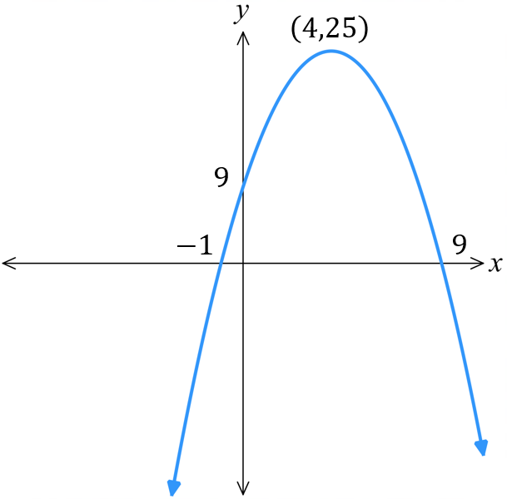  - $y=4x-x^{2}$  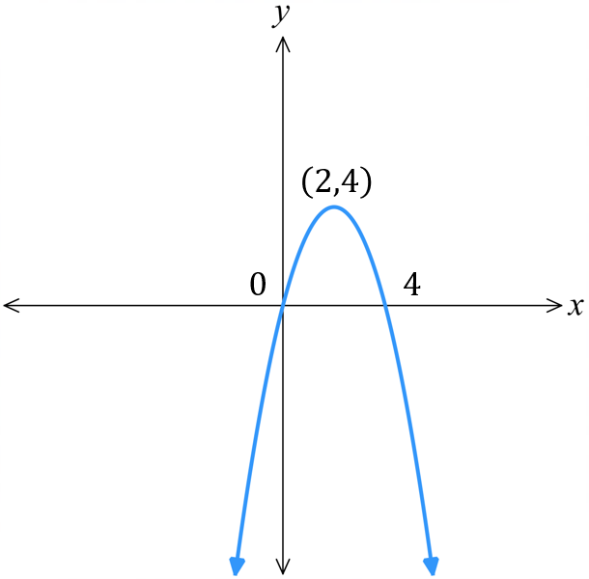
- $y=-x^{2}+2x+8$ | 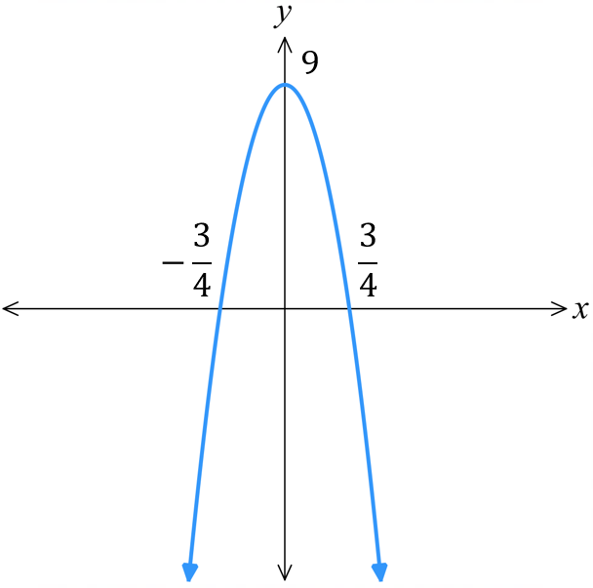  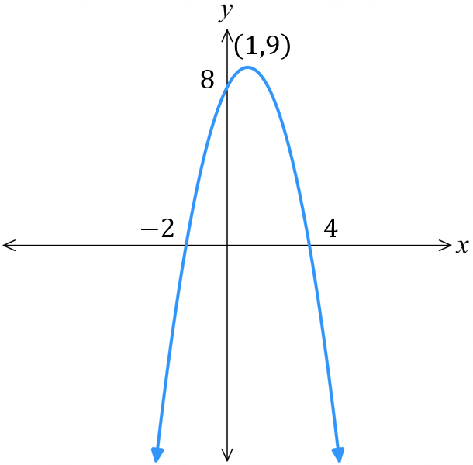  - $y=9-16x^{2}$

- With reference to the null factor law, explain why $y=\left(x-3\right)\left(x-5\right)$ and $y=2\left(x-3\right)\left(x-5\right)$ both have the same $x$-intercepts.
For both equations, null factor law says either $x-3=0$ or $x-5=0$

Further Parabola Transformations

- Review
- Recall parabola transformations for $y=kx^{2}+c$
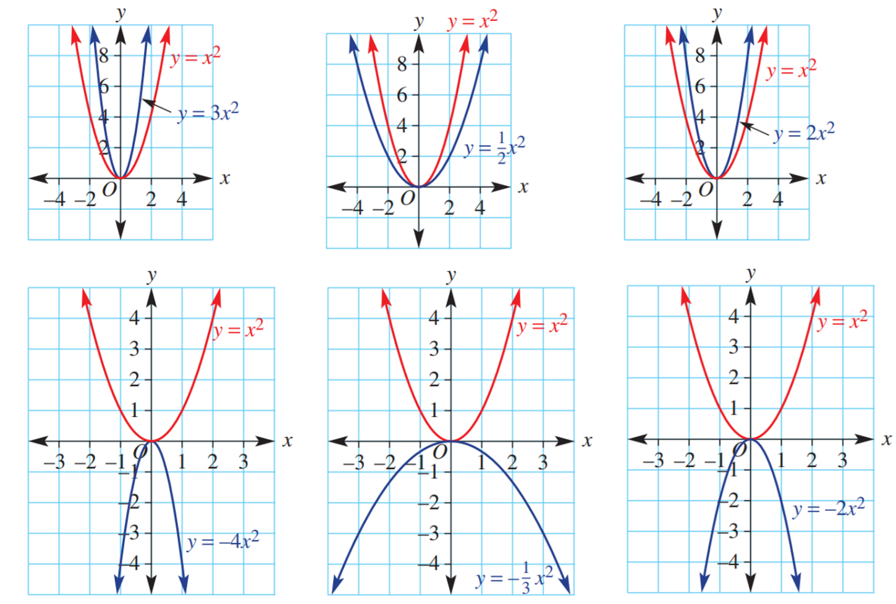
- Consider these parabolas of the form $y=kx^{2}$

For $y=kx^{2},$ when $k>1$, the parabola becomes n……………………
when $0<k<1$, the parabola becomes w……………………
narrower, wider
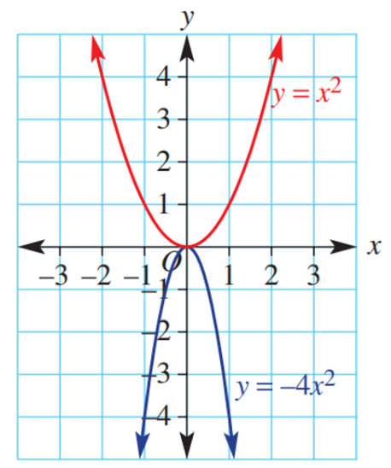
- Consider these parabolas of the form $y=kx^{2}$
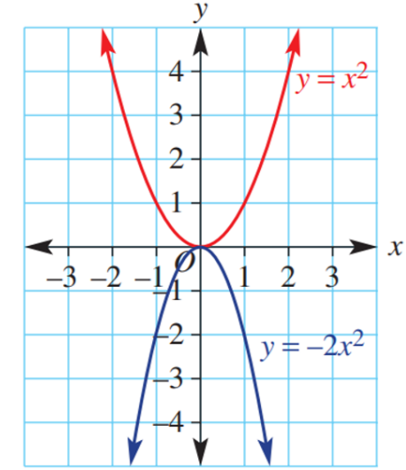

For $y=kx^{2},$ when $k<0$, the parabola is r………………… across the $x$-axis.
when $\left|k\right|>1$, the parabola becomes n……………………
when $0<\left|k\right|<1$, the parabola becomes w……………………
reflected, narrower, wider
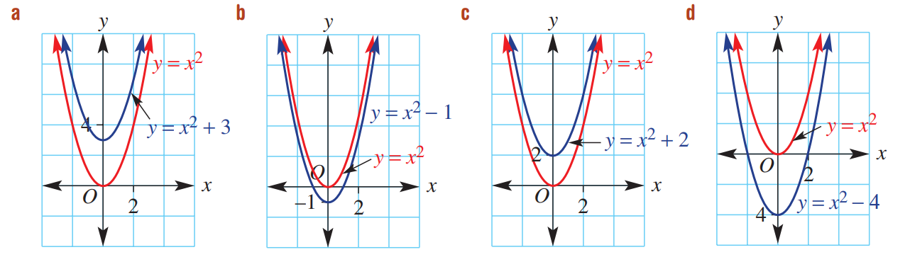
- Consider the parabolas of the form $y=x^{2}+c$

For $y=x^{2}+c,$ when $c>0$, the parabola translates u………………
when $c<0$, the parabola translates d………………
up, down

- Parabola Transformations
For a parabola $y=k{\left(x-b\right)}^{2}+c$
The variables $b,c,k$ are numbers that affect the graph in predictable ways.
These special variables are called parameters.
$k>0$, the parabola is concave ……………,  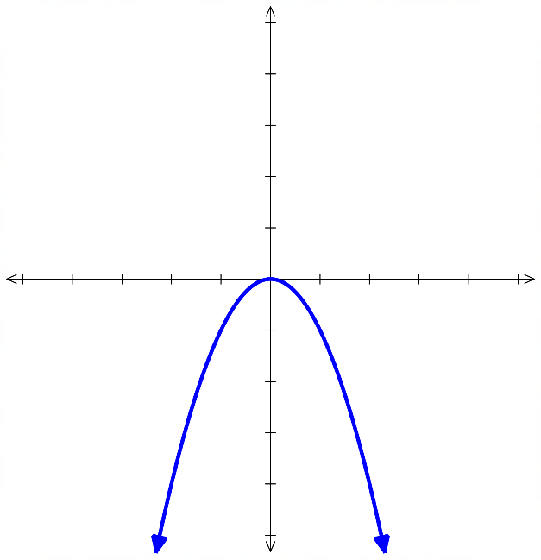  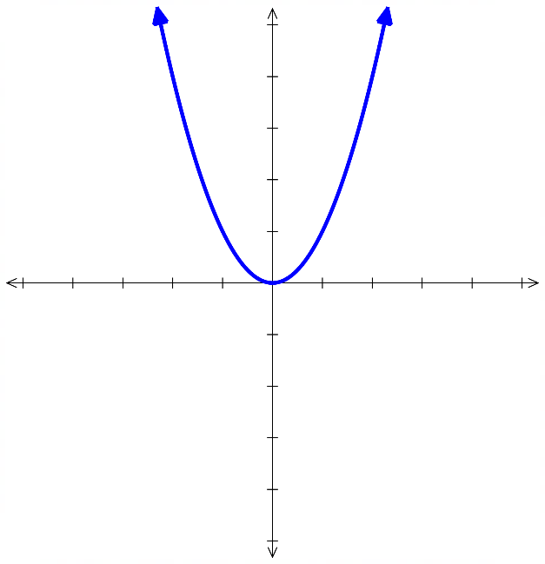  with a ………………… turning point.  $$y=1x^{2}$$ | $k<0$, the parabola is concave ……………,  with a ……………… turning point.  $$y=-1x^{2}$$
$b>0$, the parabola is shifted ……………  $$y={\left(x-3\right)}^{2}$$ | $b<0$, the parabola is shifted ……………  $$y={\left(x+3\right)}^{2}$$  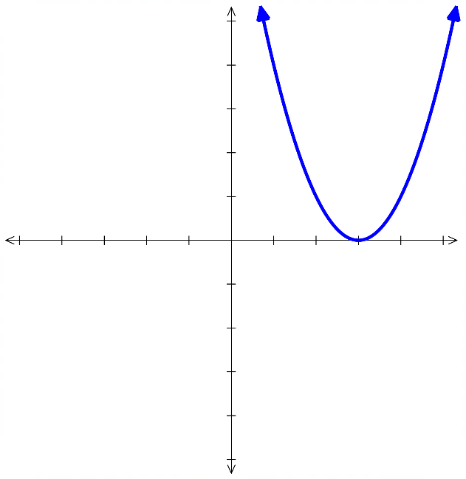  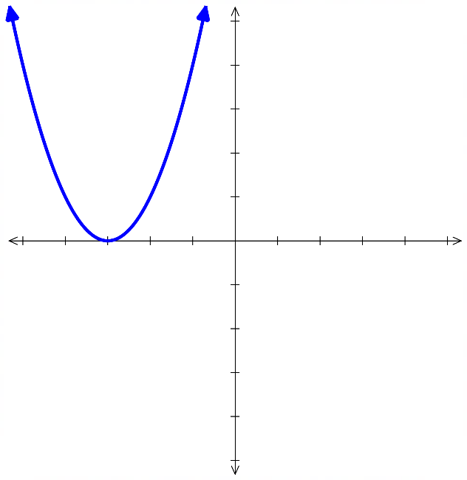
$c>0$, the parabola is shifted ……………  $$y=x^{2}+3$$ | $c<0$, the parabola is shifted ……………  $$y=x^{2}-3$$  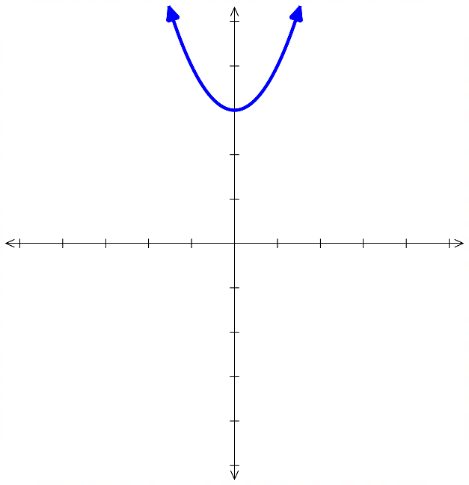  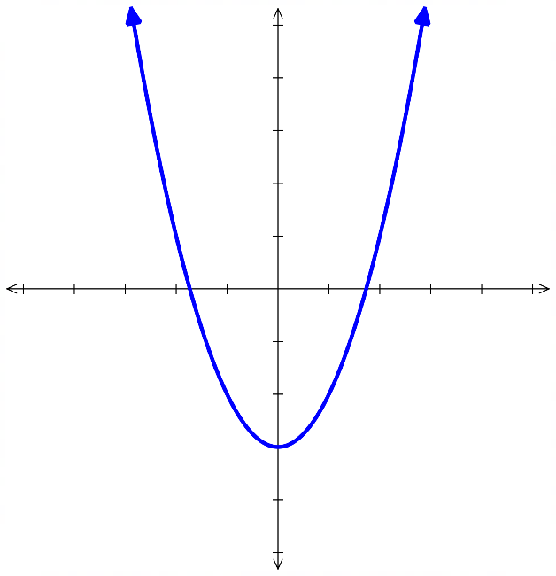
$\left|k\right|>1$, the parabola gets …………….  $$y=5x^{2}$$  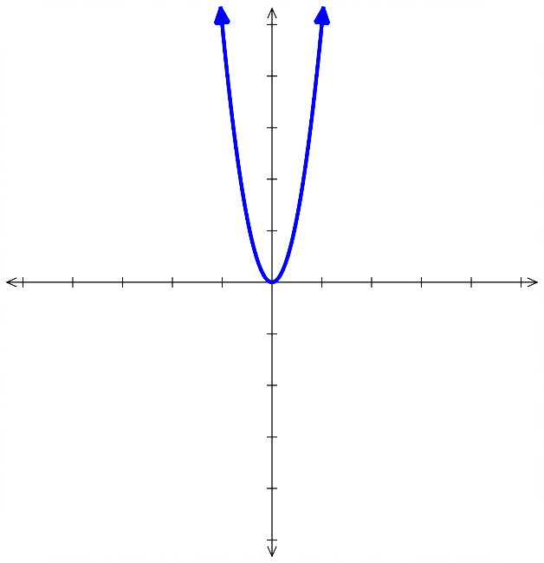 | $0<\left|k\right|<1,$ the parabola gets ……………….  $$y=\frac{1}{5}x^{2}$$  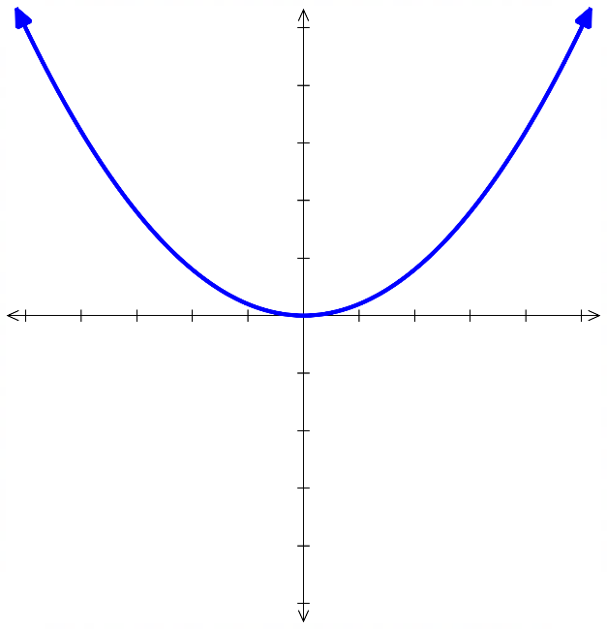
- Vertex Form of a Parabola
The vertex form of a parabola reveals its turning point because it shows the graph’s horizontal and vertical shifts.

$$y=a{\left(x-h\right)}^{2}+k$$

Concavity turning point $\left(h,k\right)$

- Identify turning point of a parabola
Equation | Turning Point (Vertex)
$y=3{\left(x-4\right)}^{2}+2$ | $$\left(4,2\right)$$
$y=3{\left(x-4\right)}^{2}-2$ | $$\left(4,-2\right)$$
$y=-3{\left(x-4\right)}^{2}-2$ | $$\left(4,-2\right)$$
$y=-3{\left(x+4\right)}^{2}-2$ | $$\left(-4,-2\right)$$
$y=-3{\left(x+4\right)}^{2}+2$ | $$\left(-4,2\right)$$
$$y=\frac{1}{3}{\left(x+4\right)}^{2}+2$$ | $$\left(-4,2\right)$$
$$y=\frac{{\left(x+4\right)}^{2}}{3}+2$$ | $$\left(-4,2\right)$$
$$y=\frac{{\left(x+4\right)}^{2}+2}{3}$$ | $$\left(-4,\frac{2}{3}\right)$$
$y={\left(x+4\right)}^{2}+2$ | $$\left(-4,2\right)$$
$y={\left(x+4\right)}^{2}$ | $$\left(-4,0\right)$$
$y=x^{2}$ | $$\left(0,0\right)$$
$y=x^{2}+5$ | $$\left(0,5\right)$$
$$y=\frac{x^{2}}{5}$$ | $$\left(0,0\right)$$
$y=-9{\left(x+1\right)}^{2}-5$ | $$\left(-1,-5\right)$$

Foundation
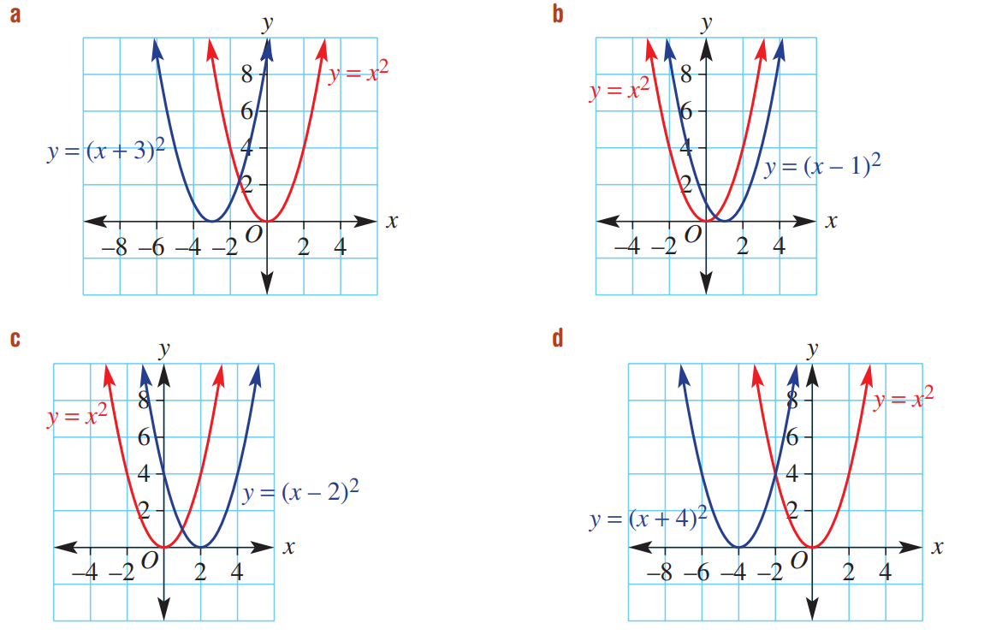
- Consider the parabolas of the form ${\left(x±b\right)}^{2}$:

When $b>0$, $y={\left(x-b\right)}^{2}$, the parabola translates to the r…………
When $b>0,$ $y={\left(x+b\right)}^{2}$, the parabola translates to the l…………
right, left
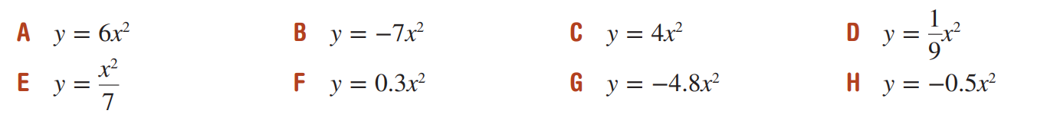
- Here are eight parabolas of the form $y=ax^{2}$:

  - Which equation would give a parabola that is concave up and the narrowest? …………
  - Which equation would give a parabola that is concave down and the widest? …………
A, H
- Identify the translation and complete these sentences.
  - Compared with $y=x^{2}$, $y=x^{2}+3$ is translated up by 3
  - Compared with $y=x^{2}$, $y=x^{2}-6$ is translated ………………
Down 6
  - Compared with $y=x^{2}$, $y={\left(x-3\right)}^{2}$ is translated ………………
Right 3
  - Compared with $y=x^{2}$, $y={\left(x+1\right)}^{2}$ is translated ………………
Left 1
  - Compared with $y=x^{2}$, $y={\left(x+3\right)}^{2}-2$ is translated left by …… and down by ……
Left 3, down 2
  - Compared with $y=x^{2}$, $y={\left(x-5\right)}^{2}-3$ is translated …………………………………
Right 5, down 3
  - Compared with $y=x^{2}$, $y={\left(x-2\right)}^{2}+3$ is translated …………………………………
Right 2, up 3
  - Compared with $y=x^{2}$, $y={\left(x+4\right)}^{2}+5$ is translated …………………………………
Left 4, up 5

Development
- Write the coordinates of the turning point for the parabolas formed by these equations.
- $y=x^{2}$  $$\left(0,0\right)$$ | - $y=-x^{2}$  $$\left(0,0\right)$$ | - $y=x^{2}+3$  $$\left(0,3\right)$$
- $y=-x^{2}-3$  $$\left(0,-3\right)$$ | - $y=-x^{2}+7$  $$\left(0,7\right)$$ | - $y={\left(x-2\right)}^{2}$  $$\left(2,0\right)$$
- $y={\left(x+5\right)}^{2}$  $$\left(-5,0\right)$$ | - $y=2x^{2}$  $$\left(0,0\right)$$ | - $y=-\frac{1}{3}x^{2}$  $$\left(0,0\right)$$

- Write the coordinates of the turning point for these parabolas.
- $y={\left(x+3\right)}^{2}+1$  $$\left(-3,1\right)$$ | - $y={\left(x+2\right)}^{2}-4$  $$\left(-2,-4\right)$$ | - $y={\left(x-1\right)}^{2}+3$  $$\left(1,3\right)$$
- $y={\left(x-4\right)}^{2}-2$  $$\left(4,-2\right)$$ | - $y={\left(x-2\right)}^{2}+2$  $$\left(2,2\right)$$ | - $y=-{\left(x-3\right)}^{2}+3$  $$\left(3,3\right)$$
- $y=-{\left(x+1\right)}^{2}+4$  $$\left(-1,4\right)$$ | - $y=-{\left(x-2\right)}^{2}-5$  $$\left(2,-5\right)$$ | - $y=-{\left(x-4\right)}^{2}-10$  $$\left(4,-10\right)$$

- Write the equation for these parabolas, when compared to $y=x^{2}$.
- reflected across $x$-axis  $$y=-x^{2}$$ | - translated 2 units left  $$y={\left(x+2\right)}^{2}$$ | - translated 5 units down  $$y=x^{2}-5$$
- translated 4 units up  $$y=x^{2}+4$$ | - translated 1 unit right  $y={\left(x-1\right)}^{2}$ | - reflected across $x$-axis and translated 2 units up  $$y=-x^{2}+2$$
- reflected across $x$-axis, translated 3 units left  $$y=-{\left(x+3\right)}^{2}$$ | - translated 5 units left and 3 units down  $$y={\left(x+5\right)}^{2}-3$$ | - translated 6 units right and 1 unit up  $$y={\left(x-6\right)}^{2}+1$$

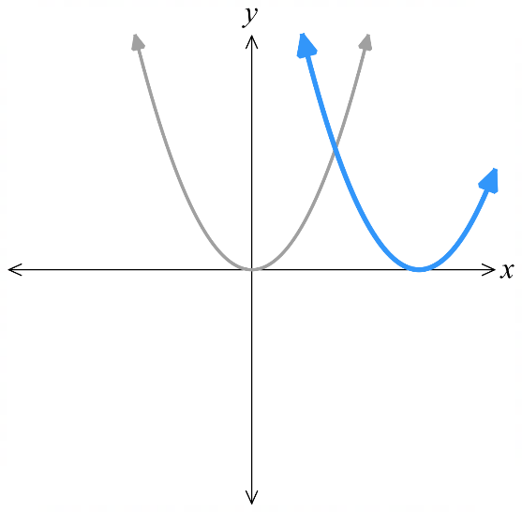
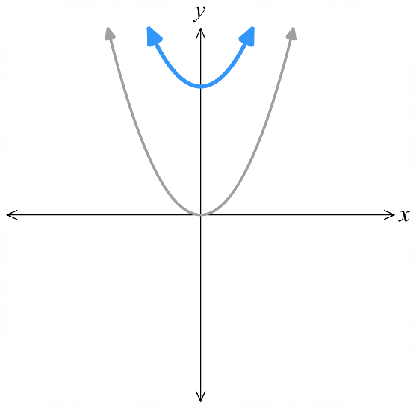
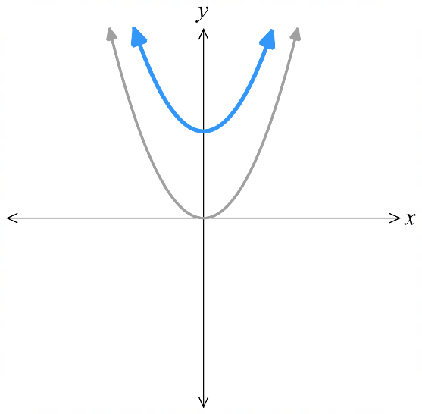
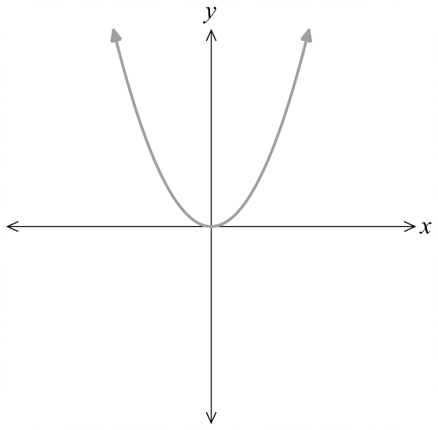
- Sketch these parabolas. The graph of $y=x^{2}$ is given. You do not need to find any points.
- $y=x^{2}-1$  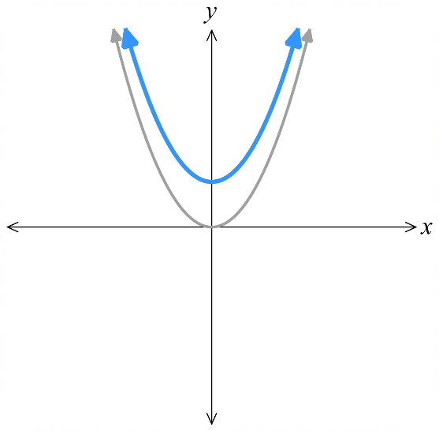  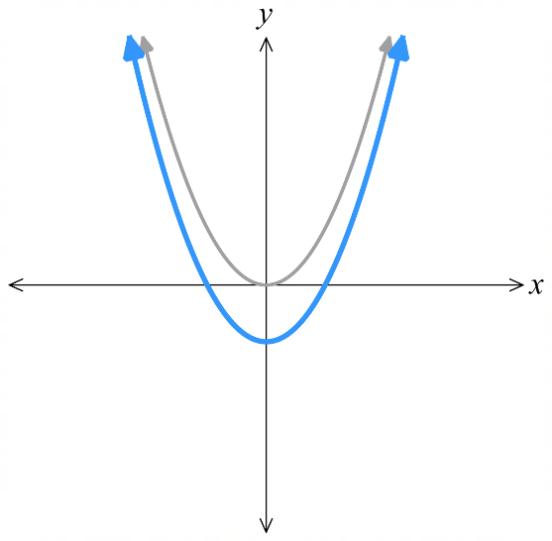 | - $y=x^{2}+1$ | - $y=x^{2}+2$ | - $y=x^{2}+3$
- $y=x^{2}-3$  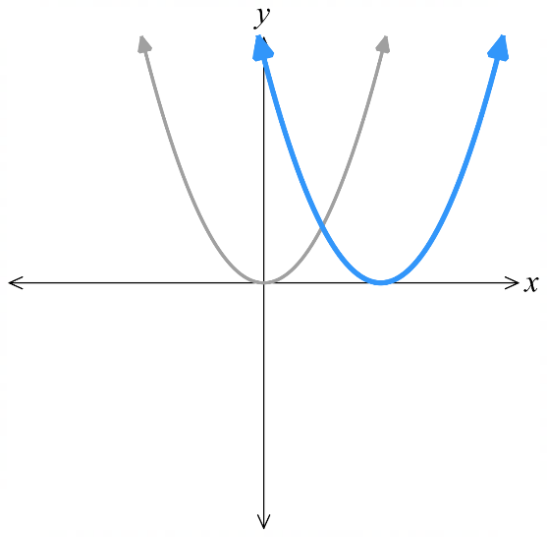  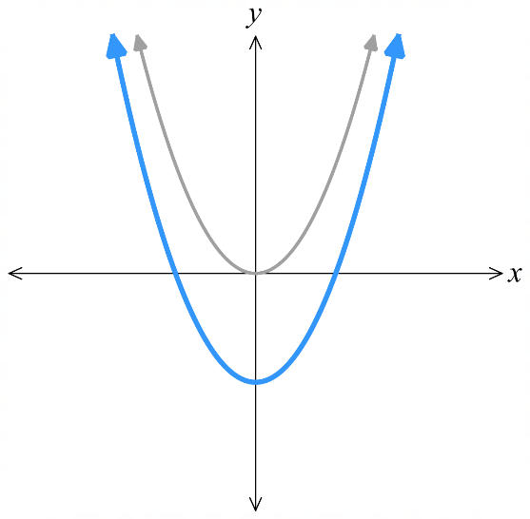  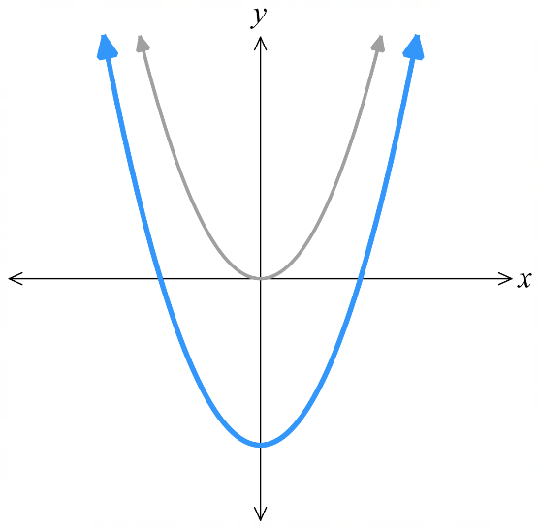 | - $y=x^{2}-2$ | - $y={\left(x-2\right)}^{2}$ | - $y={\left(x-3\right)}^{2}$
- $y={\left(x+3\right)}^{2}$  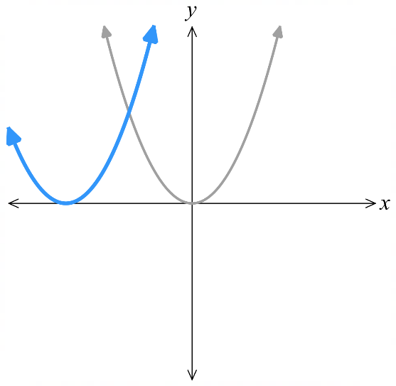  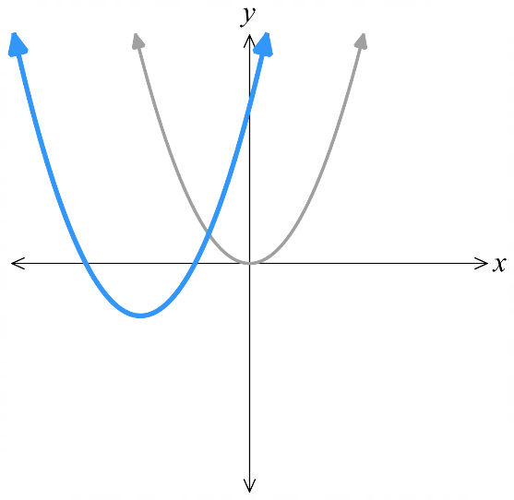  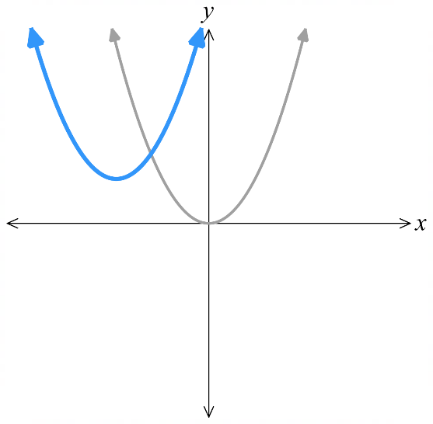  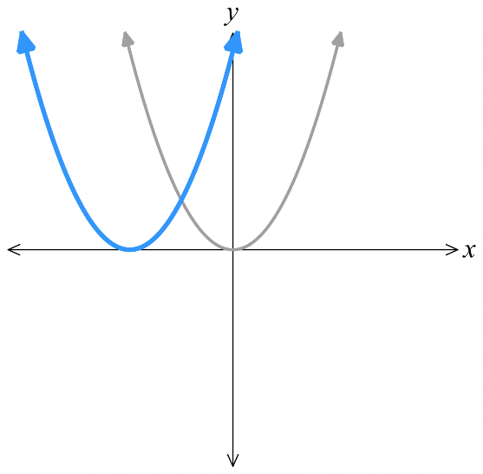 | - $y={\left(x+2\right)}^{2}$ | - $y={\left(x+2\right)}^{2}+1$ | - $y={\left(x+2\right)}^{2}-1$
- $y={\left(x-2\right)}^{2}-1$  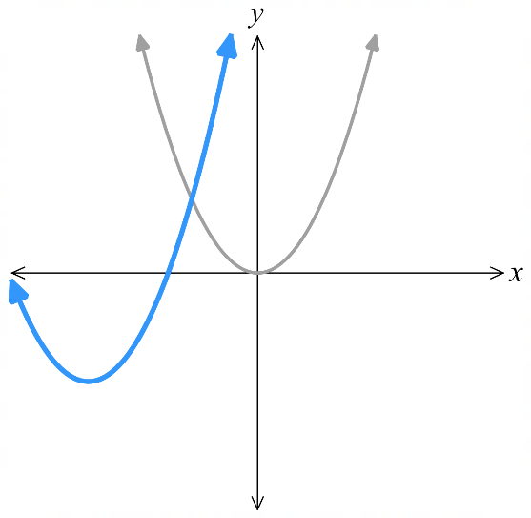  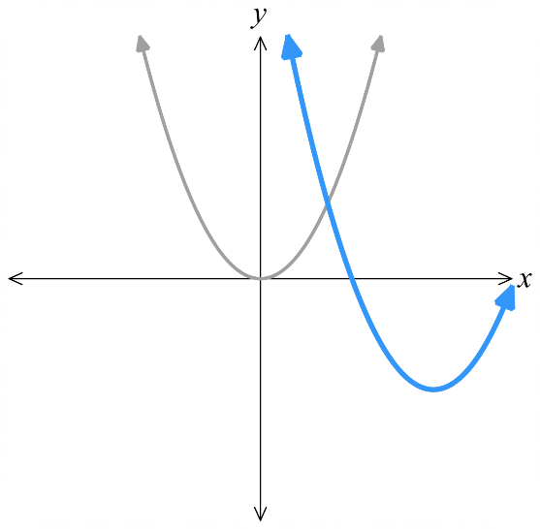  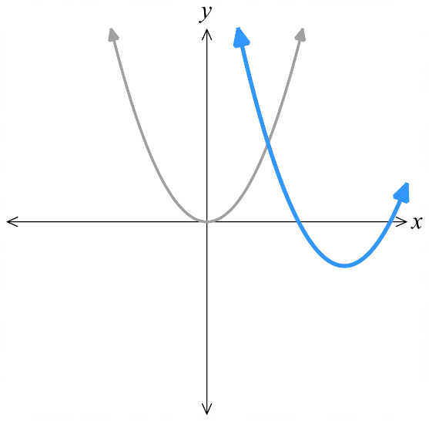  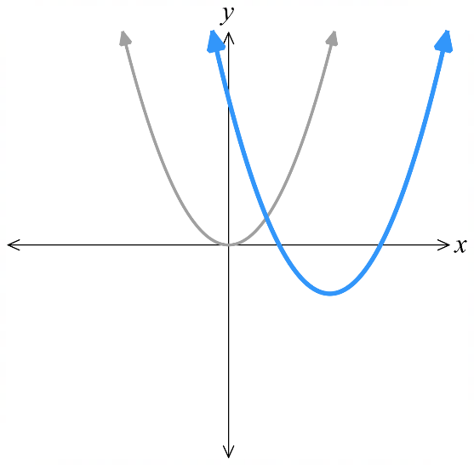 | - $y={\left(x-3\right)}^{2}-1$ | - $y={\left(x-3\right)}^{2}-2$ | - $y={\left(x+3\right)}^{2}-2$

- Sketch these parabolas. The graph of $y=x^{2}$ is given. You do not need to find any points.
- $y=2x^{2}$  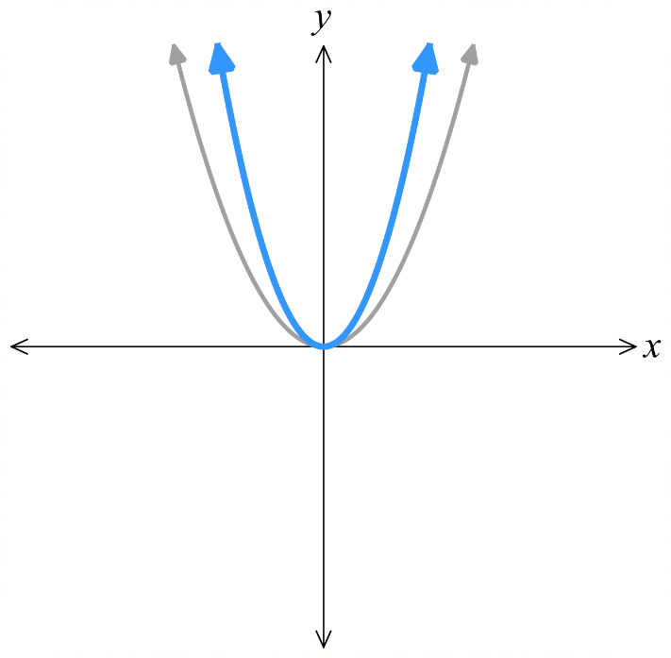  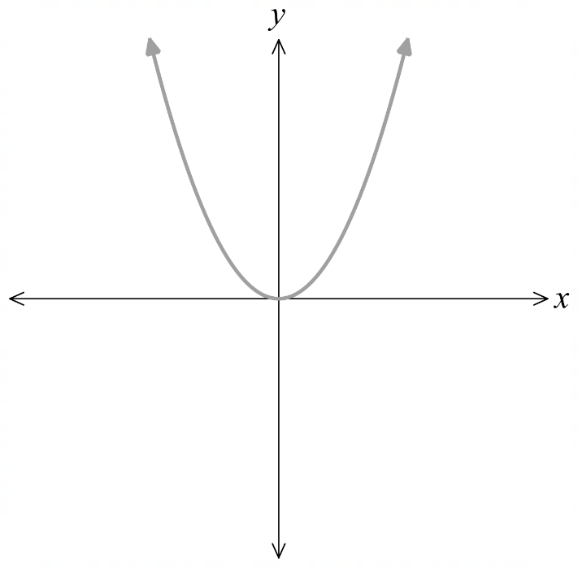 | - $y=-3x^{2}$  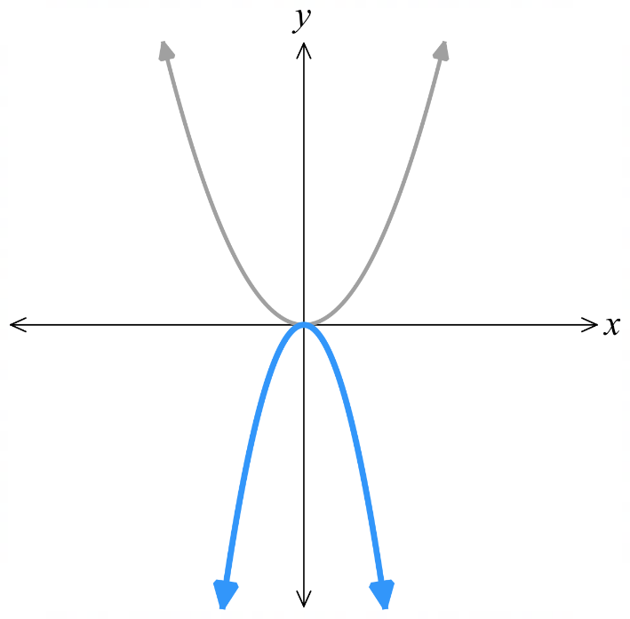 | - $y=\frac{1}{2}x^{2}$  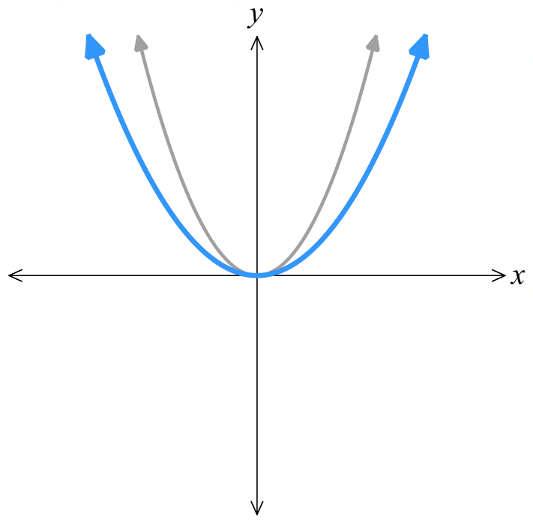
- $y=-\frac{1}{3}x^{2}$  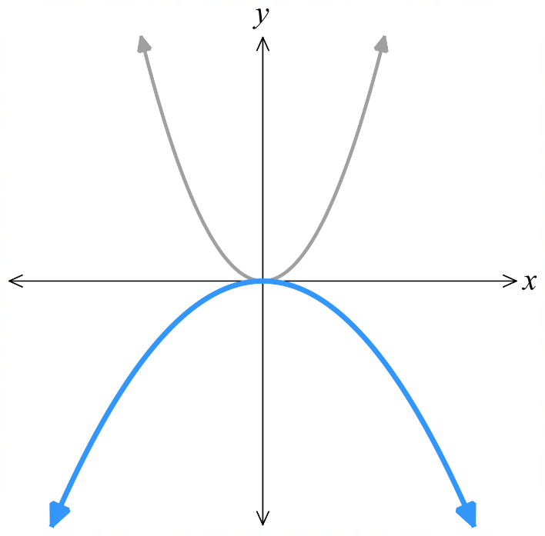 | - $y=x^{2}+2$  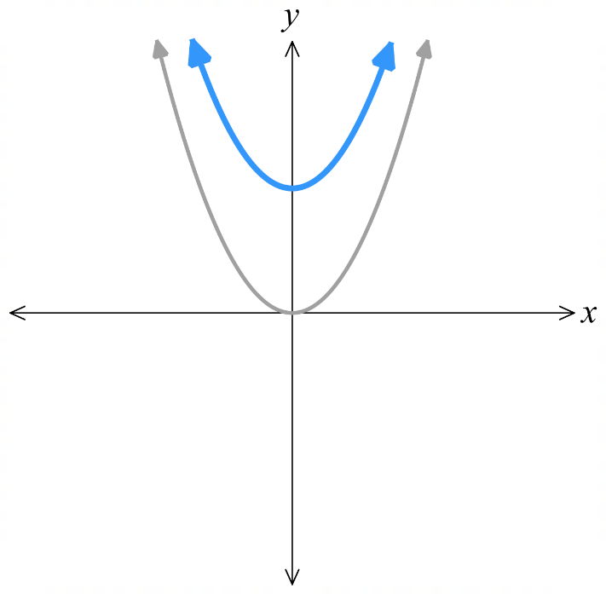 | - $y=x^{2}-4$  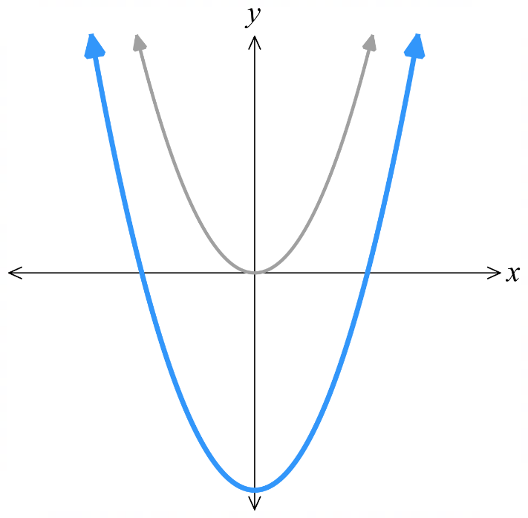
- $y=-x^{2}+1$  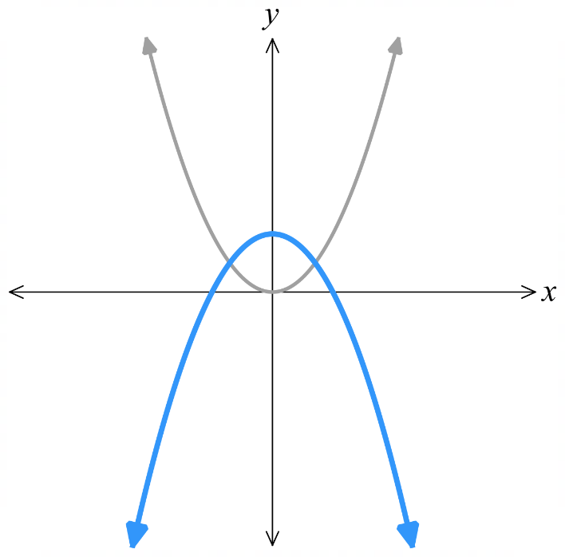 | - $y=-0.1x^{2}-1$  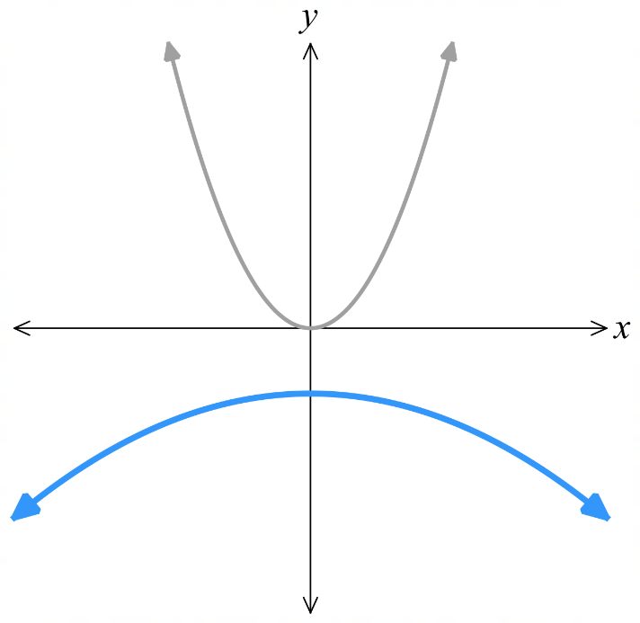 | - $y=5{\left(x+3\right)}^{2}$  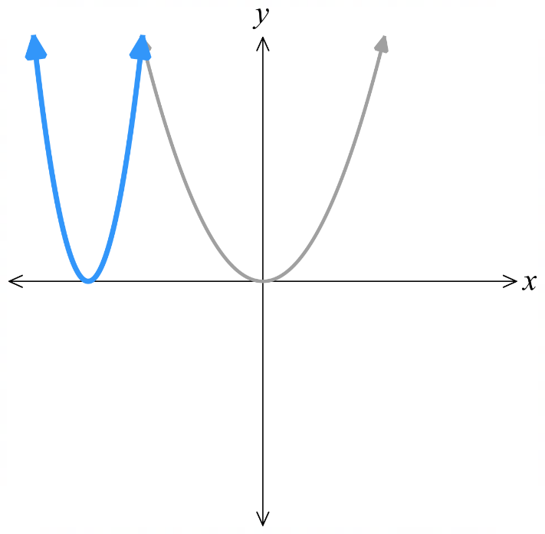
- $y=$ $\frac{{\left(x-1\right)}^{2}}{3}$  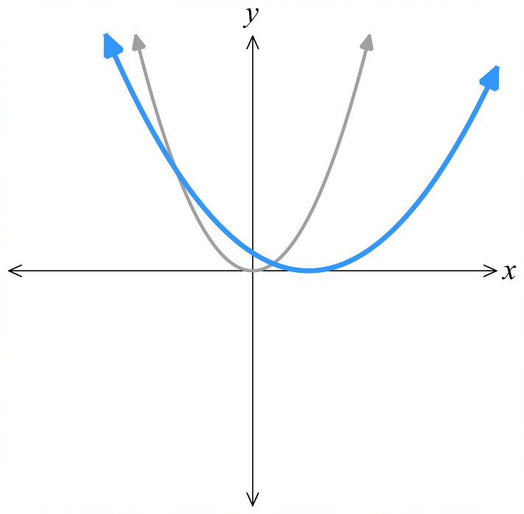 | - $y=-{\left(x+2\right)}^{2}$ | - $y=-2{\left(x-3\right)}^{2}$  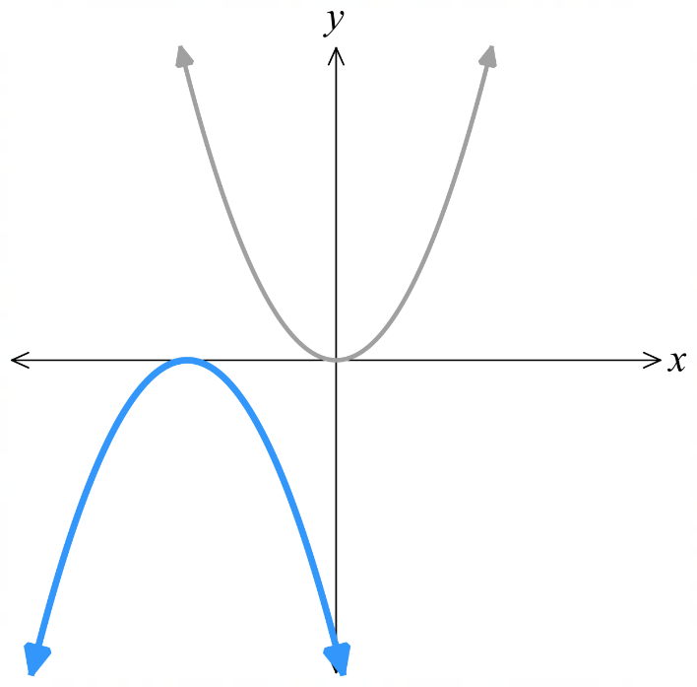  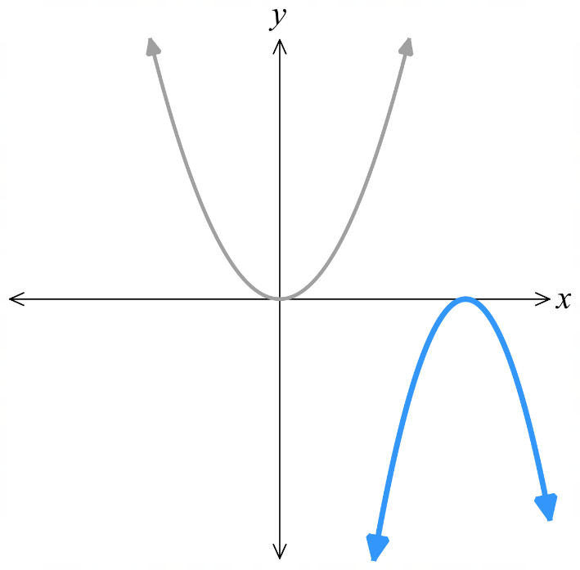

Mastery
- Match each equation to a graph.
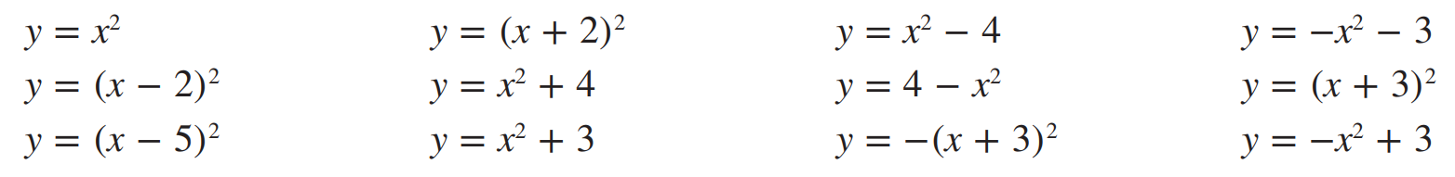

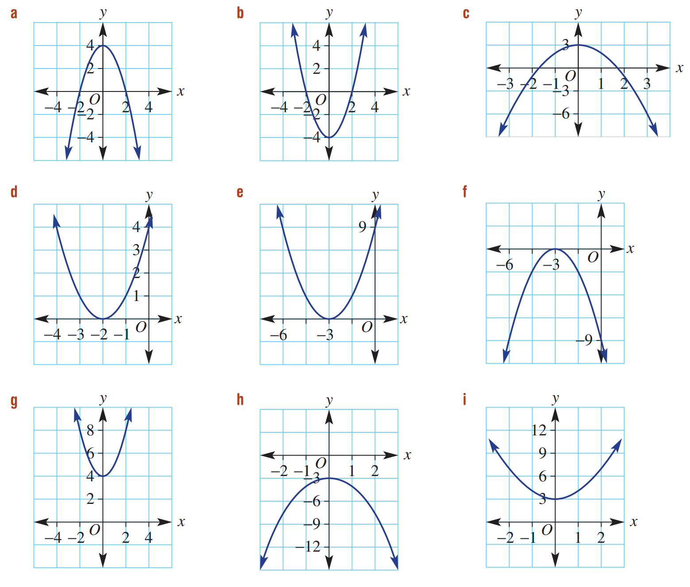  $$y=4-x^{2}$$ | $$y=x^{2}-4$$ | $$y=-x^{2}+3$$
$$y={\left(x+2\right)}^{2}$$ | $$y={\left(x+3\right)}^{2}$$ | $$y=-{\left(x+3\right)}^{2}$$
$$y=x^{2}+4$$ | $$y=-x^{2}-3$$ | $$y=x^{2}+3$$
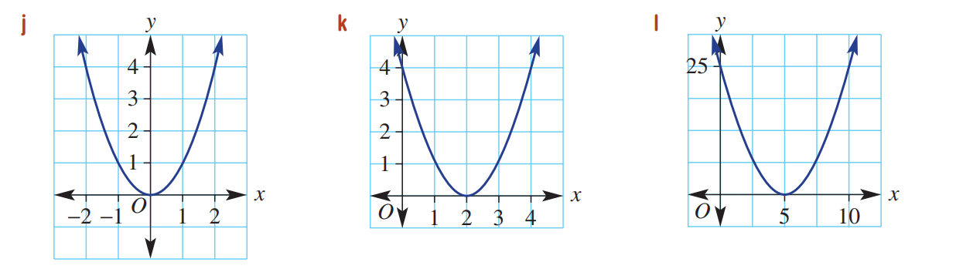  $$y-x^{2}$$ | $$y={\left(x-2\right)}^{2}$$ | $$y={\left(x-5\right)}^{2}$$

Sketching Parabolas from Vertex Form

- Sketch Parabolas from Vertex Form
To sketch $y=a{\left(x-h\right)}^{2}+k$:
- Determine the concavity.
$a>0$, concave up U $a<0$ concave down ∩.
- Find the $y$-intercept. Substitute $x=0$.
- Find the $x$-intercepts, if any. Substitute $y=0$.
- Determine the vertex. Using $\left(h,k\right)$.

- Example Sketch a parabola from vertex form
Sketch $y={\left(x-3\right)}^{2}-2$
1. Concavity: $a>0$, concave up.  2. $y$-int: Let $x=0$  $y={\left(0-3\right)}^{2}-2=7$  3. $x$-int: Let $y=0$  $0={\left(x-3\right)}^{2}-2$  $2={\left(x-3\right)}^{2}$  $±\sqrt{2}=x-3$  $3±\sqrt{2}=x$  $x$-ints at $3+\sqrt{2}$ and $3-\sqrt{2}$  4. Vertex: $\left(3,-2\right)$ | 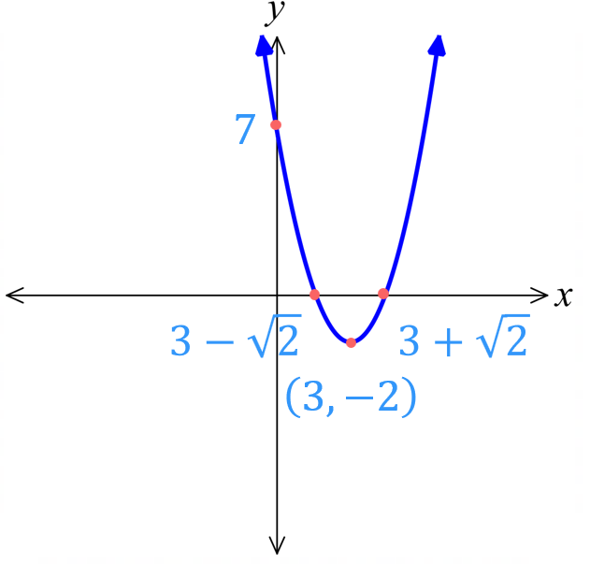

- Guided Practice
Sketch $y={\left(x+3\right)}^{2}-1$
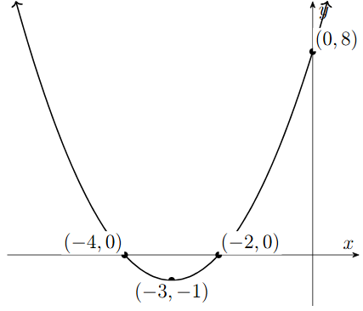
1. Concavity:
2. $y$-int:
3. $x$-int:

4. Vertex:

- Guided Practice
- $y=-{\left(x+1\right)}^{2}+4$
1. Concavity:
2. $y$-int:

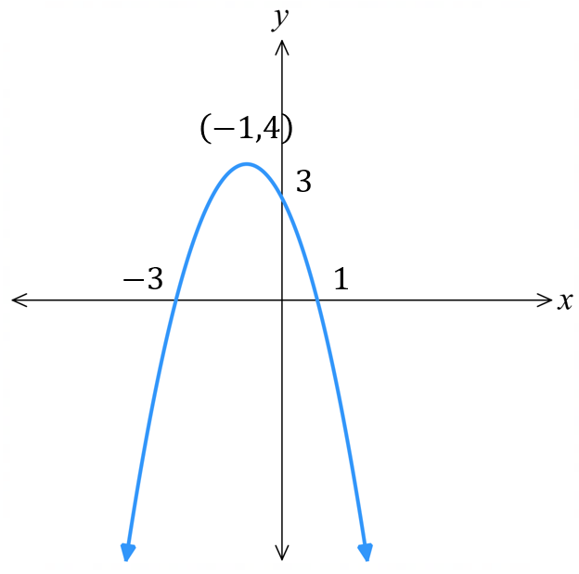
3. $x$-int:

4. Vertex:

- $y=-2{\left(x-3\right)}^{2}-2$
1. Concavity:
2. $y$-int:

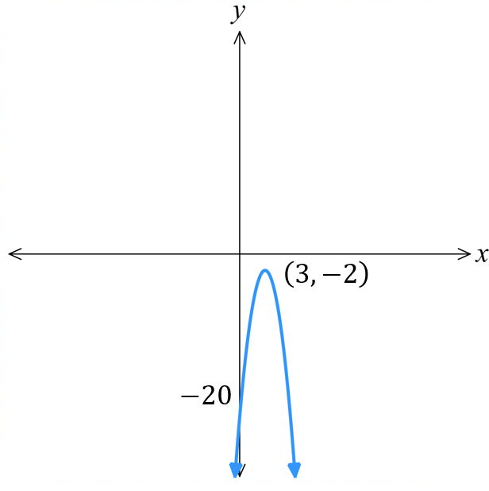
3. $x$-int:

4. Vertex:

Foundation
- By substituting $x=0$, find the $y$-intercept of these graphs.
- $y=x^{2}+3$  3 | - $y=-x^{2}-3$  $$-3$$ | - $y=2x^{2}-3$  $$-3$$
- $y=-6x^{2}-1$  $$-1$$ | - $y={\left(x-1\right)}^{2}$  $$1$$ | - $y={\left(x+2\right)}^{2}$  $$4$$
- $y=-{\left(x+4\right)}^{2}$  $$-16$$ | - $y=-{\left(x-5\right)}^{2}$  $$-25$$ | - $y=-2{\left(x+1\right)}^{2}$  $$-2$$
- $y={\left(x+1\right)}^{2}+1$  $$2$$ | - $y={\left(x-3\right)}^{2}-3$  $$6$$ | - $y=-{\left(x+7\right)}^{2}-14$  $$-63$$

- By substituting $y=0$, find the $x$-intercepts of these graphs.
- $y={\left(x+4\right)}^{2}$  $$-4$$ | - $y=-{\left(x-5\right)}^{2}$  $$5$$ | - $y=-2{\left(x+1\right)}^{2}$  $$-1$$
- $y=x^{2}+3$  none | - $y=-x^{2}-3$  none | - $y=2x^{2}-3$  $$±\sqrt{\frac{3}{2}}$$
- $y=-6x^{2}-1$  none | - $y={\left(x-1\right)}^{2}-3$  $$1±\sqrt{3}$$ | - $y=-{\left(x+2\right)}^{2}+3$  $$-2±\sqrt{3}$$
- $y={\left(x+1\right)}^{2}+1$  none | - $y={\left(x-3\right)}^{2}-3$  $$3±\sqrt{3}$$ | - $y=-{\left(x+7\right)}^{2}-14$  none

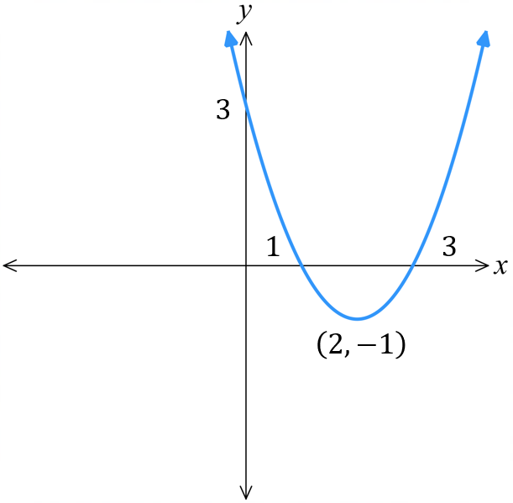
- Sketch $y={\left(x-2\right)}^{2}-1$:
  - concavity:
  - $y$-intercept:
  - $x$-intercepts:

  - vertex:

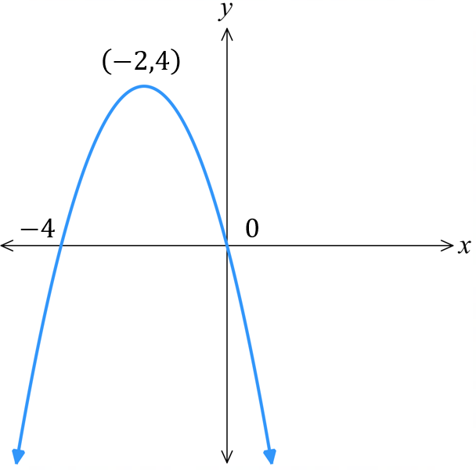
- Sketch $y={-\left(x+2\right)}^{2}+4$:
  - concavity:
  - $y$-intercept:
  - $x$-intercepts:

  - vertex:

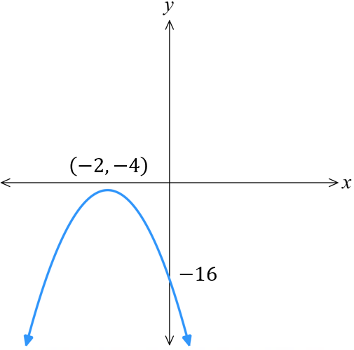
- Sketch $y={-3\left(x+2\right)}^{2}-4$:
  - concavity:
  - $y$-intercept:
  - $x$-intercepts:

  - vertex:

Development
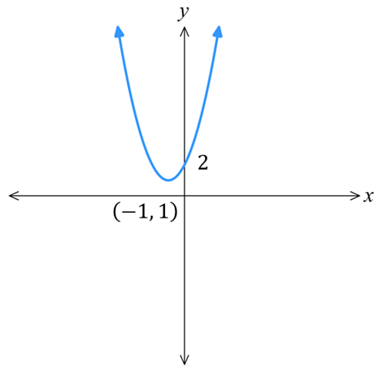
- Sketch these graphs. Clearly show the turning point and intercepts.
- $y={\left(x+1\right)}^{2}+1$ | - $y={\left(x+2\right)}^{2}-1$  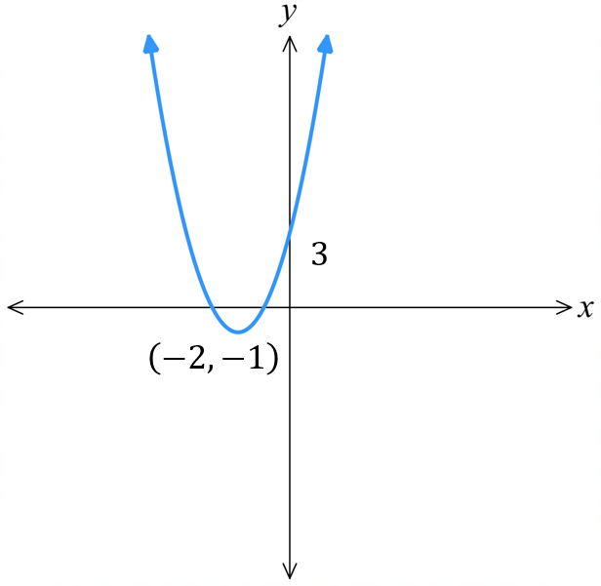
- $y={\left(x+3\right)}^{2}+2$ | 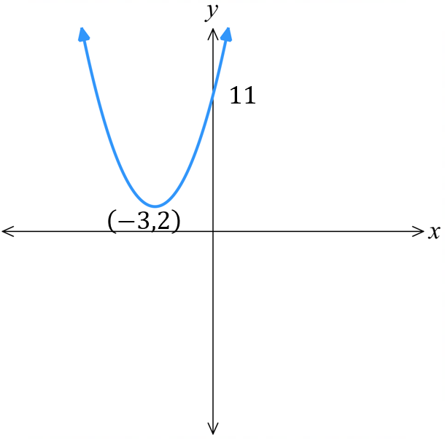  - $y={\left(x-1\right)}^{2}+2$  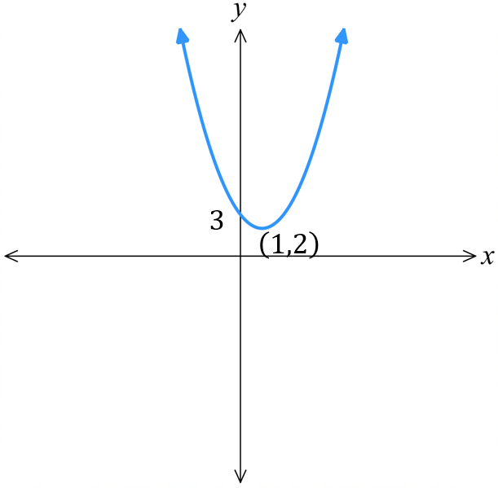
- $y={\left(x-4\right)}^{2}+1$ | 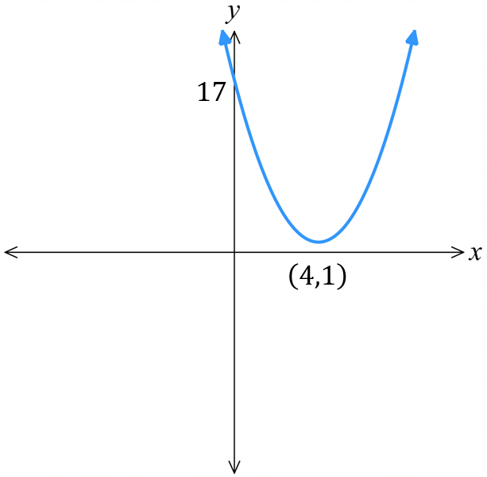  - $y=-{\left(x-1\right)}^{2}+3$  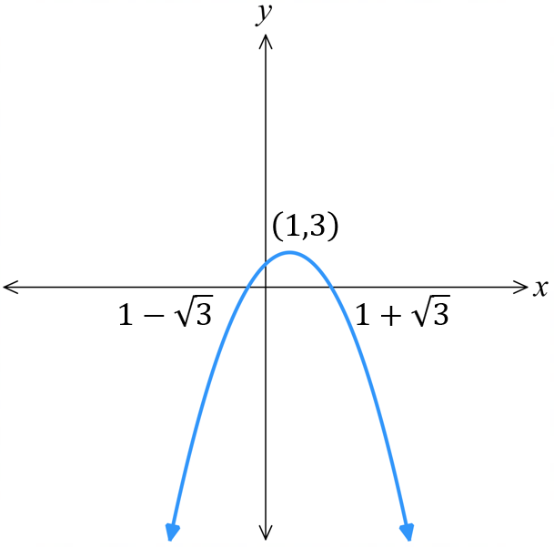
- $y=-{\left(x-2\right)}^{2}+1$ | 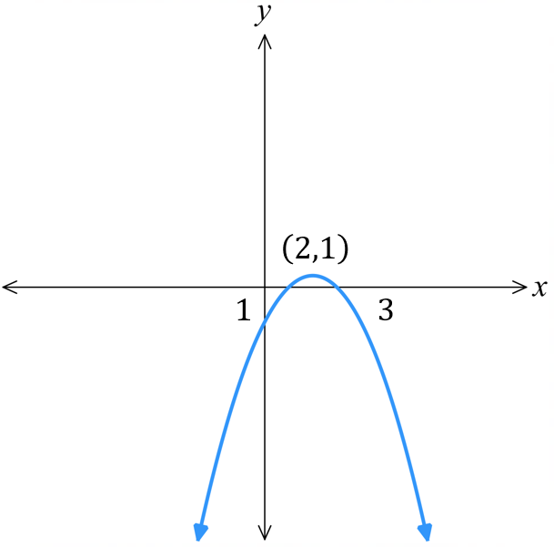  - $y=-{\left(x-4\right)}^{2}-2$  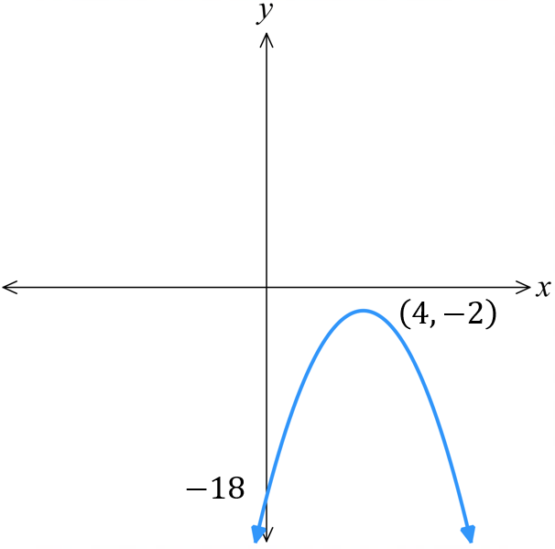
- $y=-{\left(x+2\right)}^{2}+2$ | 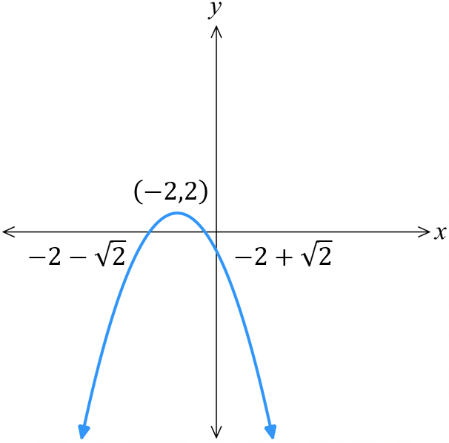  - $y={\left(x+3\right)}^{2}-1$  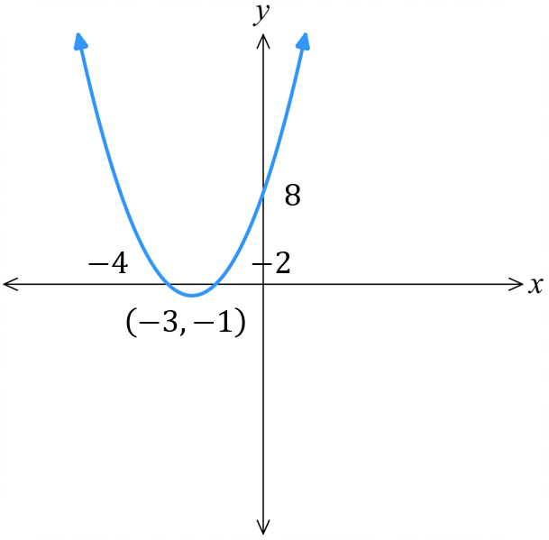
- $y=-{\left(x+6\right)}^{2}-4$ | 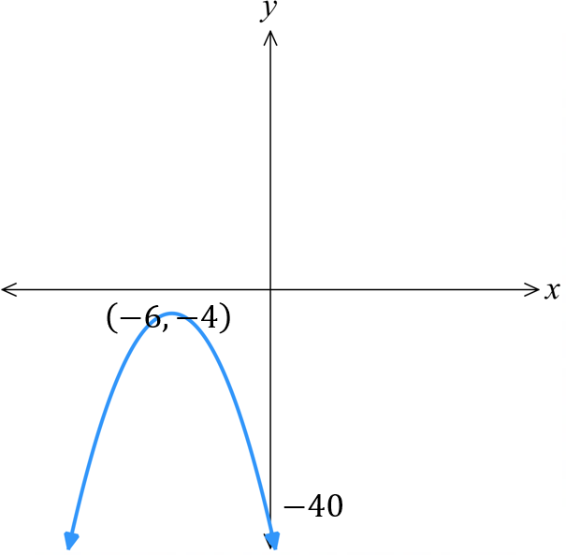  - $y={\left(x-2\right)}^{2}-7$  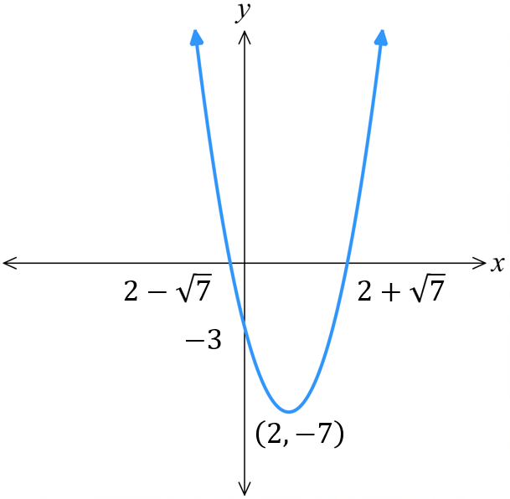

Mastery
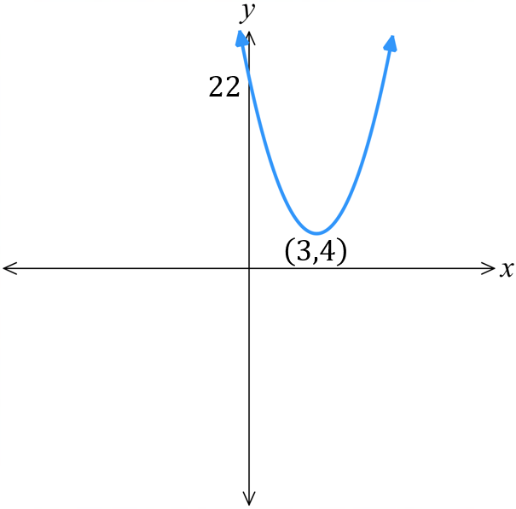
- Sketch these parabolas. Clearly show the turning points and intercepts.
- $y=2{\left(x-3\right)}^{2}+4$ | - $y=3{\left(x+2\right)}^{2}+5$  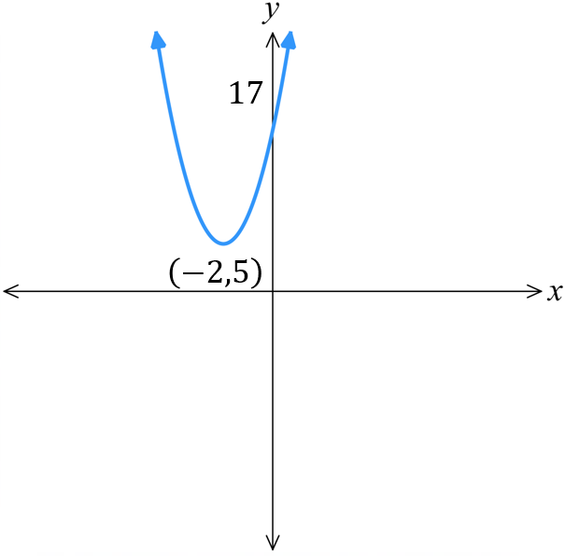
- $y=-2{\left(x-3\right)}^{2}+4$ | 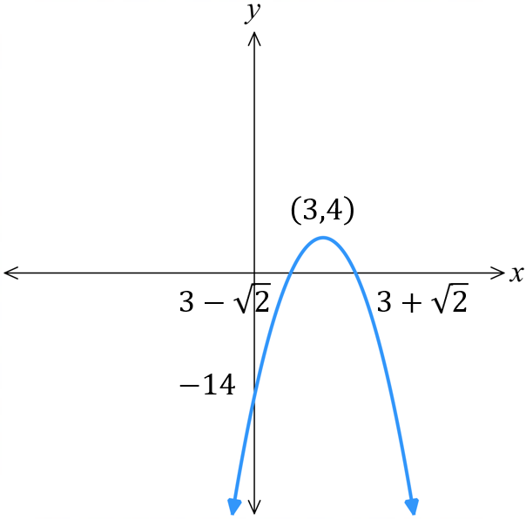  - $y=-2{\left(x+3\right)}^{2}-4$  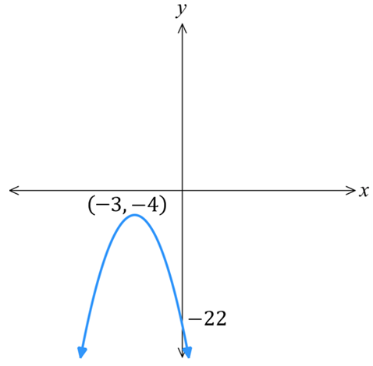
- $y=\frac{1}{2}{\left(x-3\right)}^{2}+4$ | 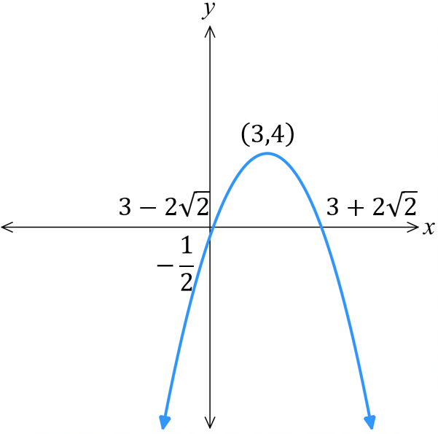  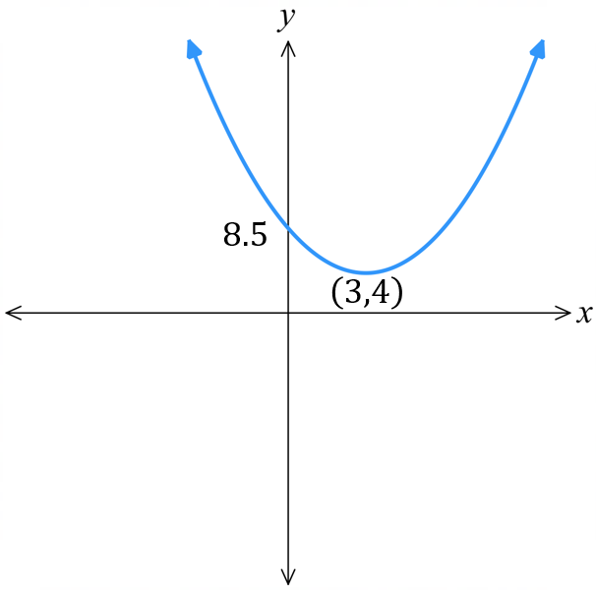  - $y=-\frac{1}{2}{\left(x-3\right)}^{2}+4$
- $y=4-x^{2}$ | 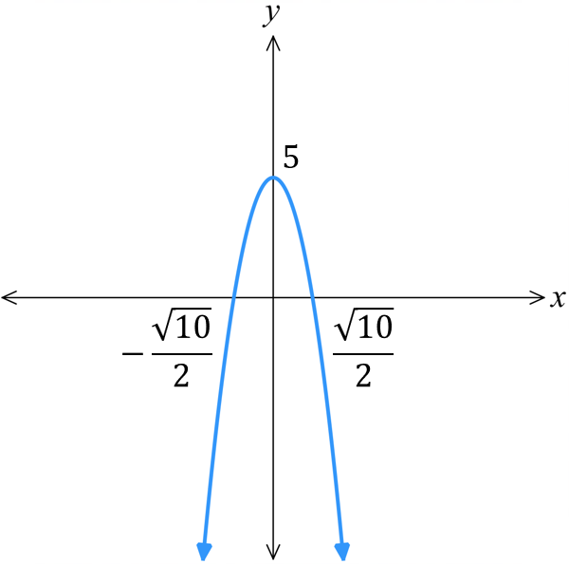  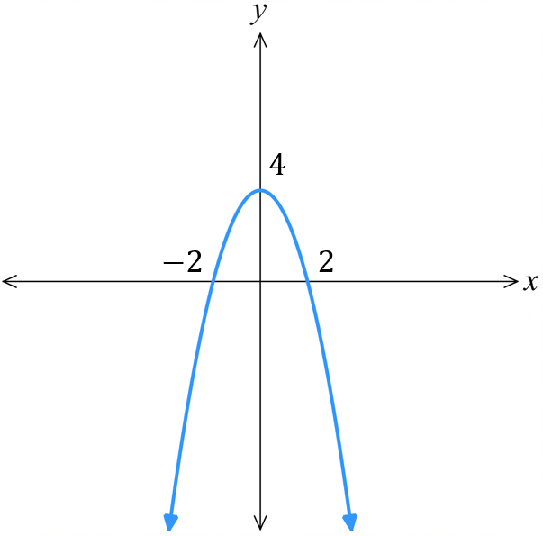  - $y=5-2x^{2}$

Sketching Parabolas by Completing the Square

- Sketch Parabolas by Completing the Square
- When factorising by PSF is not possible, complete the square to write a quadratic in vertex form.
- Write in vertex form: halve the coefficient of $x$, square it, then add and subtract this value.
- Concavity
- $y$-int
- $x$-int
- Vertex

- Example Sketch parabolas by completing the square
Sketch $y=x^{2}-4x-5$  0. Vertex form by CTS  $y=x^{2}-4x+4-4-5$  $y=\left(x^{2}-4x+4\right)-4-5$  $y={\left(x-2\right)}^{2}-9$  1. Concavity $a>0$, concave up.  2. $y$-int: Let $x=0,$  $y={\left(0-2\right)}^{2}-9=-5$  3. $x$-int: Let $y=0$  ${\left(x-2\right)}^{2}-9=0$  ${\left(x-2\right)}^{2}=9$  $x-2=±3$  $x=2±3$  $x=5$ or $-1$  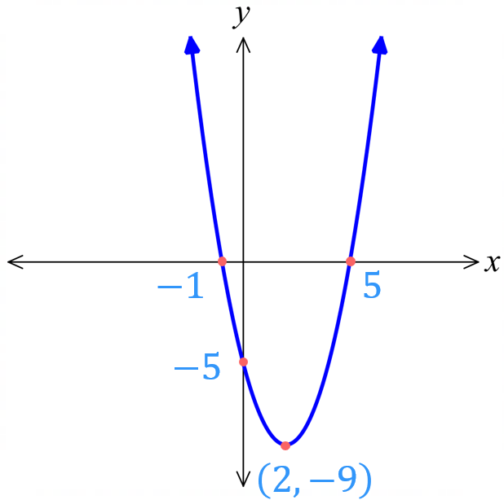  4. Vertex: $\left(2,-9\right)$ | Sketch $y=x^{2}+6x+15$  0. Vertex form by CTS  1. Concavity  2. $y$-int:  3. $x$-int:  4. Vertex:  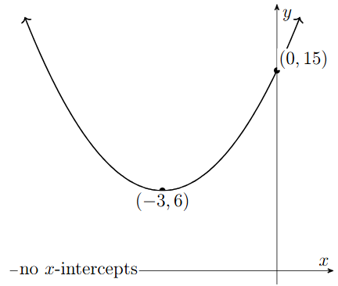
- Guided Practice
- $y=x^{2}-4x-1$  0. Vertex form by CTS  1. Concavity  2. $y$-int:  3. $x$-int:  4. Vertex:  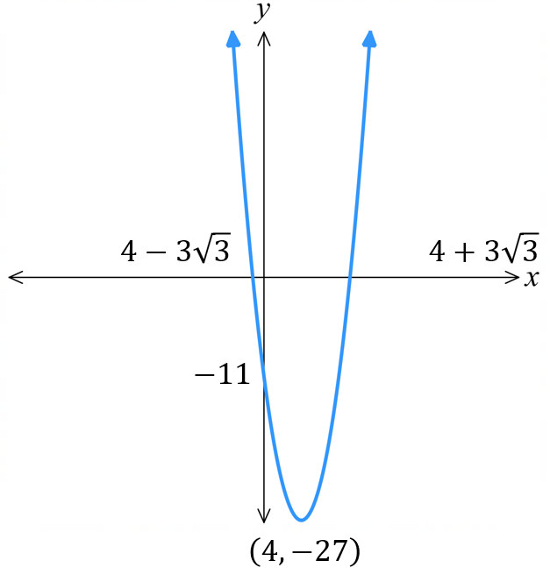  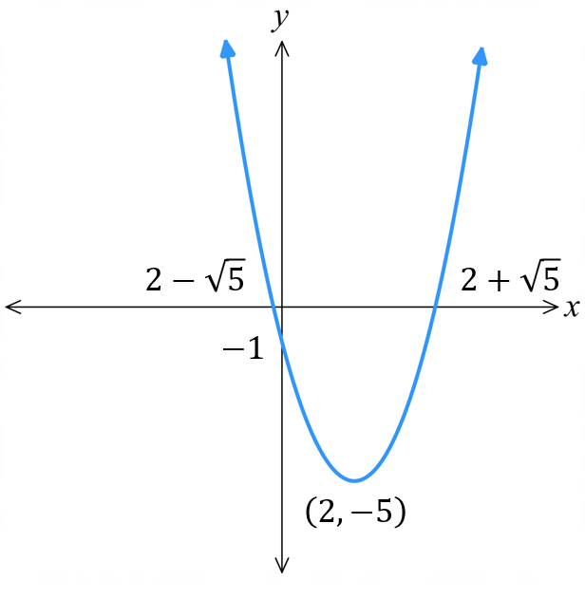 | - $y=x^{2}-8x-11$  0. Vertex form by CTS  1. Concavity  2. $y$-int:  3. $x$-int:  4. Vertex:

Foundation
- Sketch these parabolas by completing the square first. Show the vertex and all intercepts.
- $y=x^{2}-2x+6$
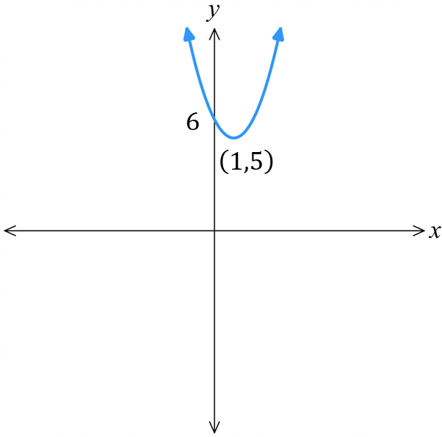
$y=x^{2}-2x+1-1+6$
$y={\left(x-1\right)}^{2}+5$

- $y=x^{2}-2x-3$
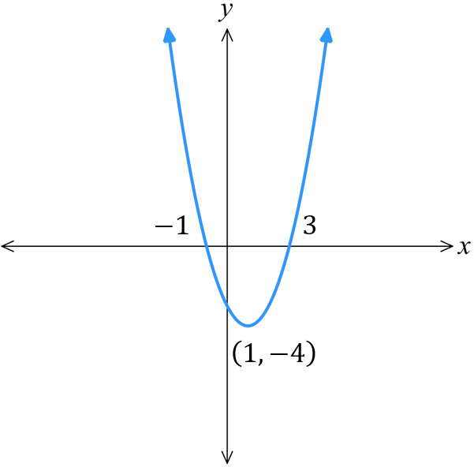

- $y=x^{2}-6x+9$
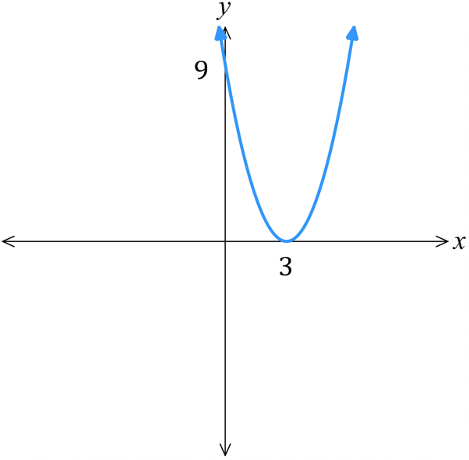

- $y=x^{2}+8x+10$
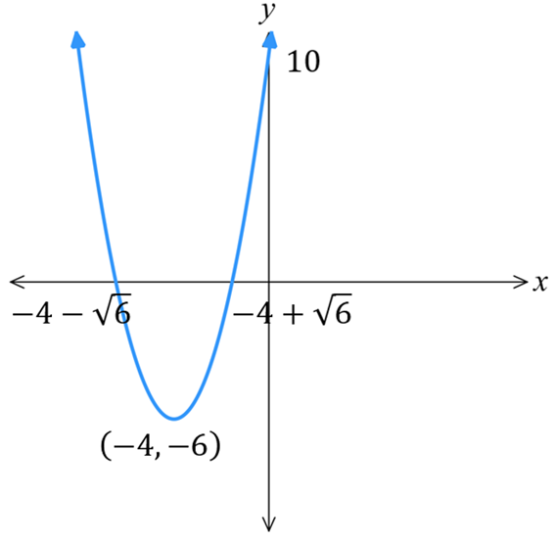

- $y=x^{2}+6x-5$
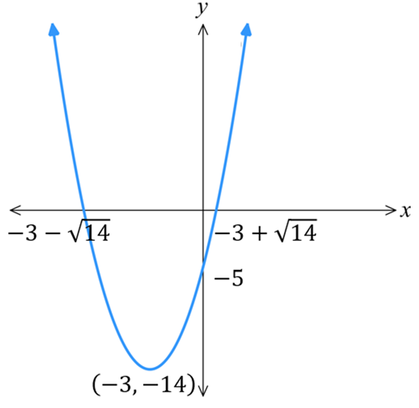

Development
- Sketch these parabolas by taking out a common factor, then CTS. Show vertex and intercepts.
- $y=2x^{2}+4x-10$
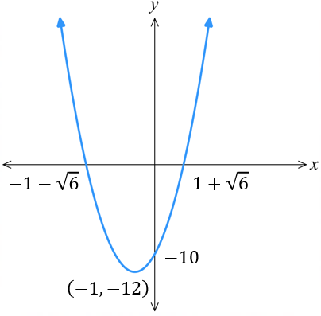
$y=2\left(x^{2}+2x-5\right)$
$y=2\left(x^{2}+2x+1-1-5\right)$
$y=2\left({\left(x+1\right)}^{2}-6\right)$
$y=2{\left(x+1\right)}^{2}-12$

- $y=3x^{2}-12x+9$
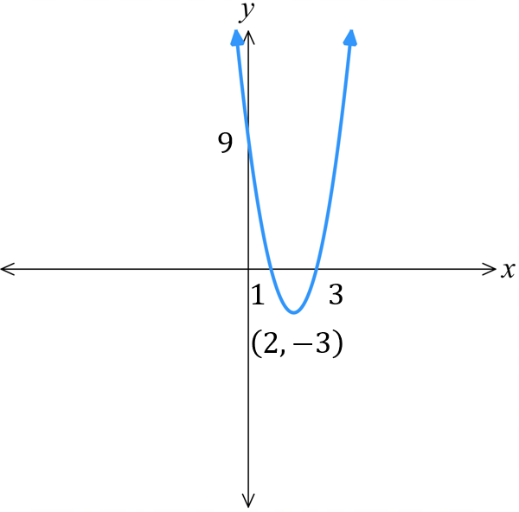

- $y=2x^{2}-12x-14$
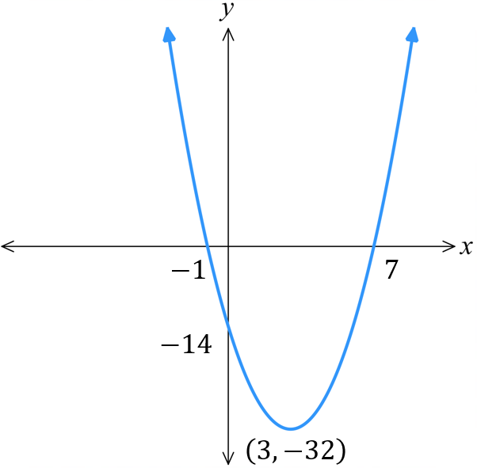

- $y=4x^{2}+16x-24$
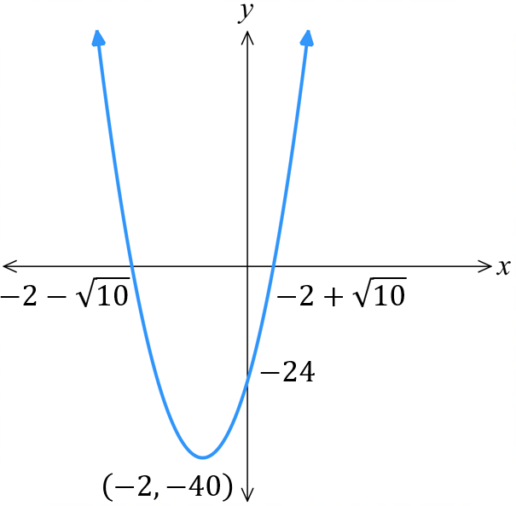

- Sketch these parabolas by taking out the negative, then completing the square.
Show the vertex and all intercepts.
- $y=-x^{2}-4x+3$
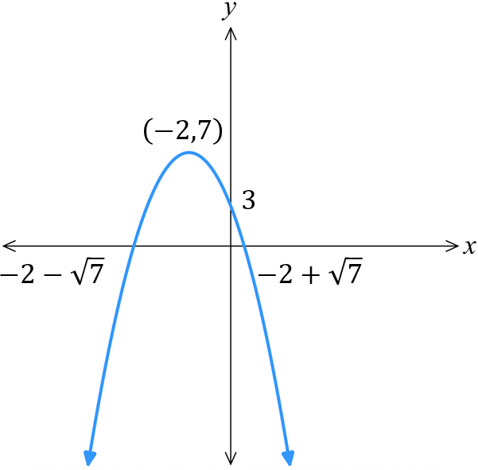
$y=-\left(x^{2}+4x-3\right)$
$y=-\left(x^{2}+4x+4-4-3\right)$
$y=-\left({\left(x+2\right)}^{2}-7\right)$
$y=-{\left(x+2\right)}^{2}+7$

- $y=-x^{2}+2x+2$
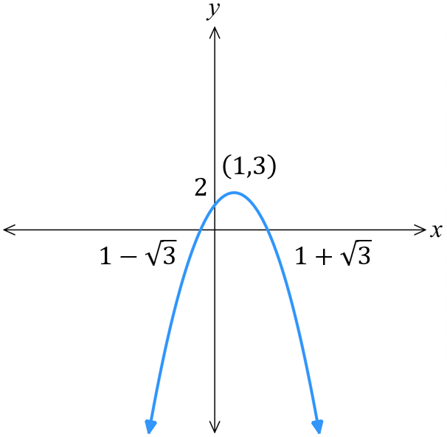

- $y=-x^{2}+6x-4$
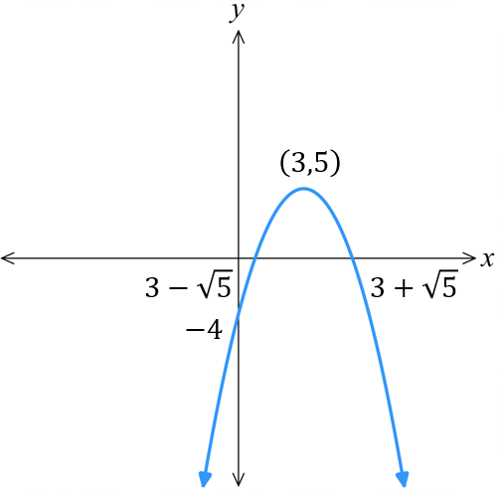

- $y=-x^{2}+8x-8$
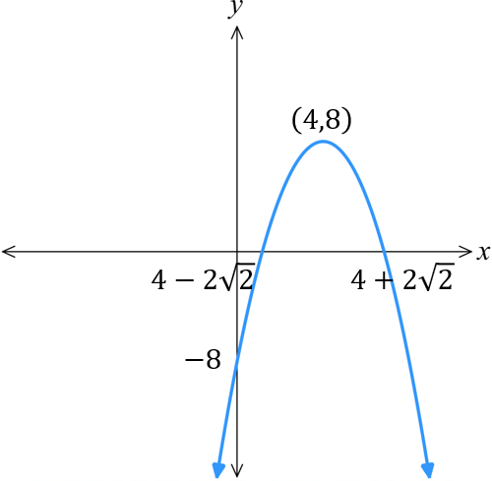

Mastery
- Sketch these parabolas by making the quadratic monic.
- $y=3x^{2}+6x+1$
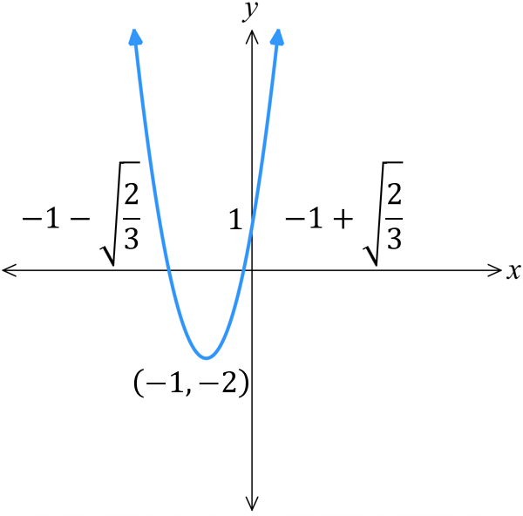
$y=3\left(x^{2}+2x+\frac{1}{3}\right)$
$y=3\left(x^{2}+2x+1-1+\frac{1}{3}\right)$
$y=3\left({\left(x+1\right)}^{2}-\frac{2}{3}\right)$
$y=3{\left(x+1\right)}^{2}-2$

- $y=4x^{2}+8x+3$
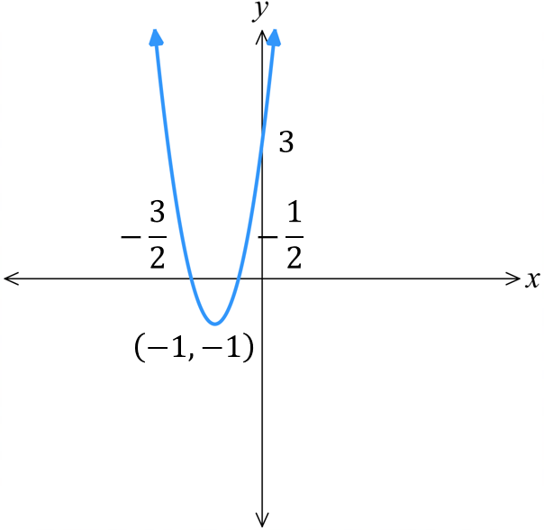

- $y=2x^{2}+12x+1$
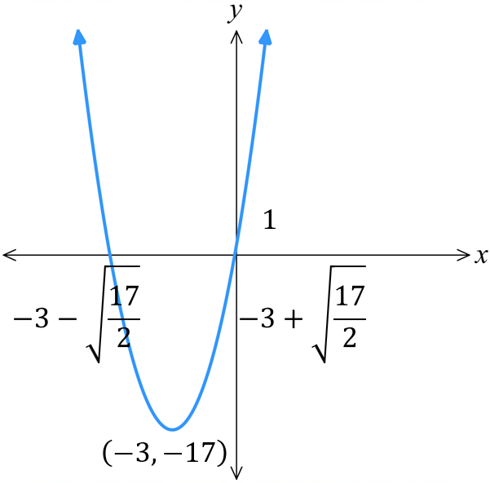

- $y=-3x^{2}-9x+2$
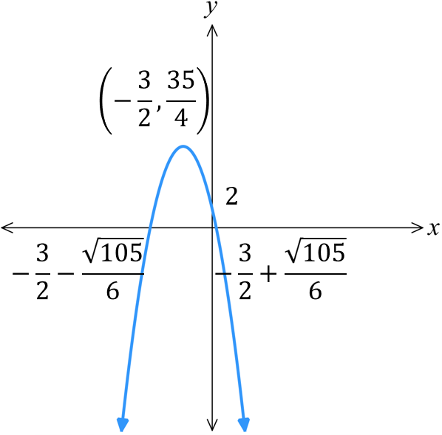

Sketching Parabolas by the Quadratic Formula

- Sketching Parabolas by Quadratic Formula
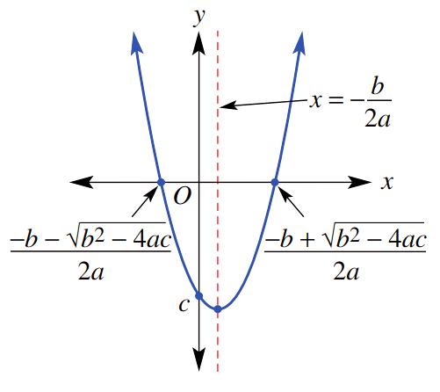
Instead of completing the square, we can use the quadratic formula to sketch instead.
- Concavity.
- $y$-int.
- $x$-ints using $x=$ $\frac{-b±\sqrt{b^{2}-4ac}}{2a}$
- Vertex using $x=-$ $\frac{b}{2a}$,
then substitute value of $x$ into the equation to find $y$.

- Example Sketch parabolas by quadratic formula
Sketch $y=-x^{2}+6x+1$  1. Concavity: $a<0$, concave down.  2. $y$-int: Let $x=0$,  $y=1$  3. $x$-int:  $$x=\frac{-6±\sqrt{6^{2}-4\left(-1\right)\left(1\right)}}{2\left(-1\right)}$$  $$=\frac{-6±\sqrt{40}}{-2}$$  $$=\frac{-6±2\sqrt{10}}{-2}$$  $=3±\sqrt{10}$  4. Vertex:  $$x=\frac{-6}{2\left(-1\right)}=3$$  $y=-{\left(3\right)}^{2}+6\left(3\right)+1$  $=10$  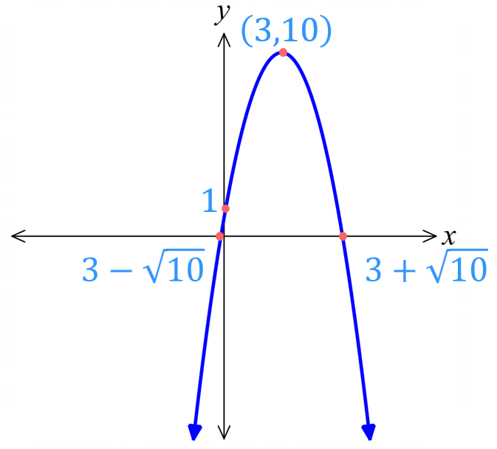  Vertex at $\left(3,10\right)$ |  | Sketch $y=x^{2}+4x+1$  1. Concavity:  2. $y$-int:  3. $x$-int:  4. Vertex:  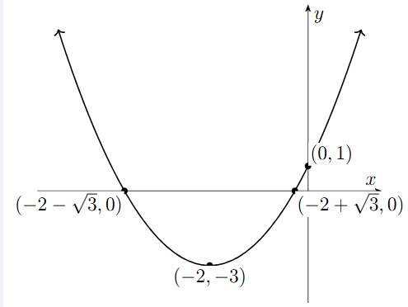
- Guided Practice
- $y=x^{2}-2x-1$  1. Concavity:  2. $y$-int:  3. $x$-int:  4. Vertex: |  | - $y={5x}^{2}-20x+20$  1. Concavity:  2. $y$-int:  3. $x$-int:  4. Vertex:  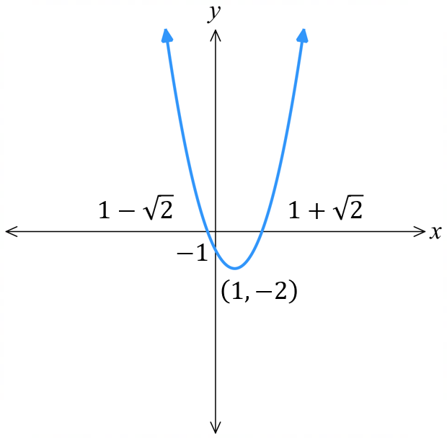  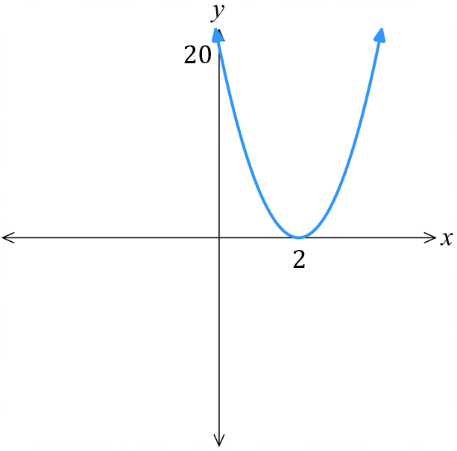
- The Discriminant and the Graph
The discriminant $Δ=b^{2}-4ac$ tells how many solutions, or $x$-intercepts, a quadratic has.
Check the discriminant first; it tells you if $x$-intercepts exist.
$$Δ>0$$  2 solutions | $$Δ=0$$  1 solution  We say the parabola is tangent to the $x$-axis. |  | $$Δ<0$$  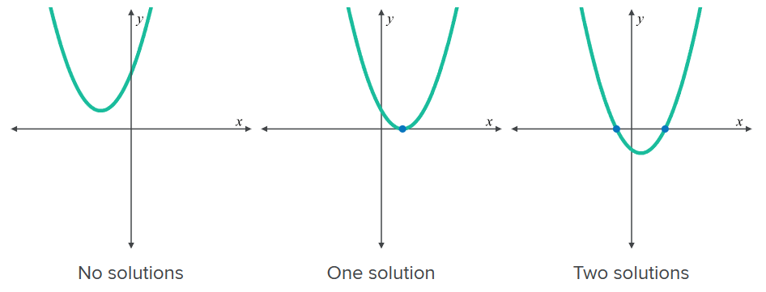  No real solutions

- Example Sketch parabolas by checking the discriminant first
Sketch $y=3x^{2}-6x+4$  1. Concavity: $a>0$, concave up.  2. $y$-int: Let $x=0$,  $y=4$  3. $x$-int:  $Δ=b^{2}-4ac$  $={\left(-6\right)}^{2}-4\left(3\right)\left(4\right)$  $=-12$  No $x$ intercepts.  4. Vertex:  $$x=\frac{-b}{2a}=\frac{-\left(-6\right)}{2\left(3\right)}=1$$  $y=3{\left(1\right)}^{2}-6\left(1\right)+4=1$  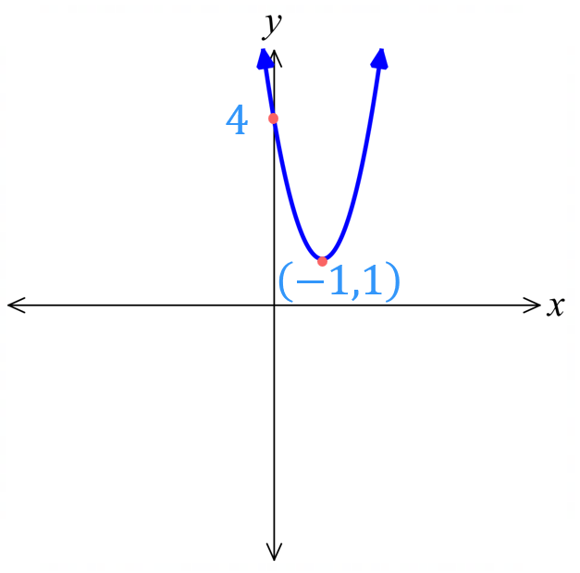  Vertex at $\left(1,1\right)$ | How did we know there were no  $x$-intercepts?  The value of the discriminant was ……………  What would have happened if you tried to use the quadratic formula?  You would be square rooting a ………………  How did finding the discriminant save us time?  We did not need to attempt to find the …… intercepts.  How did we find the vertex?  We found the $x$-coordinate using the formula …………, then substituted into the ………………… to find $y$.
- Guided Practice
Sketch these parabolas by checking the discriminant first.
$y=x^{2}-4x+5$  1. Concavity:  2. $y$-int:  3. $x$-int:  $Δ=b^{2}-4ac$  4. Vertex: | $y=-4x^{2}-13x-53$  1. Concavity:  2. $y$-int:  3. $x$-int:  $Δ=b^{2}-4ac$  4. Vertex:  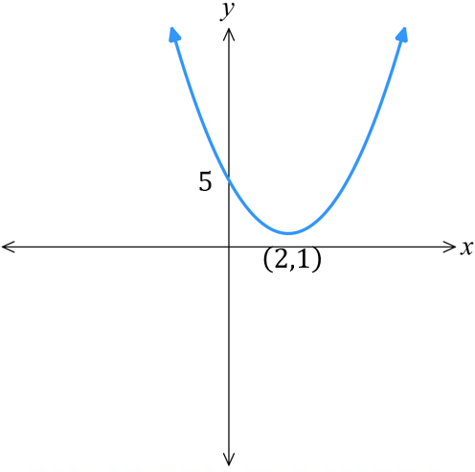  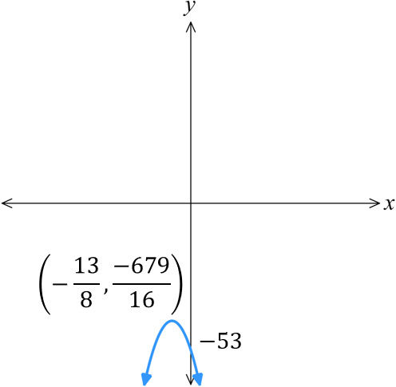

Foundation
- For these graphs, state whether the discriminant would be zero, positive, or negative.
$$Δ=0$$ | $$Δ>0$$ | 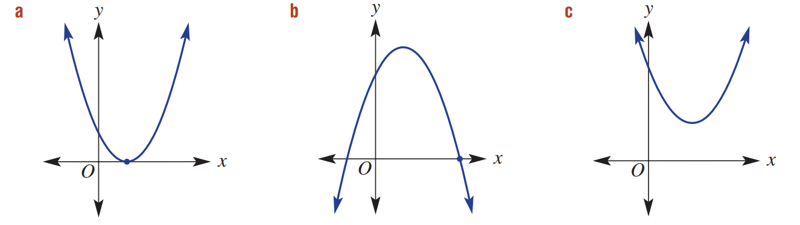  $$Δ<0$$

- Find the discriminant of these graphs.
- $y=x^{2}+2x+3$  $Δ=b^{2}-4ac$  $=$ ………………  $=$ ………………  $$-8$$ | - $y=-2x^{2}-5x+8$  89 | - $y=5x^{2}-7$  140

- Use $x=-$ $\frac{b}{2a}$ to determine the $x$-coordinate of the vertex.
- $y = x^{2}+4x-1$  $x=-$ $\frac{b}{2a}$  $=$ ………………  $=$ ………………  $$x=-2$$ | - $y=-x^{2}-3x+4$  $$x=-\frac{3}{2}$$ | - $y=4x^{2}-3x$  $$x=\frac{3}{8}$$

- A parabola has the equation $y=x^{2}-2x-1$
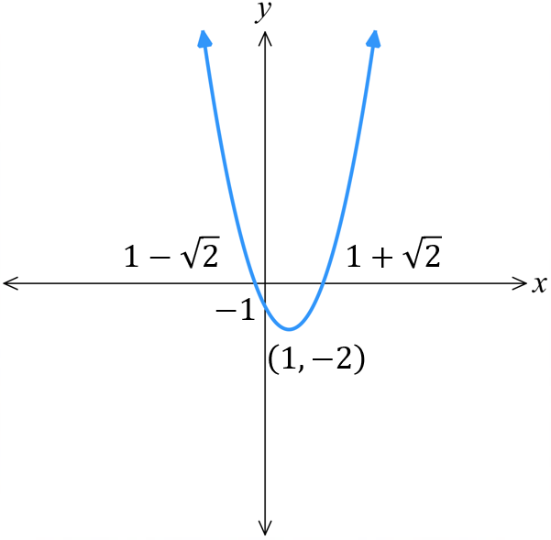
  - concavity:
  - $y$- intercept:
  - $x$- intercepts:

  - vertex:

Development
- Sketch graphs of these quadratics. Give roots in exact surd form.
- $y=2x^{2}+8x-5$  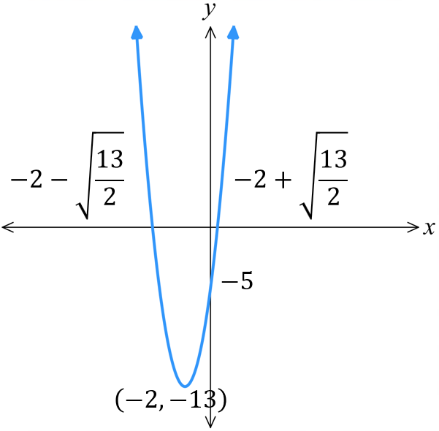 | - $y=3x^{2}+6x-2$  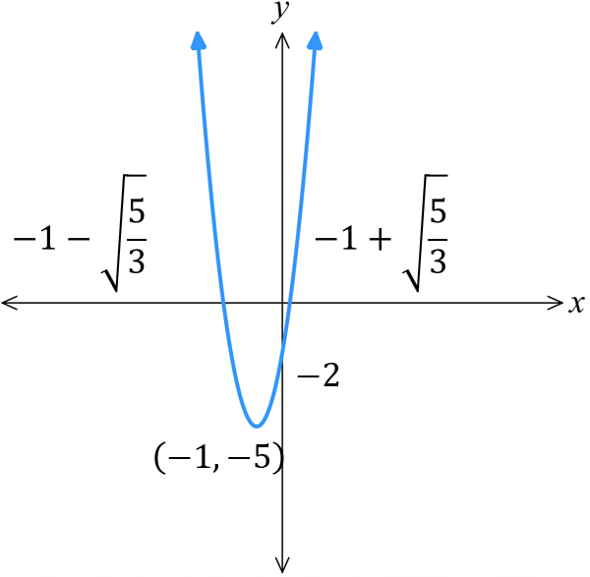
- $y=4x^{2}-2x-3$ | - $y=2x^{2}-4x-9$  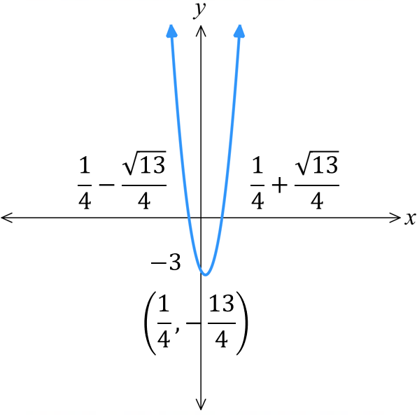  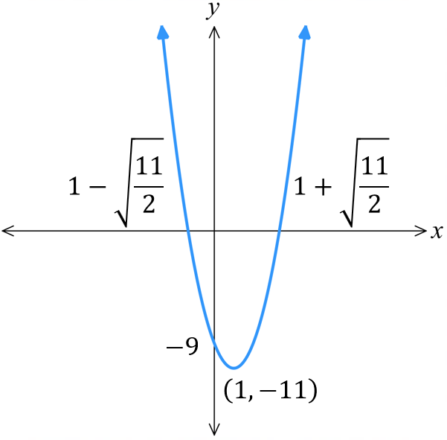
- $y=-3x^{2}+6x+8$ | - $y=-2x^{2}-4x+7$  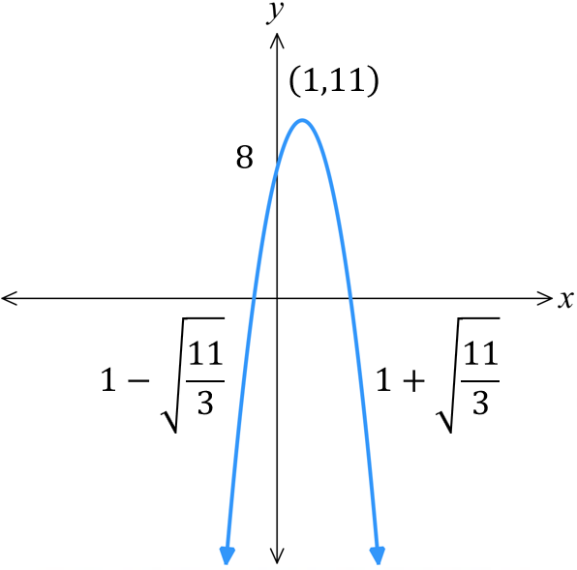  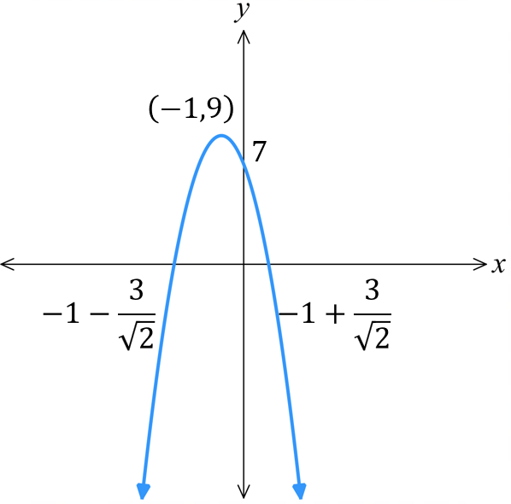

  - Express $y=x^{2}-6x+10$ in vertex form.

$$y={\left(x-3\right)}^{2}+1$$
  - Using your answer to part a, explain why the parabola is always above the $x$-axis.

The value of $y$ cannot be negative, since ${\left(x-3\right)}^{2}≥0$
  - Check the discriminant to confirm there are no $x$-intercepts.

$$Δ={\left(-6\right)}^{2}-4\left(1\right)\left(10\right)=-4<0$$
$∴$ no $x$-intercepts
  - Express $y=-x^{2}+2x-4$ in vertex form.

$$y=-{\left(x-1\right)}^{2}-3$$
  - Georgie says that $y=-x^{2}+2x-4$ is always above the $x$-axis. Explain why she is wrong.

It is always below the $x$-axis, since this is a concave down parabola with vertex below the $x$ axis.

Mastery
- Consider the general quadratic equation $y=ax^{2}+bx+c$
Match each statement to one of the graphs.
  - ……… $Δ=0$ and $a>0$.
D
  - ……… $Δ=0$ and $a<0$.
B
  - ……… $Δ>0$ and $a>0$.
A
  - ……… $Δ>0$ and $a<0$.
C
  - ……… $Δ<0$ and $a>0$.
F
  - ……… $Δ<0$ and $a<0$.
E
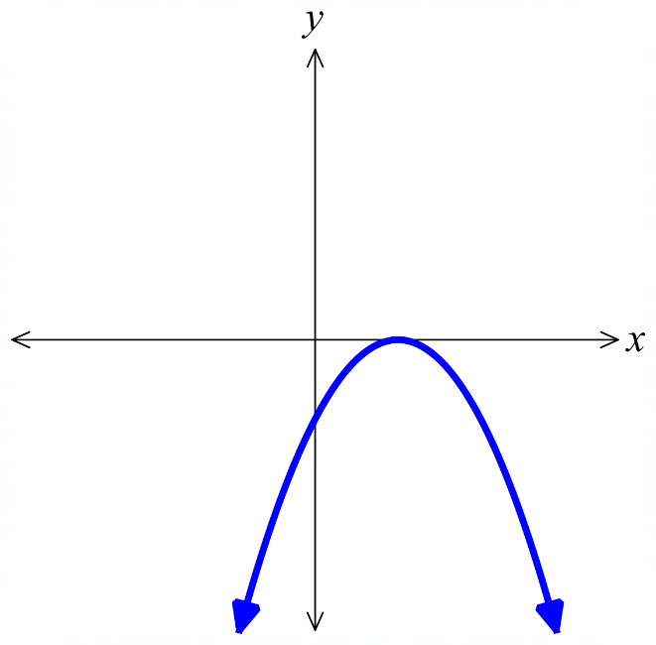
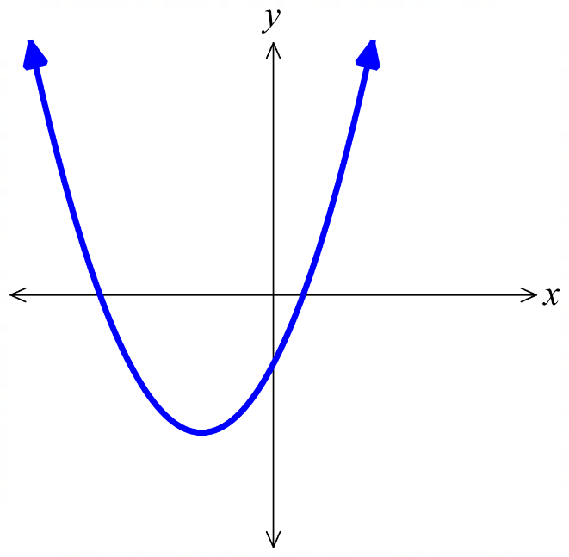
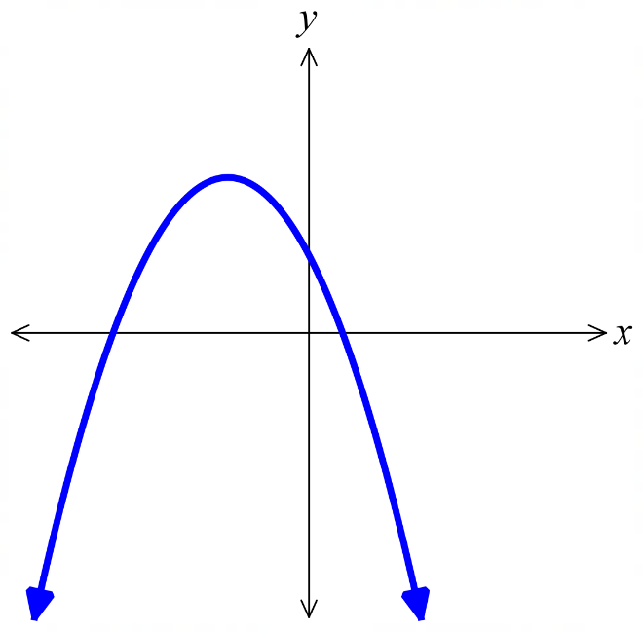

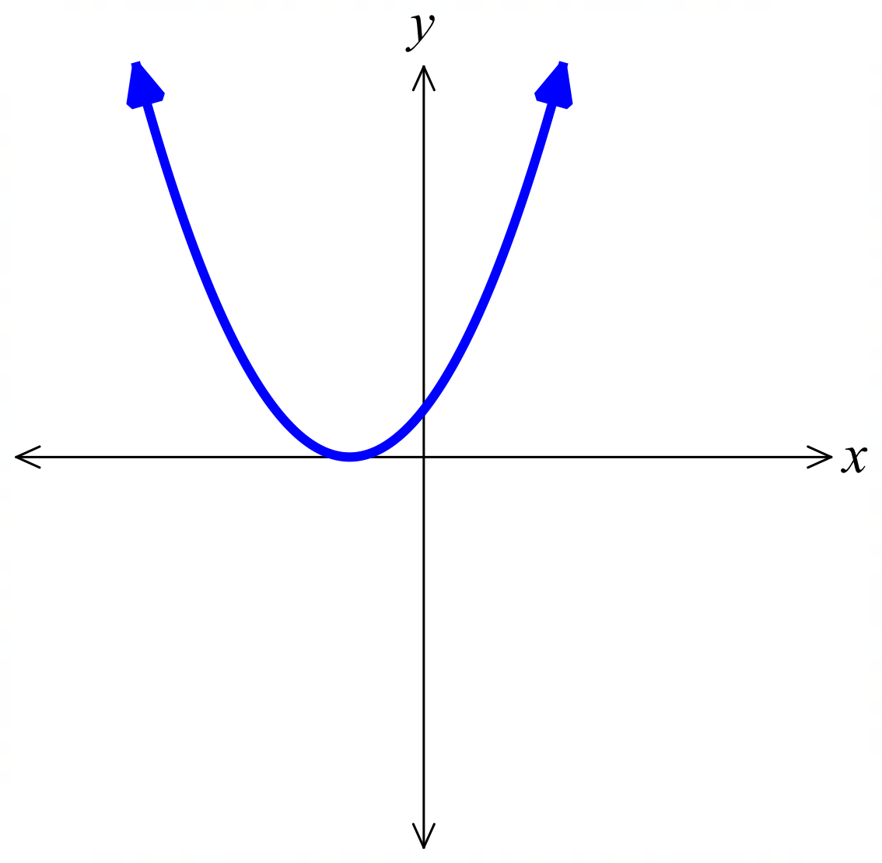 | 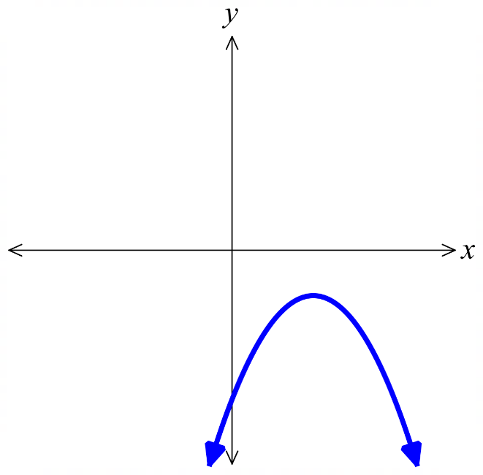 | 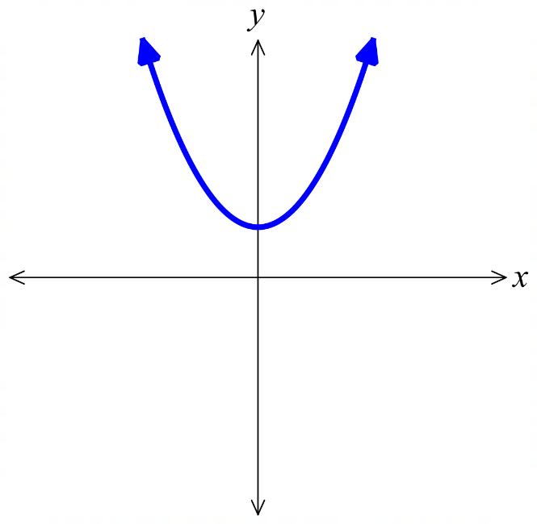
- Explain why $y=x^{2}-2x+1$ has only one $x$-intercept.

The discriminant is 0.
- Explain why $y=x^{2}+2$ has no $x$-intercepts.

The discriminant $Δ=-8$ is negative.
- Consider the general quadratic equation $y=ax^{2}+bx+c$
Match each statement to one or more of the graphs.
  - ………… The axis of symmetry is $x=3$.
A
  - ………… The coefficient of $x^{2}$ is less than one and positive.
C
  - ………… The axis of symmetry is $x=k$, where $k<0$.
E, F
  - ………… The discriminant is negative and the coefficient of $x^{2}$ is positive.
H
  - ………… The value of $-\frac{b}{2a}=1$.
B, C, G, H, I
  - ………… The constant term is $-8$.
I
  - ………… The points $\left(0,8\right)$ and $\left(2,8\right)$ lie on the curve.
G
  - ………… The discriminant is zero.
F
  - ………… When factorised to $y=\left(x-α\right)\left(x-β\right)$, $α+β$ is odd.
D
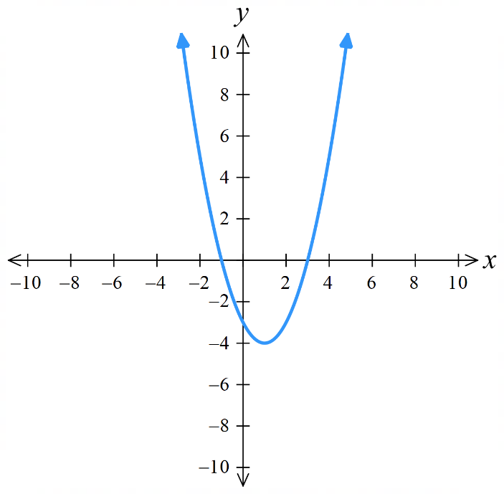  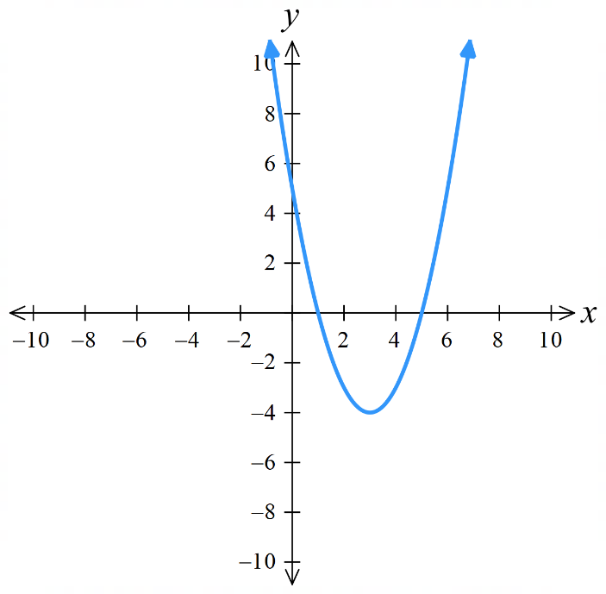 |  | 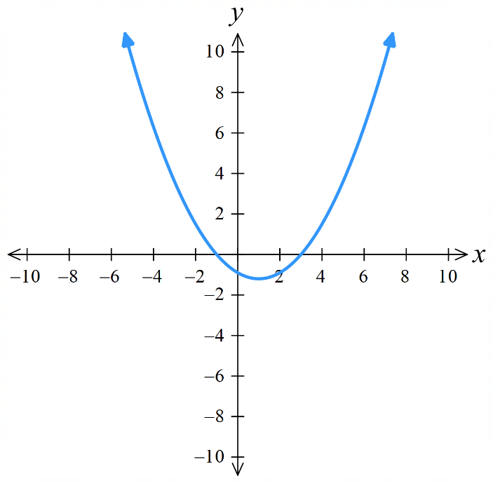
 | 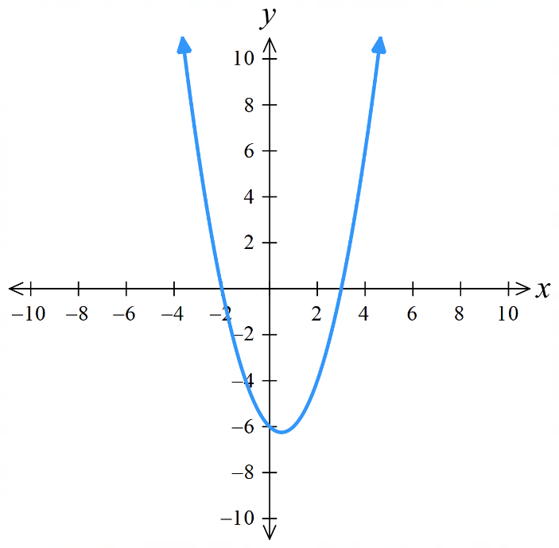  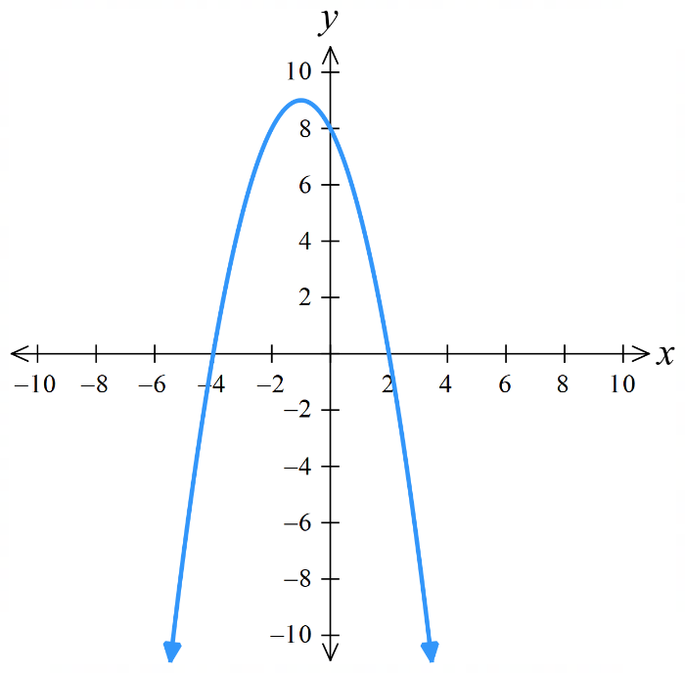 | 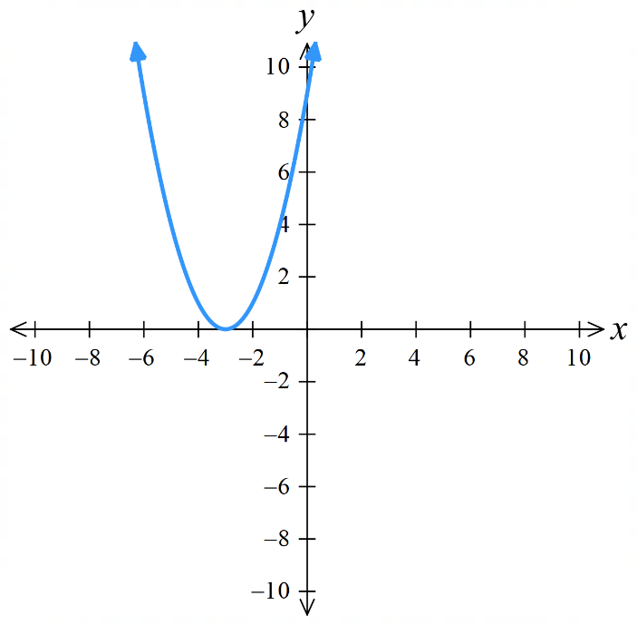
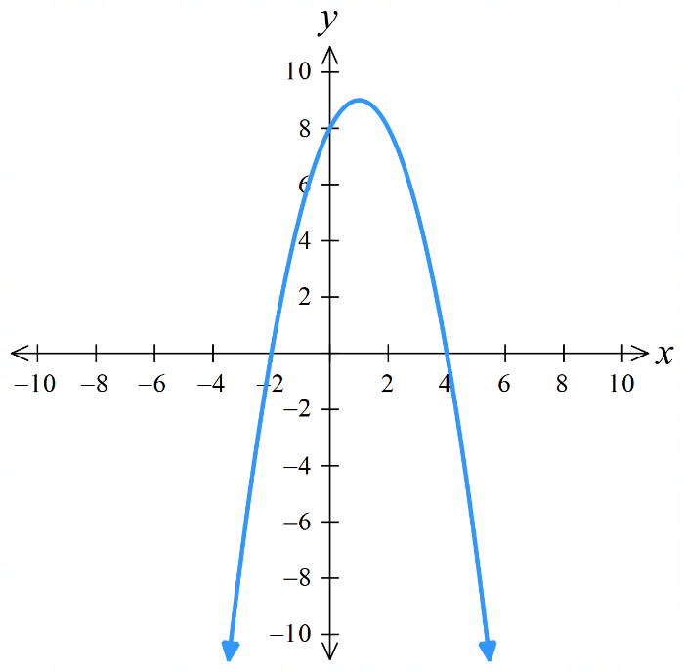 | 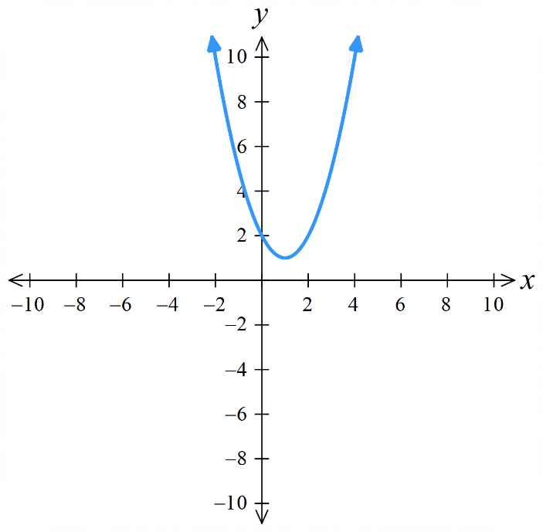 | 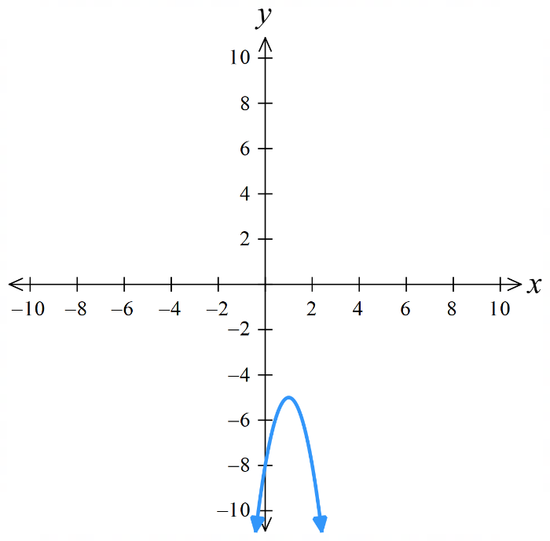

  - Show that the discriminant of $x^{2}-\left(p+1\right)x+p-1=0$ is $Δ={\left(p-1\right)}^{2}+4$

  - Hence explain why the parabola will always have two $x$-intercepts.

The discriminant $Δ={\left(p-1\right)}^{2}+4$ is always positive, so always 2 solutions and hence 2 $x$-intercepts.
- If $y=px^{2}+\left(p+1\right)x+$ $\frac{p}{4}$ , find the values of $p$ such that the parabola is always below the
$x$-axis.

$$Δ={\left(p+1\right)}^{2}-4p\left(\frac{p}{4}\right)$$
$=p^{2}+2p+1-p^{2}$
$=2p+1$
Let $Δ<0$
$$∴p<-\frac{1}{2}$$
- Show that for $y=x^{2}+2mx+m^{2}+n^{2}$, the graph is always touching or above the $x$-axis for all real values of $m$ and $n$.

$$Δ=4m^{2}-4\left(m^{2}+n^{2}\right)$$
$=-4n^{2}$
$-4n^{2}$ cannot be positive, so either $Δ=0$; graph touching $x$-axis, or $Δ<0$; graph is always above the $x$-axis and never touches it
(always above since a>0)

- Show that $y=\left(p-3\right)x^{2}+6x-\left(p+3\right)$ will always have $x$-intercepts that are rational numbers, for all integer values of $p$ (except $p=3$).

$Δ=36+4\left(p-3\right)\left(p+3\right)$
$=36+4\left(p^{2}-9\right)$
$=4p^{2}$
Since the discriminant is always a perfect square, roots will always be rational.
At $p=3$ the $x^{2}$ term disappears, so the graph is the straight line $y=6x-6$, which has $x$ intercept of 1.

Finding the Equation of a Parabola from its Graph

Foundation
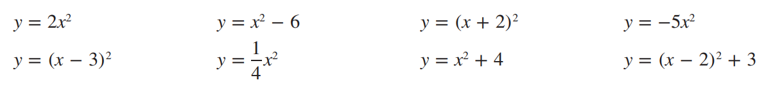
- Match each equation to a graph.

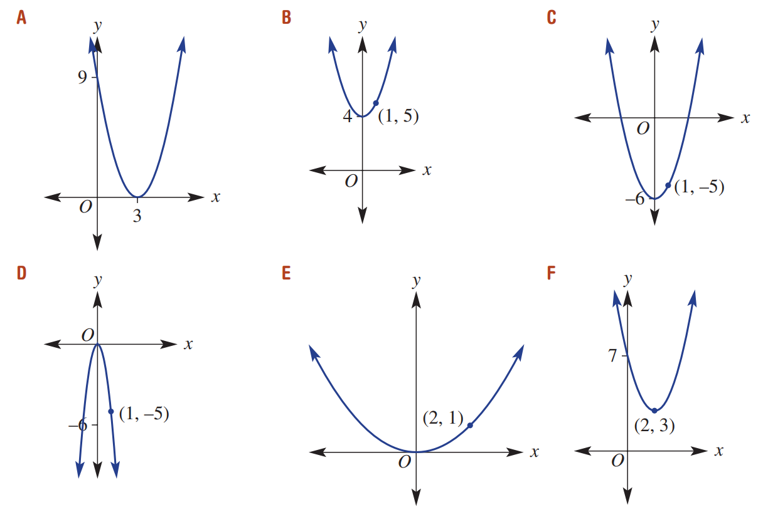  $$y={\left(x-3\right)}^{2}$$ | $$y=x^{2}+4$$ | $$y=x^{2}-6$$
$$y=-5x^{2}$$ | $$y=\frac{1}{4}x^{2}$$ | $$y={\left(x-2\right)}^{2}+3$$
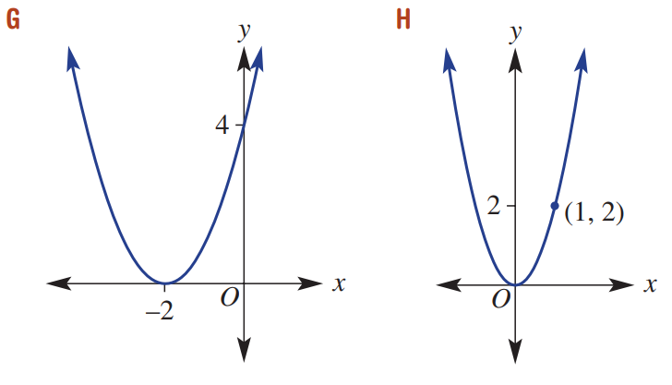  $$y={\left(x+2\right)}^{2}$$ | $$y=2x^{2}$$
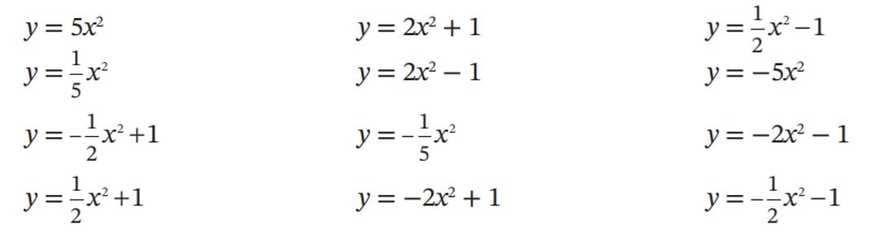
- Match these parabolas to their equation.

$$y=2x^{2}+1$$ | 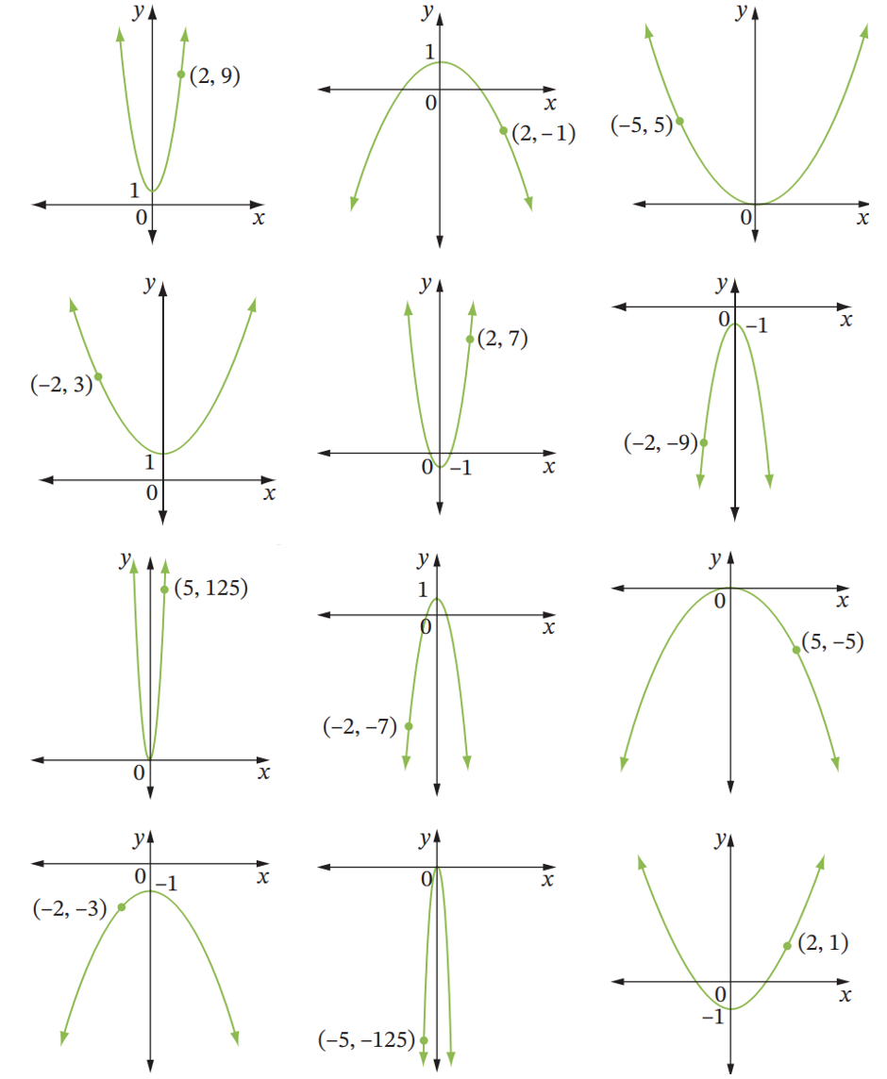  $$y=-\frac{1}{2}x^{2}+1$$ | $$y=\frac{1}{5}x^{2}$$
$$y=\frac{1}{2}x^{2}+1$$ | $$y=2x^{2}-1$$ | $$y=-2x^{2}-1$$
$$y=5x^{2}$$ | $$y=-2x^{2}+1$$ | $$y=-\frac{1}{5}x^{2}$$
$$y=-\frac{1}{2}x^{2}-1$$ | $$y=-5x^{2}$$ | $$y=\frac{1}{2}x^{2}-1$$
- These equations are of the form $y=\left(x+α\right)\left(x+β\right)$.
Use the $x$-intercepts to find the values of $α$ and $β$, then find the coordinates of the turning point.
$y=\left(x-1\right)\left(x-3\right),$turning point $\left(2,-1\right)$ | $y=\left(x+5\right)\left(x-1\right),$ turning point $\left(-2,-9\right)$ | 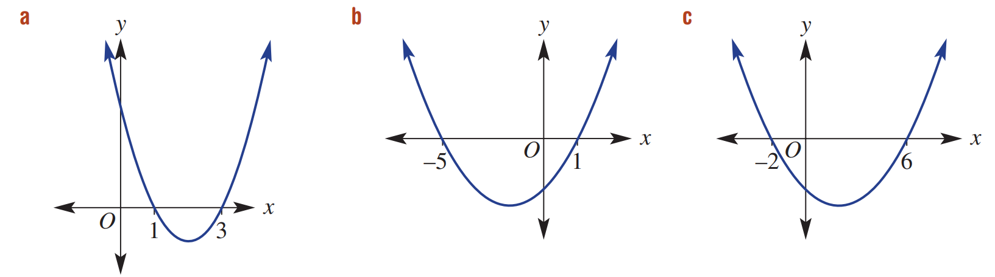  $y=\left(x+2\right)\left(x-6\right),$ turning point $\left(2,-16\right)$

- Write the equation for each of these graphs in the form $y=±{\left(x-b\right)}^{2}+c$.
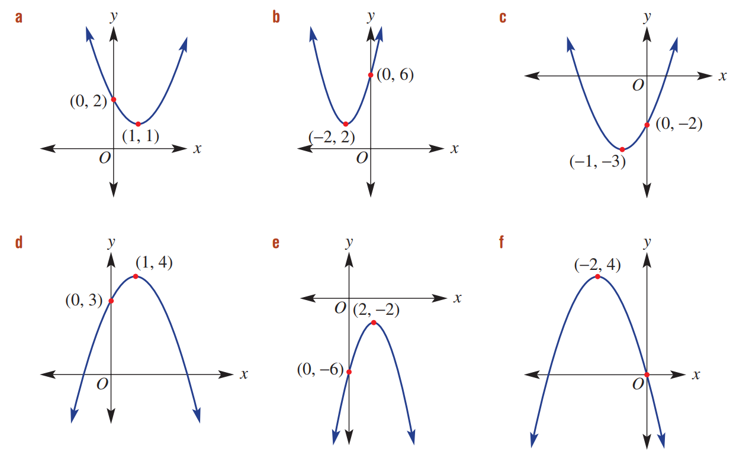  $$y={\left(x-1\right)}^{2}+1$$ | $$y={\left(x+2\right)}^{2}+2$$ | $$y={\left(x+1\right)}^{2}-3$$
$$y={-\left(x-1\right)}^{2}+4$$ | $$y=-{\left(x-2\right)}^{2}-2$$ | $$y=-{\left(x+2\right)}^{2}+4$$

Development
- Each of these equations is in the form $y=\left(x-α\right)\left(x-β\right)$ or $y=-\left(x-α\right)\left(x-β\right)$
Find the equation of these parabolas.
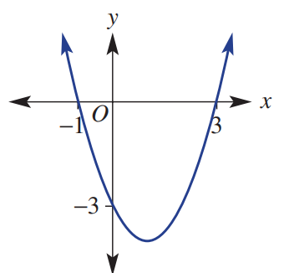  $$y=\left(x+1\right)\left(x-3\right)$$ | 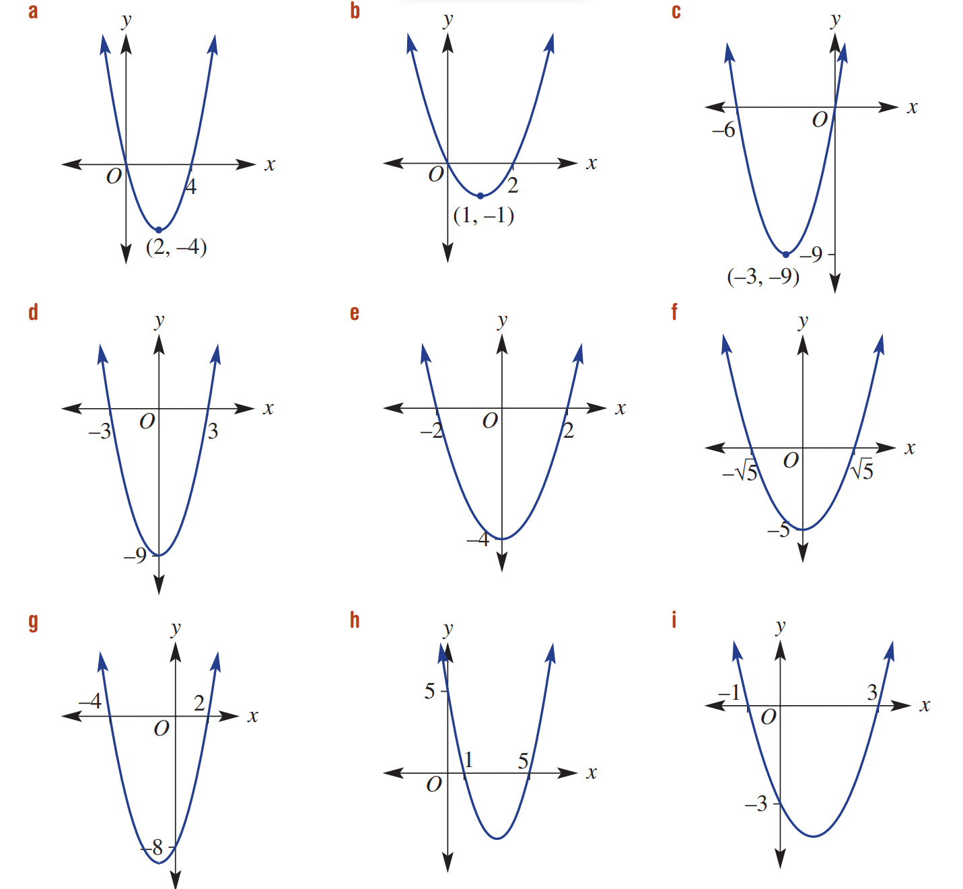  $$y=x(x-2)$$ | $$y=x(x+6)$$
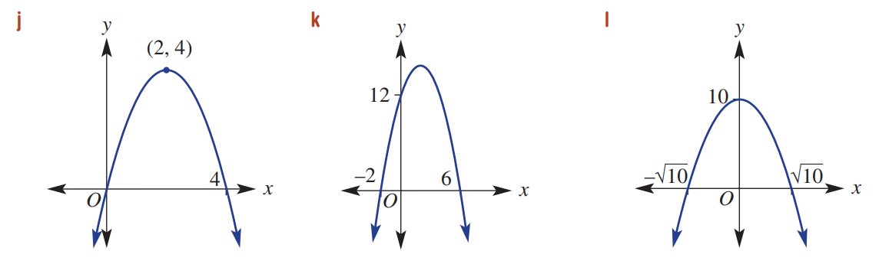  $$y = - x (x - 4)$$ | $$y=-\left(x+2\right)\left(x-6\right)$$ | $$y=-\left(x-\sqrt{10}\right)\left(x+\sqrt{10}\right)$$  Or $y=-x^{2}+10$
$$y=(x+3)(x-3)$$  or $y=x^{2}-9$ | $$y=(x+2)(x-2)$$  or $y=x^{2}-4$ | $y=\left(x+\sqrt{5}\right)\left(x-\sqrt{5}\right)$  or $y=x^{2}-5$
$y=(x+4)(x-2)$ | $$y=(x-1)(x-5)$$ | :)

- When the parabola’s equation is non-monic, we can find the equation using these steps:
- Write the equation $y=k\left(x-α\right)\left(x-β\right)$.
- Substitute $x$-intercepts $α$ and $β$.
- Substitute a third point on the parabola $\left(x_{1},y_{1}\right)$ into the equation.
- Solve for $k$.
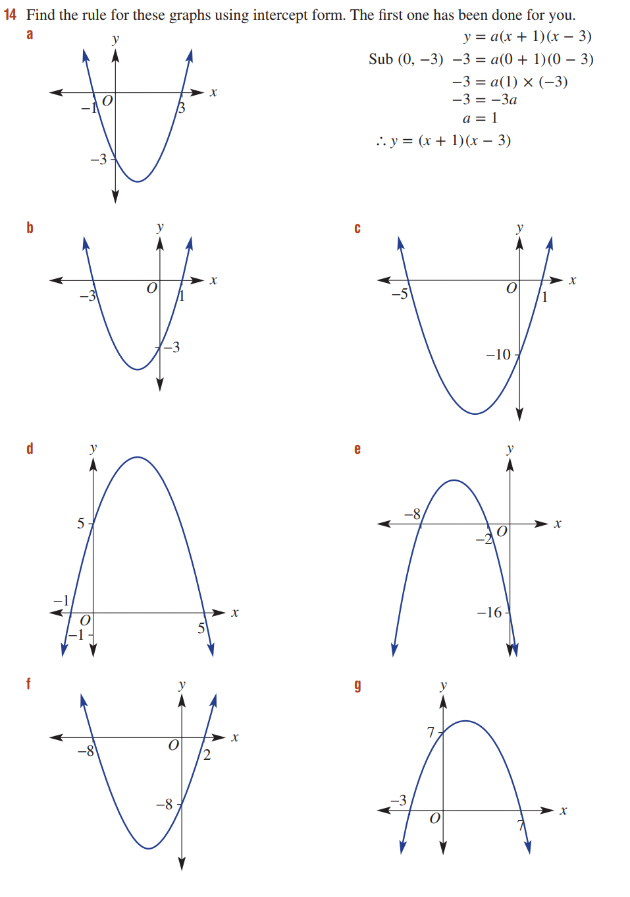  $y=k\left(x-α\right)\left(x-β\right)$  $y=k\left(x+8\right)\left(x+2\right)$  Sub $\left(0,-16\right)$  $-16=k\left(8\right)\left(2\right)$  $-16=16k$  $k=-1$  $$∴y=-\left(x+8\right)\left(x+2\right)$$ | $$y=\frac{1}{2}\left(x-2\right)\left(x+8\right)$$ | $$y=-\frac{1}{3}\left(x+3\right)\left(x-7\right)$$

- Find the equation of each parabola if it is monic.
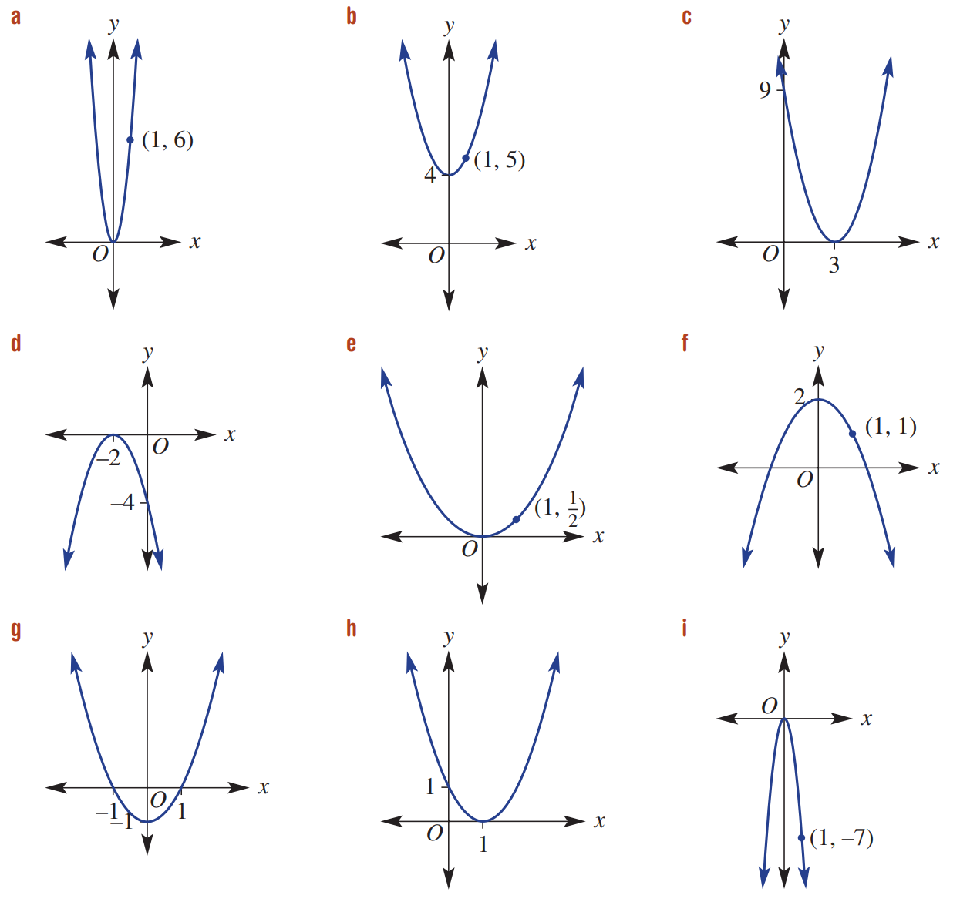  $$y=x^{2}+4$$ | $$y={\left(x-3\right)}^{2}$$ | $$y=x^{2}-1$$

- When given the vertex of a parabola, we can determine the equation by:
- Write the equation $y=a{\left(x-h\right)}^{2}+k$.
- Substitute the vertex ($h,k)$.
- Substitute a second point on the parabola $\left(x_{1},y_{1}\right)$.
- Solve for $a$.
$y=a{\left(x-h\right)}^{2}+k$  Sub $\left(0,0\right)$ $y=a{\left(x-0\right)}^{2}+0$  $y=ax^{2}$  Sub $\left(1,6\right)$ $6=a{\left(1\right)}^{2}$  $6=a$  $$∴y=6x^{2}$$ | $$y=\frac{1}{2}x^{2}$$ | $$y=-x^{2}+2$$
$$y=-7x^{2}$$ | $$y=-{\left(x+2\right)}^{2}$$ | $$y={\left(x-1\right)}^{2}$$

Mastery
- If the graph of $y=k\left(x+ 2\right)\left(x- 4\right)$ passes through the point $\left(2, 16\right)$, determine the value of
$k$ using substitution, and hence the coordinates of the turning point for this parabola.

$$16=k\left(2+2\right)\left(2-4\right), ∴k=-2$$
Turning point is halfway between $x=-2$ and $x=4$, $∴x=1$
Substitute $x=1$ into $y=-2\left(x+2\right)\left(x-4\right)$; $y=18$
Turning point at $\left(1,18\right)$
- $y=k{\left(x+4\right)}^{2}+2$ is the form of a quadratic with vertex $\left(-4,2\right)$.
Find the equation of such a quadratic if:
- The quadratic is monic.  $$y={\left(x+4\right)}^{2}+2$$ | - The coefficient of $x^{2}$ is 3.  $$y={3\left(x+4\right)}^{2}+2$$
- The $y$-intercept is 5.2  $$y=\frac{1}{5}{\left(x+4\right)}^{2}+2$$ | - The curve passes through the origin.  $$y=-\frac{1}{8}{\left(x+4\right)}^{2}+2$$

- Use the quadratic formula to find the $x$-intercepts, and hence write the function in factored form
$$y=±\left(x-α\right)\left(x-β\right)$$
- $y=x^{2}-6x+4$  $$\left(x+\sqrt{5}-3\right)\left(x-\sqrt{5}-3\right)$$ | - $y=x^{2}+2x-1$  $$\left(x+\sqrt{2}+1\right)\left(x-\sqrt{2}+1\right)$$ | - $y=-x^{2}+3x-1$  $$-\left(x-\frac{\sqrt{5}+3}{2}\right)\left(x+\frac{\sqrt{5}-3}{2}\right)$$

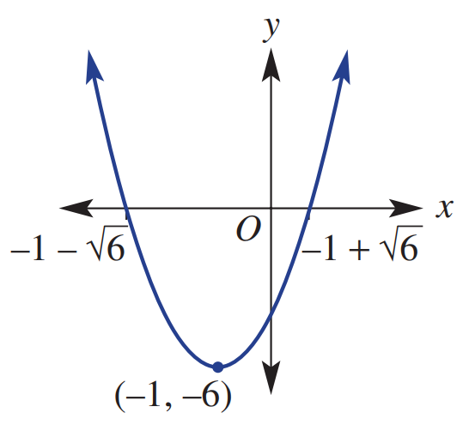
- Find the equation in the form $y=ax^{2}+bx+c$ that matches this graph.

$y={\left(x+1\right)}^{2}-6$ or
$y=\left(x+1+\sqrt{6}\right)\left(x+1-\sqrt{6}\right)$ or
$$y=x^{2}+2x-5$$
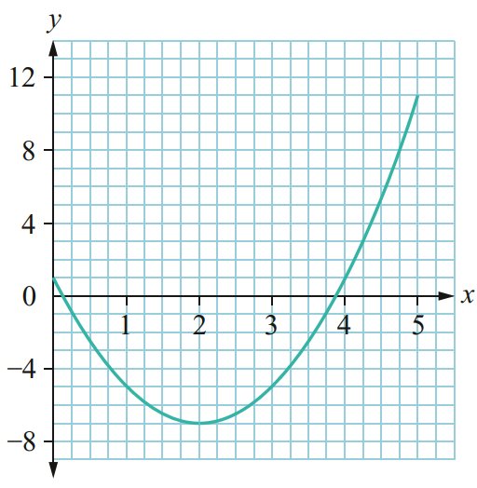
- Which of these equations matches the parabola shown? Explain your reasoning.

- $y=-2x^{2}-4x-7$
- $y=-2x^{2}-4x+1$
- $y=2x^{2}-8x+1$
- $y=2x^{2}-8x+4$

Must be C or D as parabola is concave up.
$y$-intercept is 1, so constant term is 1.
Answer is C

- $y=k\left(x-2\right)\left(x-8\right)$ is the form of a quadratic with $x$-intercepts at $x=2$ and $x=8$.
Find the value of $k$ if:
- The coefficient of $x^{2}$ is 3  $$k=3$$ | - The $y$-intercept is $-16$  $$k=-1$$
- The vertex is $\left(5,-12\right)$  $$-12=k\left(5-2\right)\left(5-8\right)$$  $$k=\frac{4}{3}$$ | - The curve passes through $\left(1,-20\right)$  $$-20=k\left(1-2\right)\left(1-8\right)$$  $$k=-\frac{20}{7}$$

- A parabola has $x$-intercepts at $x=-1$ and $x=6$. The $y$-intercept is 12. Find the equation.

$$y=k\left(x+1\right)\left(x-6\right)$$
$$12=k\left(0+1\right)\left(0-6\right)$$
$$k=-2$$
$$∴y=-2\left(x+1\right)\left(x-6\right)$$
- A parabola has $x$-intercepts at $x=-3$ and $x=3$. The $y$-intercept is $-$ $\frac{9}{2}$. Find the equation.

$$y=k\left(x+3\right)\left(x-3\right)$$
$$-\frac{9}{2}=k\left(0+3\right)\left(0-3\right)$$
$$k=\frac{1}{2}$$
$$∴y=\frac{1}{2}\left(x+3\right)\left(x-3\right)$$
- A parabola has vertex $\left(-2,1\right)$ and passes through $\left(-5,28\right)$. Find the equation of the parabola.

$y={k\left(x+2\right)}^{2}+1$
$$28={k\left(-5+2\right)}^{2}+1$$
$$k=3$$
$$∴y=3{\left(x+2\right)}^{2}+1$$

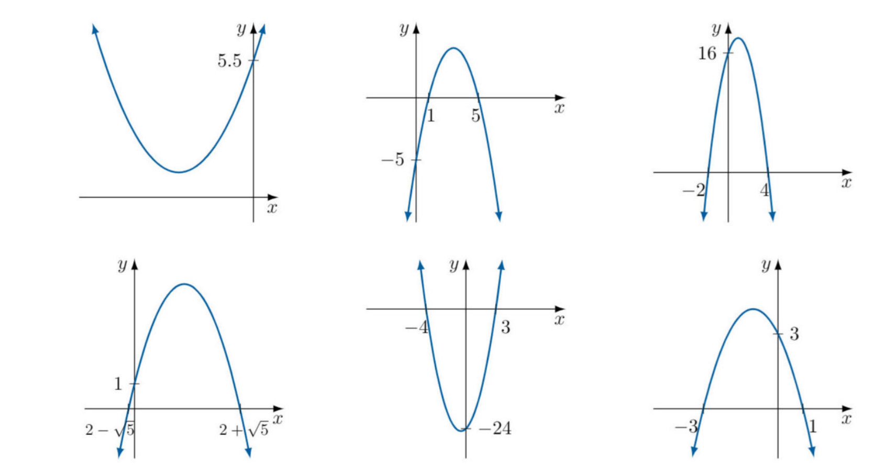
- Find the equation of each parabola. You can answer in any appropriate form.
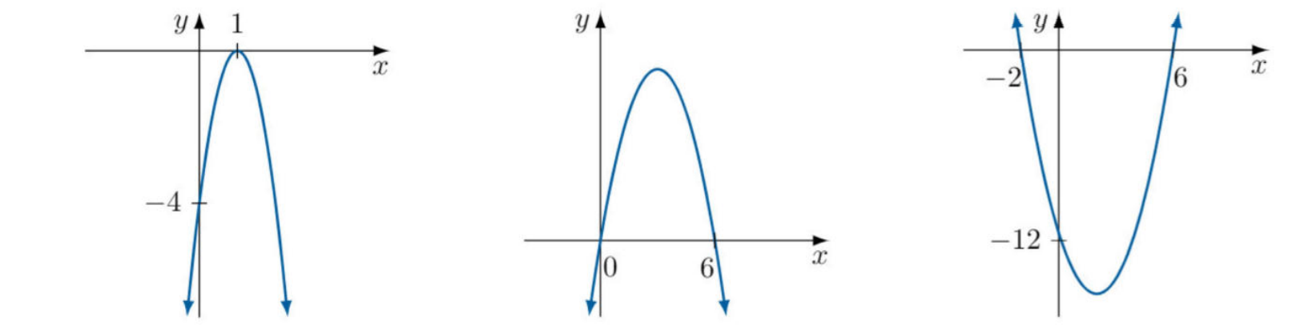  $$y=-4{\left(x-1\right)}^{2}$$ | $$y=-x\left(x-6\right)$$ | $$y=\left(x+2\right)\left(x-6\right)$$
$$y=\frac{1}{2}{\left(x+3\right)}^{2}+1$$ | $$y=-\left(x-1\right)\left(x-5\right)$$ | $$y=-2\left(x+2\right)\left(x-4\right)$$
$y=-{\left(x-2\right)}^{2}+5$ or  $$y=-\left(x-2-\sqrt{5}\right)\left(x-2+\sqrt{5}\right)$$ | $$y=2\left(x-3\right)\left(x+4\right)$$ | $$y=-{\left(x+1\right)}^{2}+4$$

Applying Parabolas to Solve Problems
In this section, you will use your knowledge of quadratic modelling and sketching parabolas to solve application problems.

Foundation
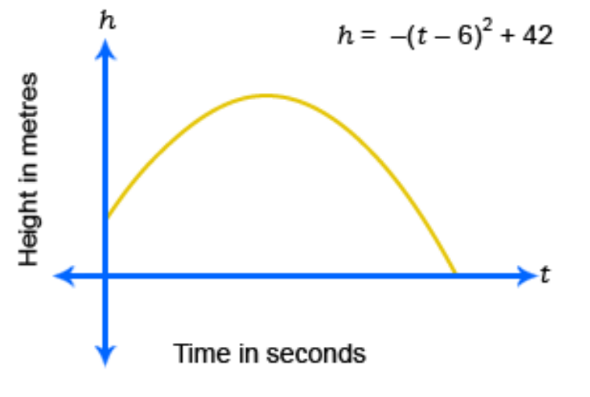
- An arrow was shot into the air. The height, $h$ metres, of the arrow above the ground at any time, $t$ seconds, is given by the formula $h= -{\left(t- 6\right)}^{2}+42$. The included sketch may be useful.

  - Using the vertex of this parabola, what was the maximum height reached by the arrow and at what time was this?
42 metres at 6 seconds
  - From what height was the arrow initially fired? (Hint: ‘Initially’ means ‘at the start’, so t = 0)
6m
  - How high above the ground was the arrow after 2 seconds?
26 m
  - How high above the ground was the arrow after 10 seconds?
26 m
  - How do the answers to (c) and (d) relate to the answers for (a)?

6 is the midpoint of 2 and 10. The height of the arrow is the same because a parabola is symmetrical.
  - How long will it take the arrow to hit the ground? (Hint: what height is the ground?)

Let $h=0$ and solve; $t=-0.48$ s and $12.48$ s. The arrow will hit the ground at 12.48 seconds.
  - Another arrow’s height can be determined using the formula $h=-a{\left(t-n\right)}^{2}+p$,
where $a$, $n$ and $p$ are unknown numbers.
Find the equation of its path if the arrow was initially fired from a height of 1 metre and it reached a maximum height of 28 m after 9 seconds.

$$h=-\frac{1}{3}{\left(t-9\right)}^{2}+28$$

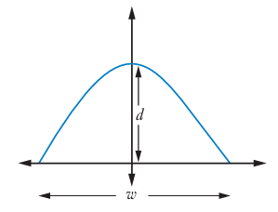
- A satellite dish is in the shape of a parabola with equation $y=-3x^{2}+6$.
All dimensions are in metres.
  - Find the depth of the dish.

$y$-intercept at 6 metres, the dish is 6 m deep.
  - Find the width of the dish. Answer to 1 d.p.

Let $y=0$, $x=±\sqrt{2}$
So, the distance is $2\sqrt{2}≈2.8$ m
- A carpenter programs a wood lathe to carve out a bowl according to the formula $d=$ $\frac{1}{3}x^{2}-27$
  - Sketch the graph for $-9≤x≤9$.

  - What is the breadth of the bowl?
18 cm
  - What is the maximum depth of the bowl?
27 cm
- The equation for the arch of a bridge is $h=-$ $\frac{1}{500}$ ${\left(x-100\right)}^{2}+20$,
where $h$ is the height above the base in metres and $x$ is distance from the left end of the bridge.
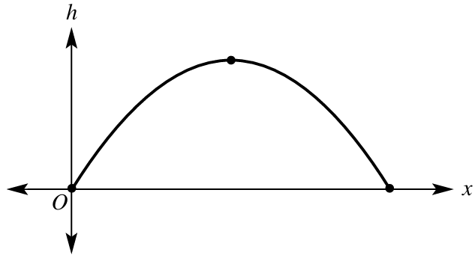

  - Determine the coordinate of the turning point of the parabola.
$$\left(100,20\right)$$
  - Determine the $x$-intercepts of the parabola.

$x=0$ and $x=200$
  - Determine the span (horizontal length) of the arch.
200 m
  - What is the maximum height of the arch?
20 m

Development
- A 20 cm piece of wire is bent to form a rectangle. Let $x$ cm be the breadth of the rectangle.
  - Using the perimeter, explain why the length of the rectangle can be written as $10-x$.
The perimeter is $x+x+l+l=20$
$2x+2l=20$
$2l=20-2x$
$l=10-x$
  - Write an equation for the area of the rectangle $A$ cm² in terms of $x$.

$A=lw$
$=x\left(10-x\right)$
  - Sketch the graph of $A$ vs $x$ for suitable values of $x$.

  - Use the graph to determine the maximum area that can be formed.

25 cm²
  - What will be the dimensions of the rectangle to achieve its maximum area?

$A=25, x=5$, therefore $l=5$

- A small toy glider is released from a cliff. It follows a parabolic path as shown.
The lowest point of the glider is 11 metres above the ground, 8 metres from the cliff.
  - Write an equation in the form $y=x^{2}+bx+c$ to model the glider’s path.
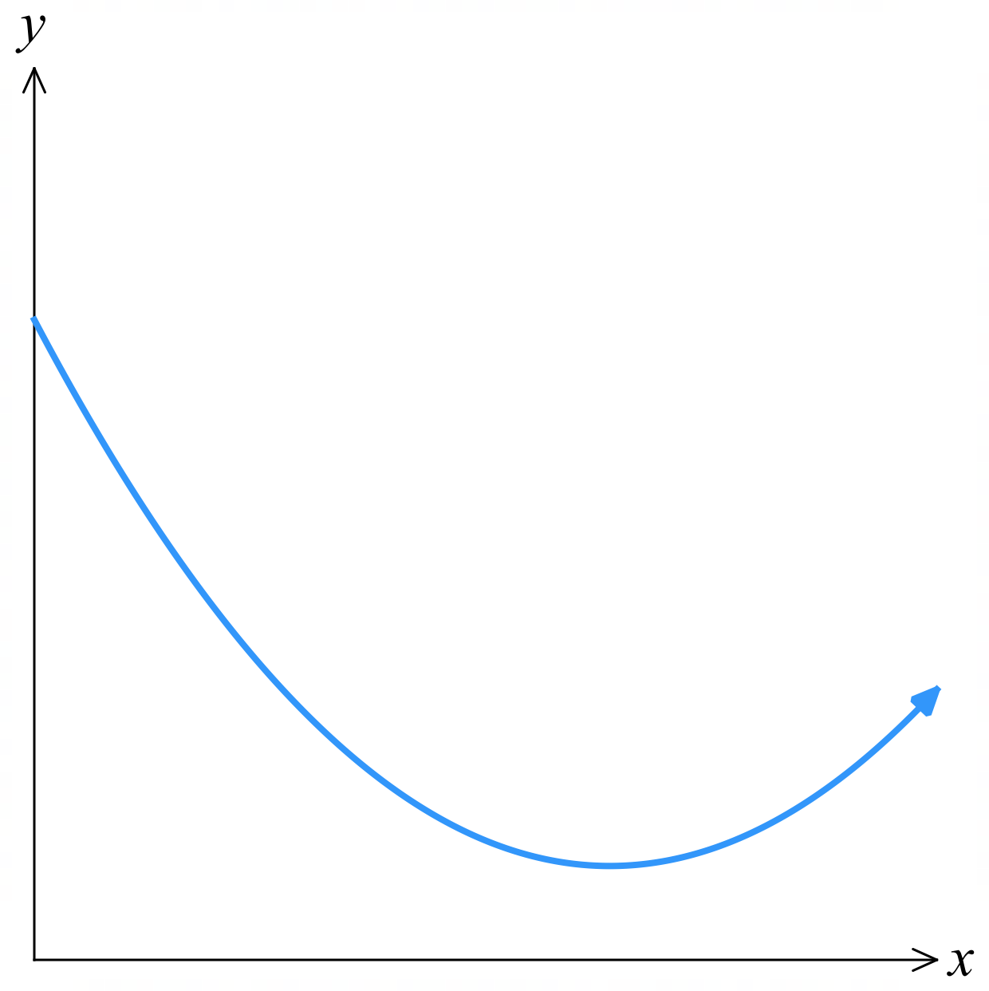

Min turning point at $\left(8,11\right)$
The question tells us it is a monic quadratic. $y={\left(x-8\right)}^{2}+11$
By expanding and comparing coefficients. $b=-16$, $c=75$
$$∴y=x^{2}-16x+75$$
  - Hence, or otherwise, from what height was the glider released?
$at x=0, y=75$. 75 m
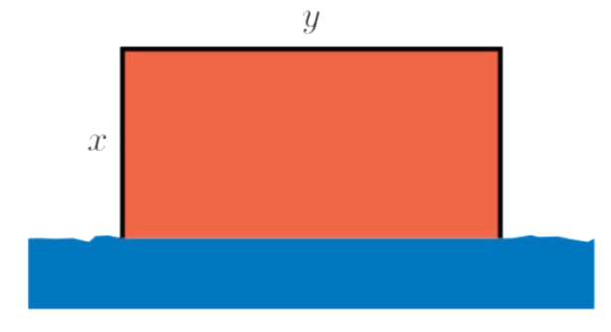
- A farmer has 400 metres of fencing to construct a rectangular field.
One of the sides is a river, so the farmer only needs to fence three sides of the rectangle.
The farmer wants to use all the fencing available to make the largest possible area.

  - Show that we can model this situation as $2x+y=400$

The amount of fencing required is $x+y+x$, and we have 400 metres,
so $2x+y=400$
  - Show that the area of the field is $A=400x-2x^{2}$

$A=xy$
$=x\left(400-2x\right)$
$=400x-2x^{2}$
  - By completing the square of the above expression, or otherwise, find the maximum area of the field that the farmer can construct.
By CTS, we get $A=-2{\left(x-100\right)}^{2}+20000$, so the maximum turning point is at $(100,20000)$
Therefore, maximum area would be $20000$ m²

Alternatively,
$$-\frac{b}{2a}=100$$
The maximum turning point is at $x=100$, substitute into $A=400x-2x^{2}$
$∴$ Maximum area is $A=20000$ m²
- 2013 HSC Standard 2 Band 6
Leanne wants to build a rectangular vegetable garden in her backyard. She has 20 metres of fencing and will use a wall as one side of the garden. The plan for her garden is shown, where $x$ metres is the width of her garden.
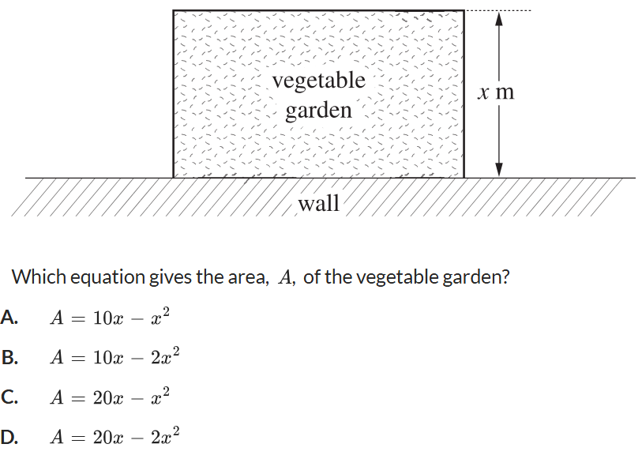
Which equation gives the area of her vegetable garden?

D

- Let $C=2x^{2}-12x+25$ represent the cost of manufacturing products in a day, where $x$ is the number of machines operating and $C\left(x\right)$ is in tens of thousands of dollars.
  - Find the cost of production if one machine is operating.

$150 000
  - If the cost of production is $90 000, how many machines are operating?

Solve $9=2x^{2}-12x+25$
2 or 4 machines
  - Find how many machines should be operated to minimise the cost of production and hence find the minimum cost of production.

By either completing the square or $x=-$ $\frac{b}{2a}$, we can determine the minimum value is at $x=3$.
3 machines, at a minimum production cost of $70 000
- A farmer has 100 m of fencing to form a rectangular paddock with a river on one side (that does not require fencing), as shown.
What will be the dimensions of the paddock to achieve its maximum area?
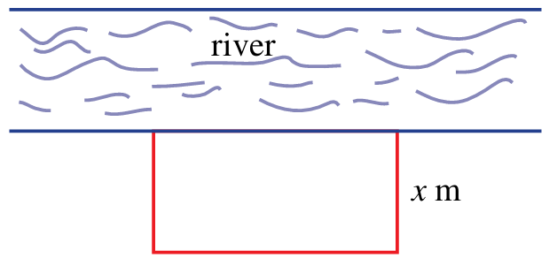

Let $x$ be width and $y$ be length.
$2x+y=100$ (from perimeter) and $A=xy$
$y=100-2x,$ substitute into area equation
$$A=x\left(100-2x\right)$$
$$=2x\left(50-x\right)$$
Therefore, maximum of this parabola is at $x=25$
Substitute $x=25$into $y=100-2x$ to get $y=50$
Breadth: 25 m, Length: 50 m

Mastery
- Revenue for a burger truck can be modelled by $R=np$, where $n$ is the number of burgers sold and $p$ is the price of a burger.
A burger truck normally sells 60 burgers a day for $10 per burger.
The owner is advised that they should increase the price of the burger.
However, for every 50 cents extra that the burger costs, the number of daily sales will drop by 2.
The owner decides to increase the price in 50-cent increments.
Let $x$ be the number of 50-cent price increases.
  - Given that revenue is $Price × Sales$, show that this scenario can be modelled using
$$R=\left(30-x\right)\left(20+x\right)$$

Revenue is $R=Price×Number of Sales$
After $x$ lots of 50c increases, price would be $10+$ $\frac{x}{2}$ and number sold is $60-2x$
So, $R=\left(10+\frac{x}{2}\right)\left(60-2x\right)$
$$=\frac{1}{2}\left(20+x\right)×2\left(30-x\right)$$
$$=\left(20+x\right)\left(30-x\right)$$
  - Find the price that the owner should charge per burger to maximise the daily revenue, and state what the maximum daily revenue is.

$x$-intercepts of the equation are at -20 and 30. Maximum turning point is at the midpoint, 5.
Therefore, 5 50c increases; the owner should charge $12.50 per burger.
The revenue is $R=\left(20+5\right)\left(30-5\right)=\$625$

- A professional tennis player returns a ball from ground level. It was hit in such a way that it will cover a horizontal distance of 22 m and land just inside the opposite end of the court.
The opponent is standing 4 m from the baseline and he can hit any ball less than 3 m high.
What is the lowest max height the ball must reach to fly over the opponent and win the point?
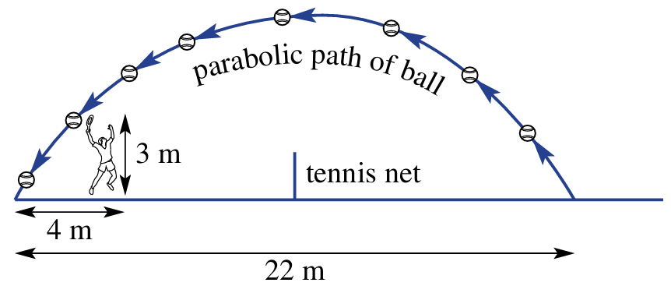
(Hint: Find the equation of the parabola using the $x$-intercepts and the point $\left(4,3\right)$)

Let $h$ be height and $x$ be distance from left
Using intercepts at $x=0$ and $x=22$ and the formula $y=k\left(x-α\right)\left(x-β\right)$:
$∴y=kx\left(x-22\right),$substitute $\left(4,3\right)$ into equation and solve to get $k=-$ $\frac{1}{24}$
$$∴y=-\frac{x}{24}\left(x-22\right)$$
The turning point is at $x=11$, substitute into equation to find $y$:
$$y=-\frac{11}{24}\left(11-22\right)=\frac{121}{24}$$
$∴$ Max height must be at least 5 $\frac{1}{24}$ metres
- Over the summer, Mr Ding and his daredevil maths teacher friends want to build a bike ramp to launch themselves into a lake. He decided that the shape of the ramp would be parabolic.
The right end of the ramp should have a height of 5 metres.
The lowest point of the ramp should be 2 metres above the ground, 3 metres from the right end.
If the left end of the ramp is 7 metres from the right end, from what height should the ramp start?
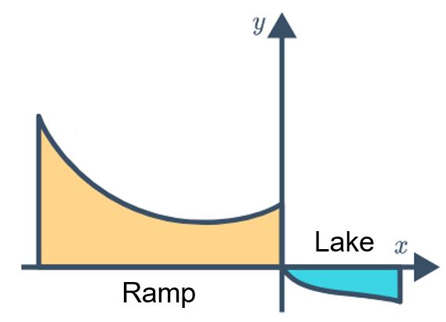

The equation of the ramp is $y=\frac{1}{3}{\left(x+3\right)}^{2}+2$
The ramp should start from a height of $7.33$ metres.
- The graph shows the trajectory of an AFL ball kicked by a Year 11 student.
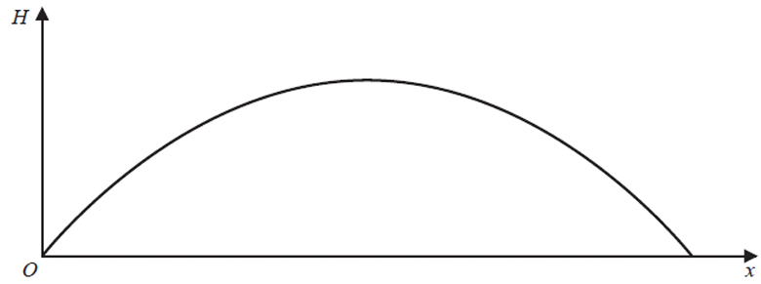
The ball reaches a maximum height of 12 metres and hits the ground 40 metres from where it was kicked. As the ball is falling, it just passes over the head of a Year 7 girl who is 134 cm tall. How far away was the Year 7 girl standing from where the ball was kicked?
Answer in metres rounded to 2 decimals.

Equation of the parabola is $y=$ $-\frac{3x}{100}$ $\left(x-40\right)$
Using quadratic formula, solve for when $y=1.34$. Y7 girl was standing 38.85 metres away
- 2023 HSC Advanced Band 6
The graph $y=x^{2}$ meets the line $y=k$, where $k>0$, at points $P$ and $Q$ as shown.
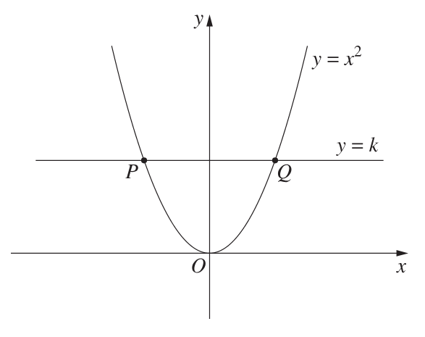
The length of interval $PQ$ is $L$.

Let $a$ be a positive number. The graph $y=$ $\frac{x^{2}}{a^{2}}$ meets the line $y=k$ at points $S$ and $T$.
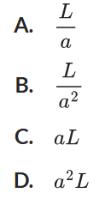
What is the length of ST? (Hint: find an expression for L, then find an expression for ST.)

Intersection of $y=x^{2}$ and $y=k$ is at $x=±\sqrt{k}$
Therefore, length of PQ is $L=2\sqrt{k}$
Intersection of $y=$ $\frac{x^{2}}{a^{2}}$ and $y=k$ is at $x=±a\sqrt{k}$
Therefore, length of $ST=2a\sqrt{k}=aL$
Answer is C

Quadratic Inequalities

- Identify the region where $y>0$ or $y<0$
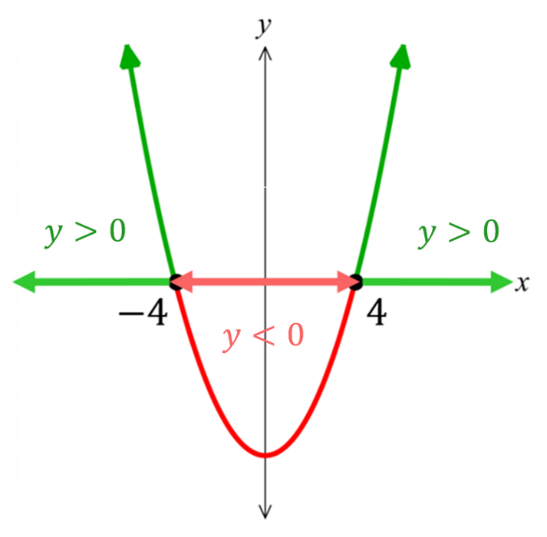  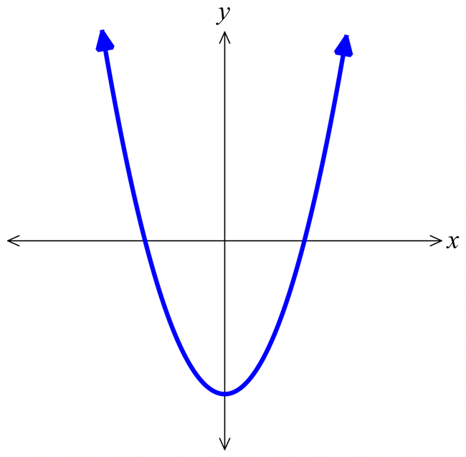  $y>0:$ $x<-4, x>4$  $y<0:$ $-4<x<4$ | 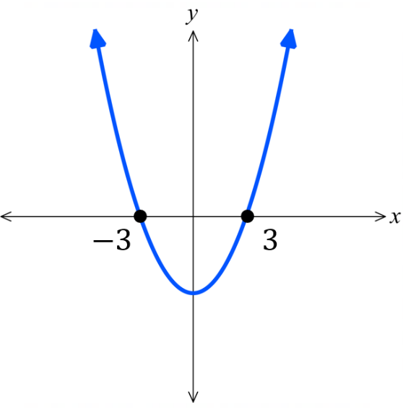  $y>0:$  $$x<-3, x>3$$  $y<0:$  $$-3<x<3$$ | 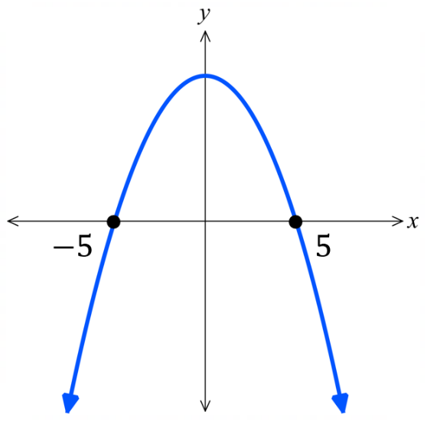  $y>0:$  $$-5<x<5$$  $y<0:$  $$x<-5, x>5$$
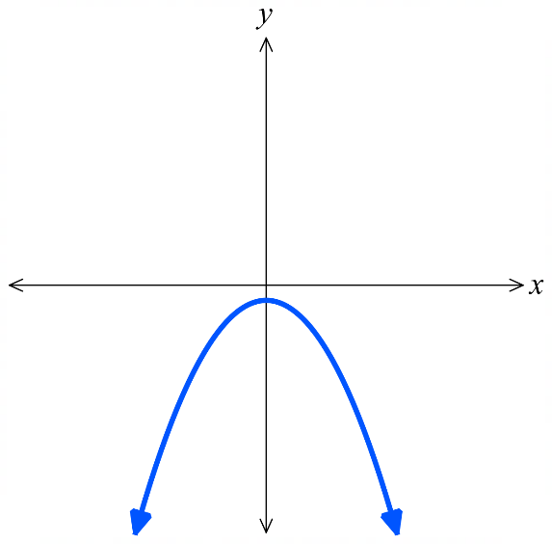  $y>0:$  no solution  $y<0:$  all real $x$ | 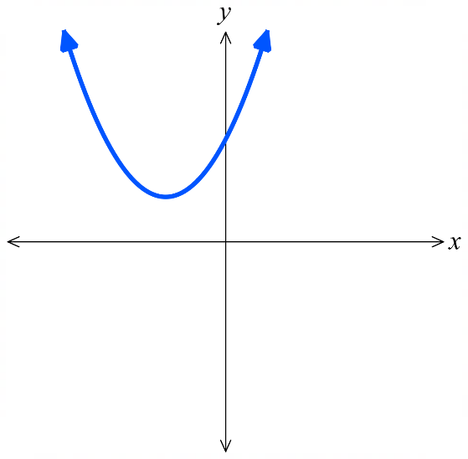  $y>0:$  all real $x$  $y<0:$  no solution | 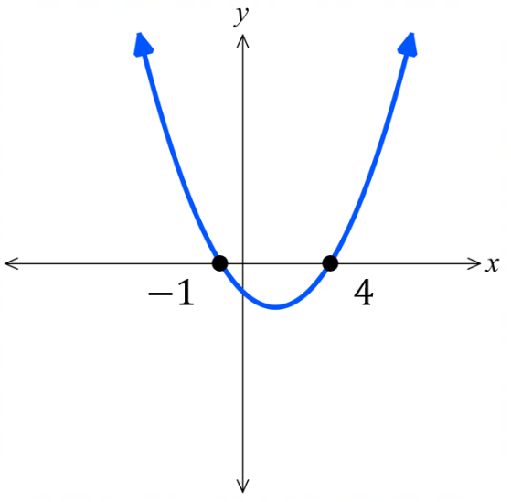  $y>0:$  $$x<-1, x>4$$  $y<0:$  $$-1<x<4$$
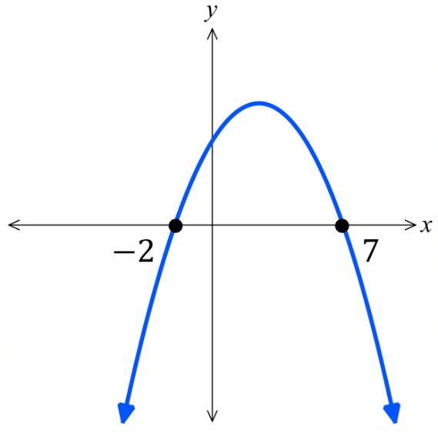  $y>0:$  $$-2<x<7$$  $y<0:$  $$x<-2, x>7$$ | 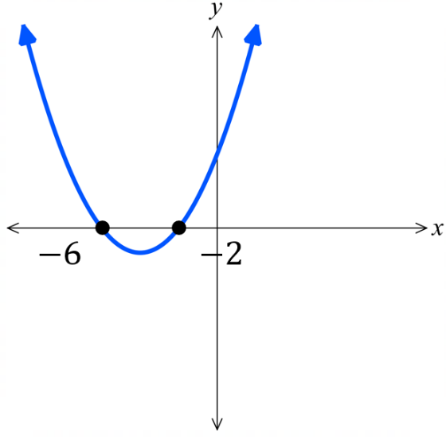  $y>0:$  $$x<-6, x>-2$$  $y<0:$  $$-6<x<-2$$

- Quadratic Inequalities
A quadratic inequality is an inequality in which the highest power of the pronumeral is $2$.
Solving quadratic inequalities is best done by sketching a parabola.

- Move all terms to one side so that you have $ax^{2}+bx+c≥0$ or $≤0$.
- Sketch the parabola $y=ax^{2}+bx+c$, showing all $x$-intercepts.
- Examine where the graph is above or below the $x$-axis.

- Example Solve quadratic inequalities using graphing techniques
Solve $x^{2}>9$  1.  $x^{2}-9>0$  2.  $\left(x+3\right)\left(x-3\right)>0$  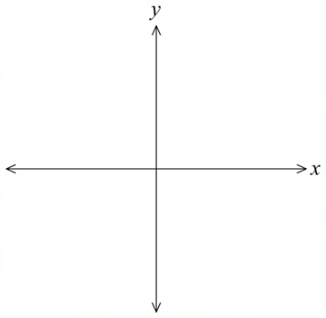  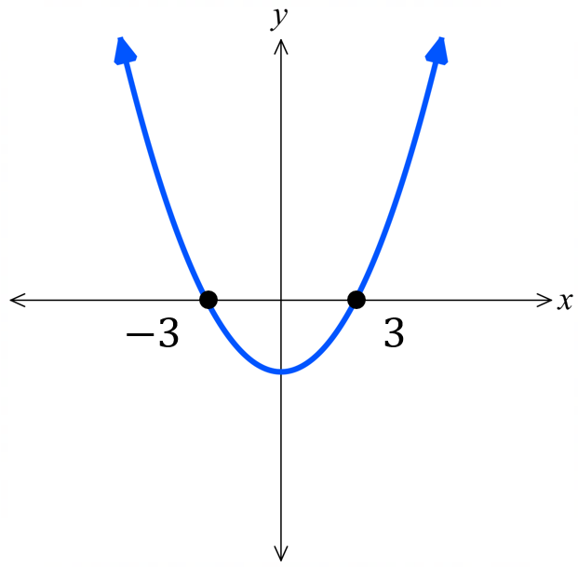  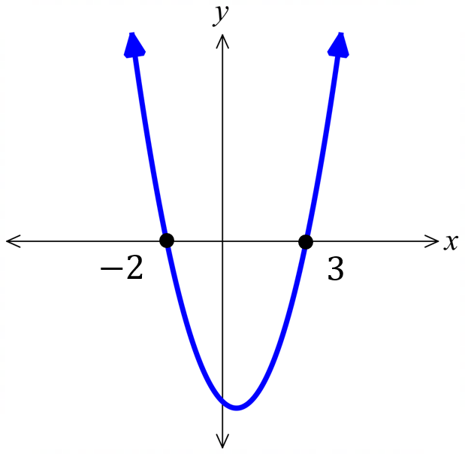  3. $x<-3$ or $x>3$ | Solve $x+6≥x^{2}$  1.  $-x^{2}+x+6≥0$  $x^{2}-x-6≤0$  2.  $\left(x-3\right)\left(x+2\right)≤0$  3. $-2≤x≤3$

- Guided Practice
- Solve $x^{2}+2x>0$  $$x<-2, x>0$$ | - Solve $x^{2}-x-12≤0$  $$-3≤x≤4$$

Foundation
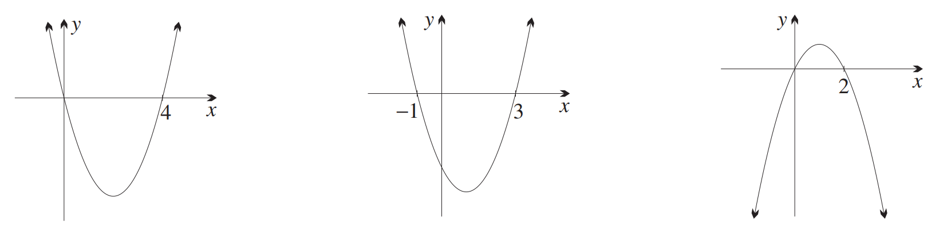
- Use the given graph to solve each inequality.
- $x(x-4)<0$  $$0<x<4$$ | - $(x-3)(x+1)≥0$  $$x≤-1, x≥3$$ | - $x(2-x)≤0$  $$x≤0, x≥2$$

- Sketch these parabolas, showing the $x$-intercepts, and hence solve the inequalities.
- $\left(x+2\right)\left(x-4\right)<0$  $$-2<x<4$$ | - $(x-3)(x+1)>0$  $$x<-1, x>3$$ | - $(2-x)(x-5)≥0$  $$2≤x≤5$$
- $(x+1)(x+3)≥0$  $$x≤-3, x≥-1$$ | - $(2x-1)(x-5)>0$  $$x<0.5, x>5$$ | - $(3x+5)(x+4)≤0$  $$-4≤x≤-\frac{5}{3}$$

Development
- Sketch these parabolas and hence solve the inequalities.
- $x^{2}+2x-3<0$  $$-3<x<1$$ | - $x^{2}-5x+4≥0$  $$x≤1, x≥4$$ | - $x^{2}+6x+8>0$  $$x<-4, x>-2$$
- $x^{2}-x-6≤0$  $$-2≤x≤3$$ | - $2x^{2}-x-3≤0$  $$-1≤x≤1.5$$ | - $4+3x-x^{2}>0$  $$-1<x<4$$
- $x^{2}>3x$  $$x<0,x>3$$ | - $x^{2}≥144$  $$x≤-12, x≥12$$ | - $x^{2}+9≤6x$  $$x=3$$
- $2a^{2}≤5a-3$  $$1≤a≤\frac{3}{2}$$ | - $5y^{2}+6y≥8$  $$y≤-2, y≥\frac{4}{5}$$ | - $-6m^{2}>-15+m$  $$-\frac{5}{3}< m<\frac{3}{2}$$
- Consider the equation $3x^{2}+kx+1=0$.
Find values of $k$ for which the equation has one, two, or no solutions.
- One solution $Δ=0$  $$k=±2\sqrt{3}$$ | - Two solutions $Δ>0$  $$k>2\sqrt{3}, k<-2\sqrt{3}$$ | - No solutions $Δ<0$  $$-2\sqrt{3}<k<2\sqrt{3}$$
- Find the values for $k$ for which $x^{2}+\left(k+1\right)x+4=0$ has real roots.

Real roots mean $Δ≥0$
$$k≤-5, k≥3$$
- Find values of $m$ for which the quadratic equation $x^{2}-2mx+9=0$ has real and different roots.

Real distinct roots mean $Δ≥0$
$$m<-3, m>3$$
- Find values of $k$ for which the parabola $y=kx^{2}+3kx+9$ is always above the $x$-axis.

$$Δ<0$$
$0<k<4$
- Consider the inequalities
$$x^{2}-9>0 and x^{2}>9$$
The solution sets are $x<-3$ and $x>3$, shown in green in the graphical representations below.
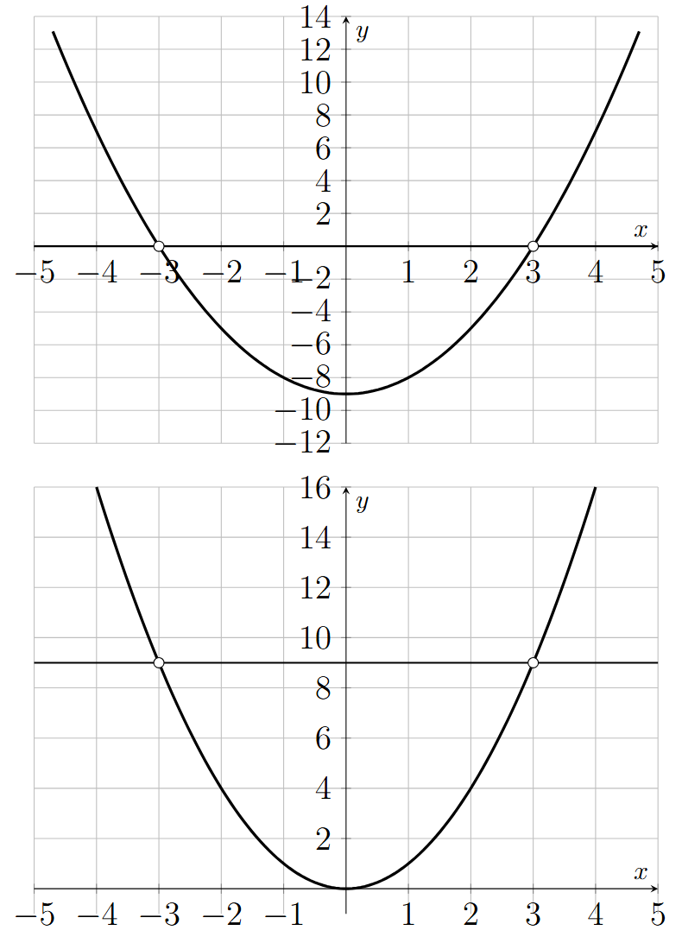

How are the two representations related? Does it make sense that the solution set is the same?

Subtracting $9$ from both sides moves both graphs down by $9$.
The horizontal positions of the intersections do not change.

- Consider $9-x^{2}>0$ and $x^{2}-9<0.$ The relevant parabolas are shown below.
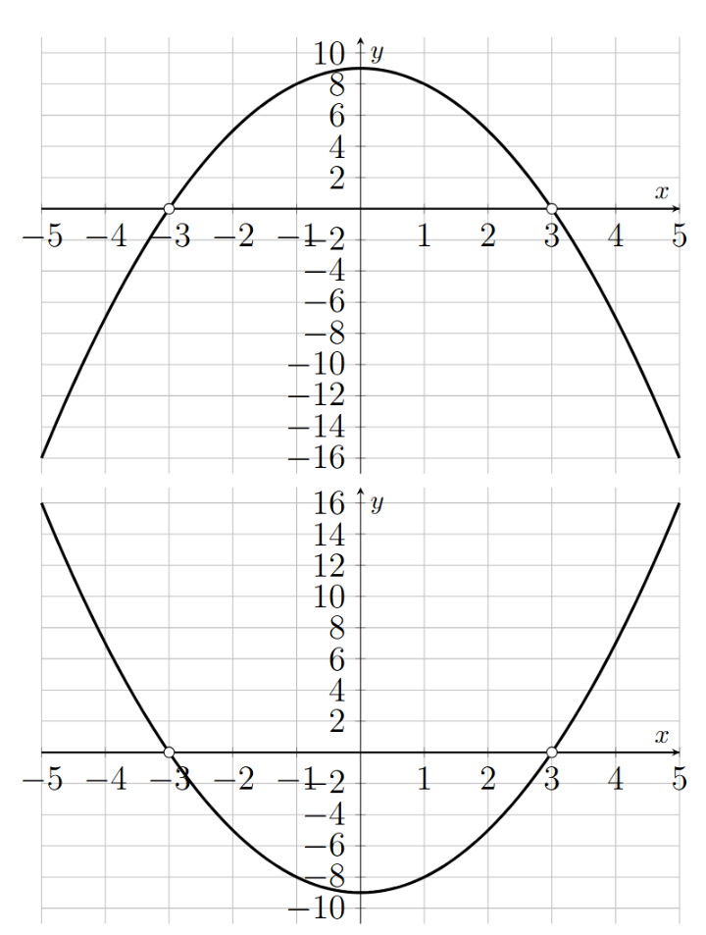

How are the two representations related? Does it make sense that the solution set is the same.

When multiplying by $-1$, the graph is flipped, and so is the inequality sign.
So, the required region is the same.

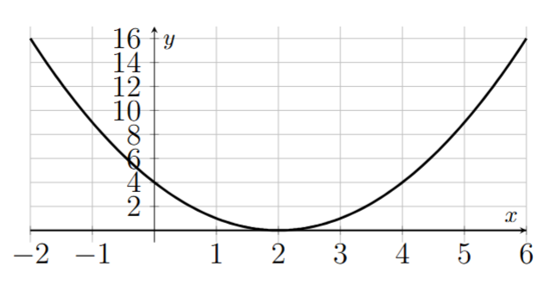
- Solve the three inequalities below. State the differences between the three solution sets.

$$(x-2)^{2}<0, (x-2)^{2}≤0, (x-2)^{2}>0.$$
$(x-2)^{2}<0$ has no solution, since a square is never negative
$(x-2)^{2}≤0$ has a single solution $x=2$
$(x-2)^{2}>0$ is true all real $x$ except $x=2$

- A student is solving $x^{2}>-4$.

Since $x^{2}=-4$ has no solution, this inequality also has no solution.

Explain why she is incorrect.

By considering the graph, the parabola $x^{2}$ is always above $y=-4$, so $x^{2}>-4$ is true for all values of $x$.

- Consider an alternative method to solving quadratic inequalities, without using a parabola.
Considering cases
$$x\left(x-4\right)<0$$
For a product to be less than zero, the factors must be opposite signs.
Case 1  $x>0$ and $x-4<0$  $x<4$  The combined interval is $0<x<4$. | Case 2  $x<0$ and $x-4>0$  $x>4$  No interval can satisfy $x<0$ and $x>4.$
So, the solution is $0<x<4$.
Solve $\left(x-3\right)\left(x+5\right)<0$ using the same method.

$$-5<x<3$$
- Consider another alternative method to solving quadratic inequalities, without using a parabola.
Testing regions method
$$x\left(x-4\right)<0$$
1. Critical points
By considering the LHS, the critical points for this expression are $x=0$ and $x=4$.
2. Set up a number line and test a point from each region.
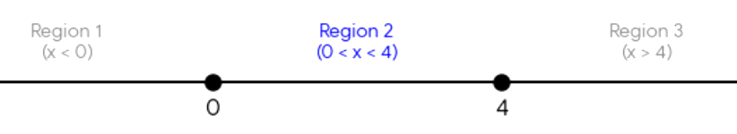

When $x=-1, x\left(x-4\right)=5$  Which doesn’t satisfy the inequality. | when $x=1$, $x\left(x-4\right)=-3$  which satisfies the inequality. | when $x=5,$ $x\left(x-4\right)=5$  which doesn’t satisfy
So only numbers in the region $0<x<4$ satisfy the inequality.
Solve $\left(x-3\right)\left(x+5\right)>0$ using the same method.

$$x<-5, x>3$$

- Determine the $x$ values for which the $y$ value is defined.
- $y=\sqrt{x^{2}-4}$  Expression inside square root must be greater than or equal to zero  $$x^{2}-4≥0$$  $x≤-2$ or $x≥2$ | - $y=$ $\frac{1}{\sqrt{1-x^{2}}}$  Expression inside square root must be greater than or equal to zero  Also, denominator cannot be zero  $$1-x^{2}>0$$  $$-1<x<1$$

Challenge Exercise
- [A moving family of vertices]
For each real value of $p$, consider
$$y=(x-p)(x-p-4)+p$$
  - Write the equation in vertex form.
  - State the vertex and axis of symmetry in terms of $p$.
  - As $p$ varies, the vertices lie on a straight line. Find its equation.
  - Determine the values of $p$ for which the parabola has:
    - two $x$-intercepts
    - exactly one $x$-intercept
    - no $x$-intercepts.
  - Find the value of $p$ for which the vertex lies on the $y$-axis.
  - When the intercepts exist, express them exactly in terms of $p$.
a. Complete the square around the midpoint of the two factors:
$$y=(x-p)(x-p-4)+p$$
$$y=\left((x-p-2)+2\right)\left((x-p-2)-2\right)+p$$
$$y=(x-p-2)^{2}+p-4.$$

b. Hence the vertex is
$$(p+2,p-4),$$
and the axis of symmetry is
$$x=p+2.$$
c. Let the vertex be $(X,Y)$. Since $X=p+2$ and $Y=p-4$,
$$p=X-2,$$

$$Y=(X-2)-4=X-6.$$
The vertex locus is
$$y=x-6.$$
d. For an $x$-intercept,
$$0=(x-p-2)^{2}+p-4,$$
$$(x-p-2)^{2}=4-p.$$
Therefore:
two intercepts when $p<4$;
one intercept when $p=4$;
no intercepts when $p>4$.

e. The vertex lies on the $y$-axis when
$$p+2=0,$$
$$p=-2.$$
The vertex is then $(0,-6)$.

f. When $p≤4$,
$$x-p-2=±\sqrt{4-p},$$
$$x=p+2±\sqrt{4-p}.$$
https://www.desmos.com/calculator/kqdpf58al7
- [A fixed point]
Consider the family
$$y=x^{2}+px-p$$
  - Show that every parabola in the family passes through one fixed point, regardless of the value of $p$.
  - Use the discriminant to find the two values of $p$ for which the parabola is tangent to the $x$-axis.
  - Find the point of tangency in each case.
  - Classify the number of $x$-intercepts when:
$$p<-4, -4<p<0, p>0.$$
a. Rewrite the equation as
$$y=x^{2}+p(x-1).$$
The value is independent of $p$ when $x-1=0$. Thus $x=1$ and
$$y=1^{2}=1.$$
Every member of the family passes through $(1,1)$.

b. Here $a=1$, $b=p$ and $c=-p$. Therefore
$$Δ=b^{2}-4ac=p^{2}+4p=p(p+4).$$
Tangency requires $Δ=0$:
$$p(p+4)=0,$$
$$p=0 \text{or} p=-4.$$

c. If $p=0$,
$$y=x^{2},$$
so the tangency point is $(0,0)$.
If $p=-4$,
$$y=x^{2}-4x+4=(x-2)^{2},$$
so the tangency point is $(2,0)$.

d. Since $Δ=p(p+4)$:
$p<-4$ gives $Δ>0$, so there are two intercepts;
$-4<p<0$ gives $Δ<0$, so there are no intercepts;
$p>0$ gives $Δ>0$, so there are two intercepts.
At the boundary values $p=-4$ and $p=0$, there is one intercept.
https://www.desmos.com/calculator/85ie0rvrx7

- [A horizontal chord]
The parabolas
$$y=(x-3)^{2}-4$$
and
$$y=-\frac{1}{2}(x-3)^{2}+8$$
intersect at points $A$ and $B$.
  - Find the coordinates of $A$ and $B$ exactly.
  - Explain why $AB$ must be horizontal before solving any equations.
  - Find the exact length of $AB$.
a. At an intersection,
$$(x-3)^{2}-4=-\frac{1}{2}(x-3)^{2}+8.$$
Hence
$$\frac{3}{2}(x-3)^{2}=12,$$
$$(x-3)^{2}=8$$
$$x=3±2\sqrt{2}.$$
Substitution gives
$$y=8-4=4.$$
Therefore
$$A=(3-2\sqrt{2},4), B=(3+2\sqrt{2},4).$$

b. Both parabolas have axis of symmetry $x=3$. Their intersection points must therefore be reflections of one another across this vertical line, so they have the same $y$-coordinate. Thus $AB$ is horizontal.

c. Since $AB$ is horizontal,
$$AB=(3+2\sqrt{2})-(3-2\sqrt{2})=4\sqrt{2}.$$
https://www.desmos.com/calculator/lugs4x1uws

- [Reconstructing a parabola]
An upward-opening parabola has vertex $(2,-3)$. The horizontal line $y=5$ intersects it at points $A$ and $B$, where $AB=8$.
  - Find the equation of the parabola.
  - Find its $y$-intercept.
  - Find its $x$-intercepts exactly.
  - Sketch the graph, clearly identifying all features.
a. Using the vertex, write
$$y=a(x-2)^{2}-3.$$
The chord $AB$ is centred on $x=2$ and has length $8$, so its endpoints have $x$-coordinates $-2$ and $6$.
Using either endpoint, for example $(-2,5)$
$$5=a(-2-2)^{2}-3$$
$$8=16a$$
$$a=\frac{1}{2}.$$

$$y=\frac{1}{2}(x-2)^{2}-3.$$

b. At $x=0$,
$$y=\frac{1}{2}(0-2)^{2}-3=-1.$$
The $y$-intercept is $(0,-1)$.

c. Set $y=0$:
$$\frac{1}{2}(x-2)^{2}-3=0.$$
$$(x-2)^{2}=6,$$
$$x=2±\sqrt{6}.$$
d. The sketch is concave up, with vertex $(2,-3)$, axis $x=2$, $y$-intercept $(0,-1)$ and $x$-intercepts $(2-\sqrt{6},0)$ and $(2+\sqrt{6},0)$.

- [Finding integer intercepts]
The parabola
$$y=x^{2}-10x+c$$
has two distinct, positive integer $x$-intercepts. Its $y$-intercept is less than $21$.
  - Find every possible value of $c$.
  - For each possible parabola, find its two $x$-intercepts and vertex.
  - Explain why there are no other possibilities.

Let the positive integer roots be $α$ and $β$. Then
$$y=(x-α)(x-β)$$
and comparison with $x^{2}-10x+c$ gives
$$α+β=10, αβ=c.$$
a. The distinct positive integer pairs with sum $10$ are
$$(1,9), (2,8), (3,7), (4,6).$$
Their products are
$$9, 16, 21, 24.$$
Since the $y$-intercept $c$ is less than $21$,
$$c=9 \text{or} c=16.$$

b. If $c=9$,
$$y=(x-1)(x-9),$$
so the roots are $1$ and $9$. The axis is $x=5$, and
$$y(5)=25-50+9=-16.$$
The vertex is $(5,-16)$.
If $c=16$,
$$y=(x-2)(x-8),$$
so the roots are $2$ and $8$. Also,
$$y(5)=25-50+16=-9.$$
The vertex is $(5,-9)$.

c. The four pairs listed above are all distinct positive integer pairs with sum $10$.
The final two have products at least $21$, so they do not satisfy $c<21$.

- [A root that doesn’t move]
For an integer $n≠2$, consider
$$y=(n-2)x^{2}+4x-(n+2).$$
  - Show that its discriminant is $4n^{2}$.
  - Factorise the quadratic. (Hint: split the middle term)
  - Hence show that one $x$-intercept is the same for every permitted value of $n$.
  - Find the other $x$-intercept in terms of $n$.
  - Explain why all the roots are rational.
  - For which value of $n$ is the parabola tangent to the $x$-axis?
a. $a=n-2, b=4, c=-(n+2).$
$$Δ=4^{2}-4(n-2)(-(n+2)).$$
$$Δ=16+4(n^{2}-4)=4n^{2}.$$

b. Split middle term using $4x=-\left(n-2\right)x+\left(n+2\right)x$
$$\left(n-2\right)x^{2}+4x-\left(n+2\right)$$
$$=\left(n-2\right)x^{2}-\left(n-2\right)x+\left(n+2\right)x-\left(n+2\right)$$
$$=\left(n-2\right)x\left(x-1\right)+\left(n+2\right)\left(x-1\right)$$
$$=(x-1)((n-2)x+n+2))$$
Expanding confirms the original quadratic.

c. The factor $x-1$ gives the fixed intercept
$$x=1.$$

d. The second factor gives
$$(n-2)x+n+2=0,$$
$$x=-\frac{n+2}{n-2}.$$

e. The first root is the integer $1$. The second is a ratio of integers, and $n≠2$ ensures its denominator is non-zero. Both roots are rational.

f. Tangency occurs when
$$Δ=4n^{2}=0,$$
$$n=0.$$
Therefore, the quadratic becomes
$$y=-2(x-1)^{2}.$$
https://www.desmos.com/calculator/fpywbpjaty

- [One parameter that controls everything]
Consider
$$y=x^{2}-2(m+1)x+m^{2}+1.$$
  - Write the expression in vertex form.
  - State the vertex and minimum value in terms of $m$.
  - Determine the values of $m$ for which the graph has zero, one or two $x$-intercepts.
  - Calculate the discriminant and explain why it gives exactly the same classification.
  - Find the $x$-intercepts when $m=8$.
a. Complete the square:
$$y=x^{2}-2(m+1)x+m^{2}+1$$
$$y=(x-(m+1))^{2}-(m+1)^{2}+m^{2}+1$$
$$y=(x-m-1)^{2}-2m.$$

b. The vertex is
$$(m+1,-2m),$$
so the minimum value is
$$-2m.$$

c. The parabola opens upwards. Therefore:
$m<0$ gives minimum value $-2m>0$, so there are no intercepts;
$m=0$ gives minimum value $0$, so there is one intercept;
$m>0$ gives minimum value $-2m<0$, so there are two intercepts.

d. The discriminant is
$$Δ=(-2(m+1))^{2}-4(m^{2}+1)$$
$$=4(m+1)^{2}-4(m^{2}+1)=8m.$$
Thus its sign gives the same three cases.

e. For $m=8$,
$$y=(x-9)^{2}-16.$$
Setting $y=0$ gives
$$(x-9)^{2}=16,$$
$$x=5 \text{or} x=13.$$
https://www.desmos.com/calculator/6dptukkuxc

- [All above and all below]
For $r≠1$, consider
$$y=(r-1)x^{2}+2x+r+1.$$
  - Show that
$$Δ=4(2-r^{2}).$$
  - Find all values of $r$ for which the parabola does not meet the $x$-axis.
  - For each interval found in part b, state whether the graph lies entirely above or entirely below the $x$-axis.
  - Find the exact point of tangency of the graph and the $x$-axis when:
$$r=\sqrt{2} \text{and} r=-\sqrt{2}.$$

a. Here
$$a=r-1, b=2, c=r+1.$$

$$Δ=2^{2}-4(r-1)(r+1)$$
$$=4-4(r^{2}-1)=4(2-r^{2}).$$

b. The graph does not meet the $x$-axis when $Δ<0$:
$$4(2-r^{2})<0.$$
$$r^{2}>2,$$

$$r<-\sqrt{2} \text{or} r>\sqrt{2}.$$

c. If $r>\sqrt{2}$, then $r-1>0$, so the parabola opens upwards and lies entirely above the $x$-axis.
If $r<-\sqrt{2}$, then $r-1<0$, so the parabola opens downwards and lies entirely below the $x$-axis.

d. At tangency,
$$x=-\frac{b}{2a}=-\frac{1}{r-1}.$$
For $r=\sqrt{2}$,
$$x=-\frac{1}{\sqrt{2}-1}=-(\sqrt{2}+1).$$
The point is
$$(-1-\sqrt{2},0).$$
For $r=-\sqrt{2}$,
$$x=-\frac{1}{-\sqrt{2}-1}=\frac{1}{\sqrt{2}+1}=\sqrt{2}-1.$$
The point is
$$(\sqrt{2}-1,0).$$
https://www.desmos.com/calculator/frucqsny75

- [An area inside a parabola]
Consider the family
$$y=k(x-2)(x-8), k≠0.$$
The two $x$-intercepts and the vertex form a triangle.
  - Find the vertex in terms of $k$.
  - Show that the area of the triangle is
$$27|k|.$$
  - Find every value of $k$ for which the triangle has area $54$ square units.
  - Give the equation and vertex of each resulting parabola.

a. The axis lies midway between the roots $2$ and $8$:
$$x=\frac{2+8}{2}=5.$$
At $x=5$,
$$y=k(5-2)(5-8)=-9k.$$
The vertex is
$$(5,-9k).$$

b. The triangle has base
$$8-2=6$$
and perpendicular height
$$|-9k|=9|k|.$$
Hence
$$\text{Area}=\frac{1}{2}(6)(9|k|)=27|k|.$$

c. Set the area equal to $54$:
$$27|k|=54.$$
$$|k|=2,$$
so
$$k=2 \text{or} k=-2.$$

d. For $k=2$,
$$y=2(x-2)(x-8),$$
with vertex $(5,-18)$.
For $k=-2$,
$$y=-2(x-2)(x-8),$$
with vertex $(5,18)$.
https://www.desmos.com/geometry/ltij7ejrh6

- [Surd intercepts and integer coefficients]
A concave-down parabola has $x$-intercepts
$$3-\sqrt{5} \text{and} 3+\sqrt{5},$$
and $y$-intercept $-4$.
  - Find its equation in factorised form.
  - Express it in vertex form.
  - Express it in general form.
  - State its maximum value.
  - Explain why the irrational intercepts produce integer coefficients.
a. Begin with
$$y=a\left(x-(3-\sqrt{5})\right)\left(x-(3+\sqrt{5})\right).$$
At $x=0$, the product of the two factors is
$$(\sqrt{5}-3)(-3-\sqrt{5})=4.$$
Since the $y$-intercept is $-4$, $4a=-4$, so $a=-1$. Thus
$$y=-\left(x-(3-\sqrt{5})\right)\left(x-(3+\sqrt{5})\right).$$

b. The factors are conjugates:
$$\left(x-(3-\sqrt{5})\right)\left(x-(3+\sqrt{5})\right)=(x-3)^{2}-5.$$
$$y=-(x-3)^{2}+5.$$

c. Expanding gives
$$y=-\left(x^{2}-6x+9\right)+5$$
$$y=-x^{2}+6x-4.$$

d. The vertex is $(3,5)$, so the maximum value is $5.$

e. The roots are conjugates.
Their sum is $6$ and their product is $4$, so the $\sqrt{5}$ terms cancel when the factors are expanded, leaving integer coefficients.

- [Axis first, then equation]
A parabola has axis of symmetry
$$x=-2$$
and passes through the points
$$(-5,11) \text{and} (0,1).$$
  - Find its equation in vertex form.
  - Express the equation in general form.
  - Find the vertex.
  - Find the $x$-intercepts exactly.

a. Since the axis is $x=-2$, write
$$y=a(x+2)^{2}+k.$$
Using $(-5,11)$ and $(0,1)$ gives
$$9a+k=11$$
$$4a+k=1.$$
Subtracting,
$$5a=10,$$
$a=2$.
$$4(2)+k=1,$$
$k=-7$.
$$∴y=2(x+2)^{2}-7.$$

b. Expanding,
$$y=2(x^{2}+4x+4)-7$$
$$y=2x^{2}+8x+1.$$

c. The vertex is
$$(-2,-7).$$

d. Set $y=0$:
$$2(x+2)^{2}-7=0.$$
$$(x+2)^{2}=\frac{7}{2},$$
$$x=-2±\sqrt{\frac{7}{2}}=-2±\frac{\sqrt{14}}{2}.$$

- A parabolic bridge arch has a span of $24$ metres and a maximum height of $9$ metres at its centre. Let $x$ be the distance from the left end of the arch.
  - Find an equation for the arch.
  - A flat-topped truck is $6$ metres wide and travels exactly through the centre of the arch. Find the maximum possible height of the truck. Give the answer exactly and to two decimal places.
a. The arch has roots $0$ and $24$, so
$$h=ax(x-24).$$
Its vertex is $(12,9)$, hence
$$9=a(12)(-12)=-144a.$$
$$a=-\frac{1}{16},$$
$$h=-\frac{1}{16}x(x-24)=-\frac{1}{16}(x-12)^{2}+9.$$

b. A centred truck of width $6$ has outer edges at
$$x=12±3,$$
so $x=9$ and $x=15$. The arch has the same height at both edges:
$$h(9)=-\frac{1}{16}(9-12)^{2}+9=9-\frac{9}{16}=\frac{135}{16}.$$
This edge clearance determines the greatest possible truck height.
The maximum truck height is
$$\frac{135}{16}\text{ m}=8.4375\text{ m}≈8.44\text{ m}.$$

- A farmer has $300$ metres of fencing. A rectangular field is built beside a river, so the river-facing side requires no fence. The farmer also installs one internal dividing fence perpendicular to the river.
Let $x$ be the distance perpendicular to the river and $y$ the length parallel to it.
  - Show that
$$3x+y=300.$$
  - Write the area $A$ as a quadratic function of $x$.
  - Write the area function in vertex form.
  - Find the dimensions that maximise the area.
  - Find the maximum area.
  - State the relationship between the optimal length and width.

a. The fencing consists of two outer sides of length $x$, one internal divider of length $x$, and one side of length $y$. Thus
$$3x+y=300.$$

b. Since
$$y=300-3x,$$
the area is
$$A=xy=x(300-3x)$$
$$A=-3x^{2}+300x.$$

c. Complete the square:
$$A=-3(x^{2}-100x)$$
$$A=-3\left((x-50)^{2}-2500\right)$$
$$A=-3(x-50)^{2}+7500.$$

d. The maximum occurs at $x=50$. Then
$$y=300-3(50)=150.$$
The optimal dimensions are $50$ metres by $150$ metres.

e. The maximum area is
$$A=7500{\text{ m}}^{2}.$$
f. At the optimum,
$$y=150=3(50)=3x.$$
The optimal length is three times the width.

- A food stall normally sells $80$ sandwiches per day for $6 each. For every $25$-cent increase in price, daily sales fall by $2$ sandwiches.
Let $x$ be the number of $25$-cent increases, where $x$ is a non-negative integer.
  - Show that the revenue is
$$R=\left(6+\frac{x}{4}\right)(80-2x).$$
  - Express $R$ in general form.
  - Express $R$ in vertex form.
  - Find the price, number of sales and maximum daily revenue.

a. After $x$ increases, the price is
$$6+0.25x=6+\frac{x}{4},$$
and the number sold is
$$80-2x.$$
$$R=\left(6+\frac{x}{4}\right)(80-2x).$$

b. Expanding,
$$R=480-12x+20x-\frac{1}{2}x^{2},$$
$$R=-\frac{1}{2}x^{2}+8x+480.$$

c. Complete the square:
$$R=-\frac{1}{2}(x^{2}-16x)+480$$
$$R=-\frac{1}{2}\left((x-8)^{2}-64\right)+480$$
$$R=-\frac{1}{2}(x-8)^{2}+512.$$

d. The maximum occurs at $x=8$. Therefore
$$\text{price}=6+\frac{8}{4}=8,$$
$$\text{sales}=80-2(8)=64,$$
$$R_{max}=512.$$
The stall should charge $8, sell $64$ sandwiches and earn a maximum daily revenue of $512.

- A parabola:
- passes through the origin;
- has two $x$-intercepts that are $4$ units apart;
- has its vertex on the line
$$y=x-6.$$
Find every possible equation of the parabola.

Passing through the origin means that one $x$-intercept is $0$. Since the two intercepts are $4$ units apart, the other intercept is either $4$ or $-4$.
Case 1: roots $0$ and $4$.
$$y=ax(x-4), a≠0.$$
The vertex lies midway between the roots, so its $x$-coordinate is $2$. Its $y$-coordinate is
$$y=a(2)(-2)=-4a.$$
Because the vertex lies on $y=x-6$,
$$-4a=2-6=-4.$$
Thus $a=1$, giving
$$y=x(x-4).$$
Its vertex is $(2,-4)$.

Case 2: roots $0$ and $-4$.
$$y=ax(x+4), a≠0.$$
The vertex has $x$-coordinate $-2$ and $y$-coordinate
$$y=a(-2)(2)=-4a.$$
The line gives
$$-4a=-2-6=-8.$$
Thus $a=2$, giving
$$y=2x(x+4).$$
Its vertex is $(-2,-8)$.

These are the only possibilities because the second root must be exactly $4$ or $-4$, and in each case the vertex condition determines a unique non-zero value of $a$.

